**Why do we need both client side and server-side validation?**

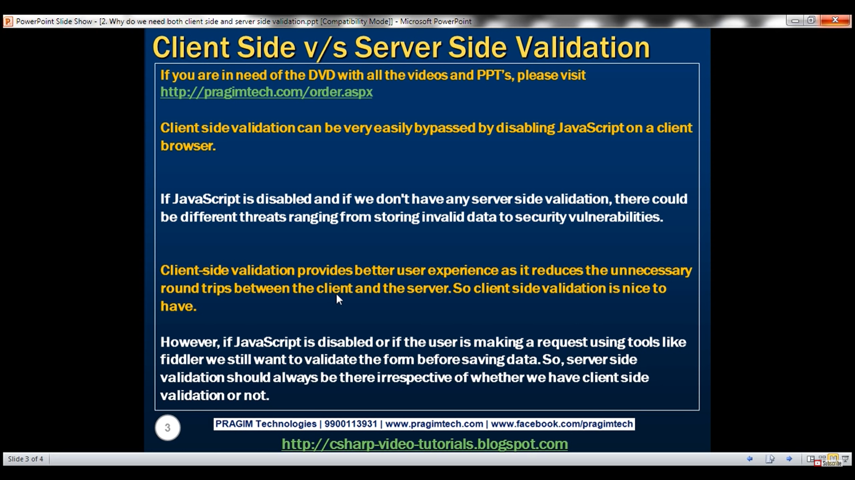

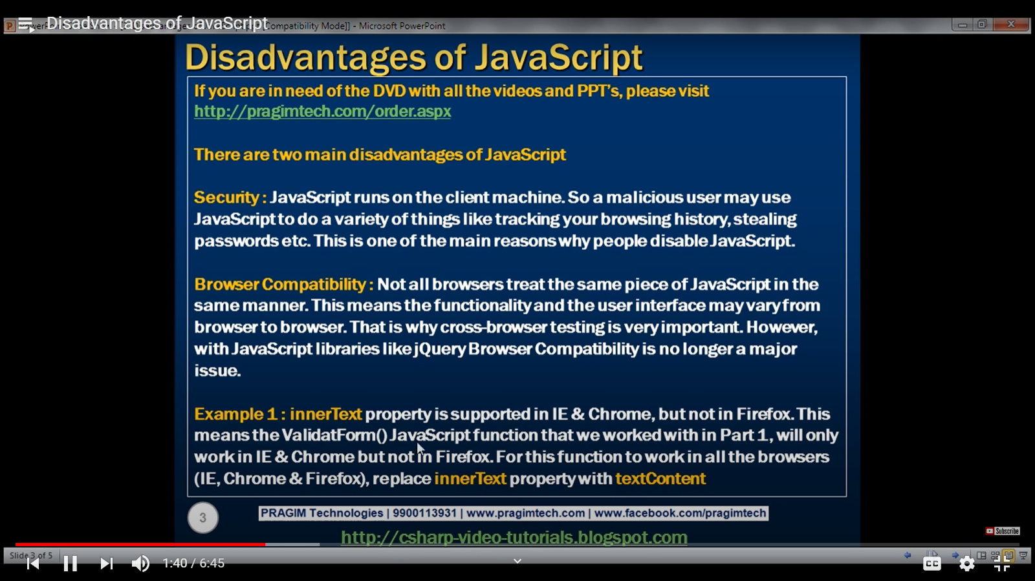

JavaScript is also used to spread viruses. So, if we do not trust a specific website, we should **disable the JavaScript** of that website.

Default browser for debugging JS is Internet Explorer in Visual Studio.

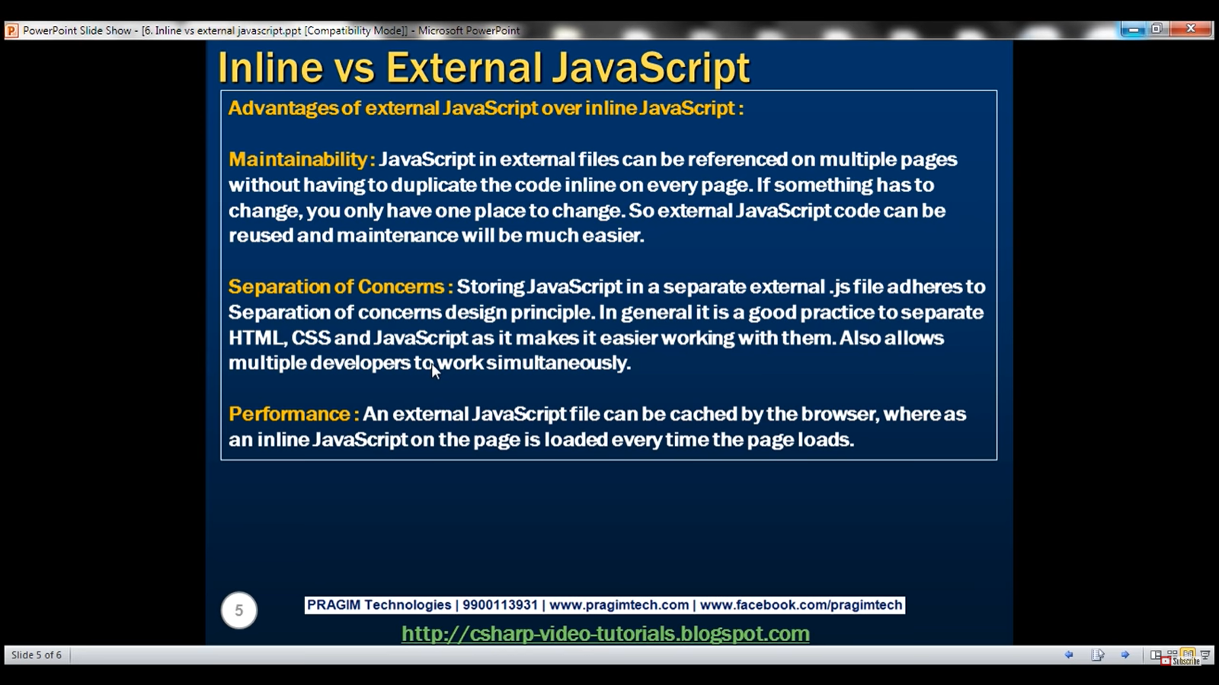

Where to put the script tags:

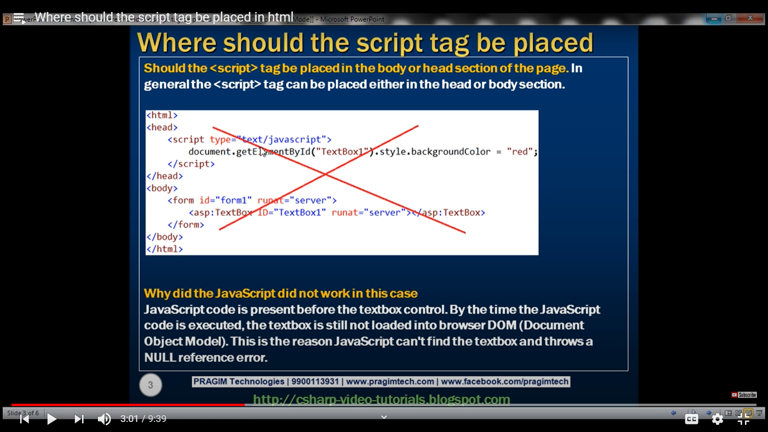

If the script file is laced inside head tags.

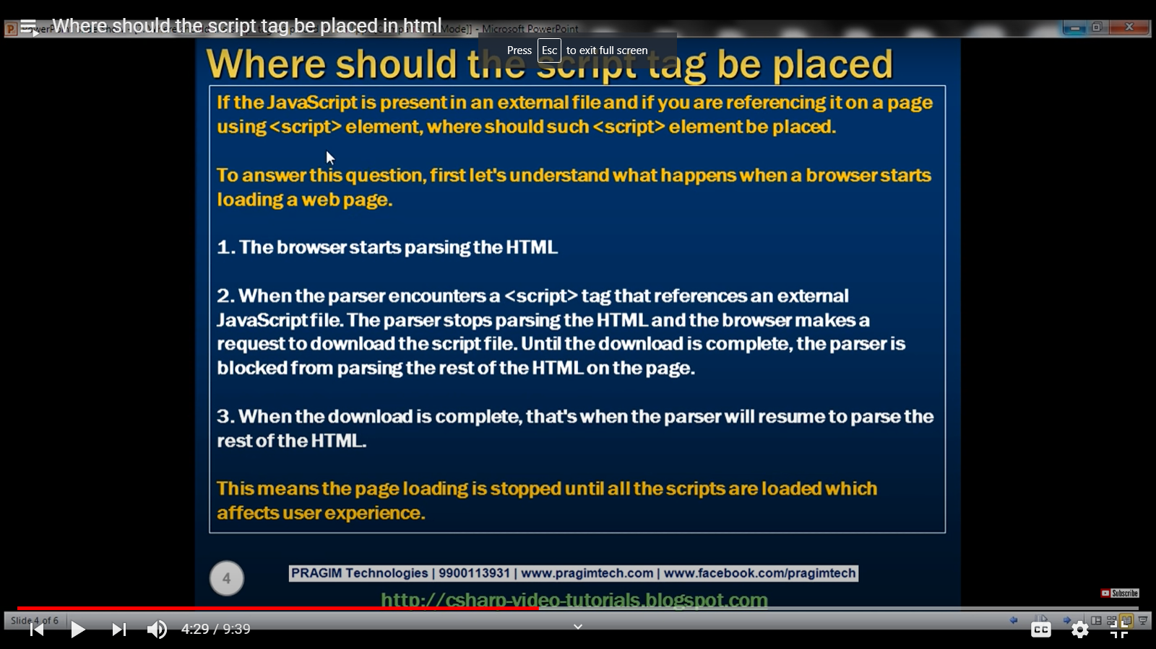

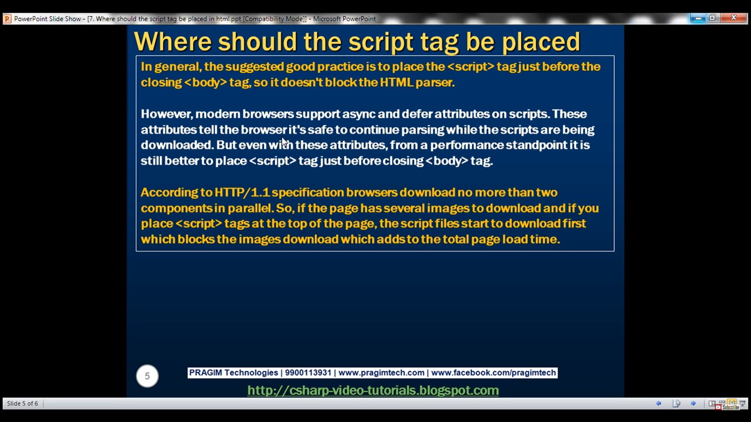

Hence it is good practice to put the script tags just before the closing body tag.

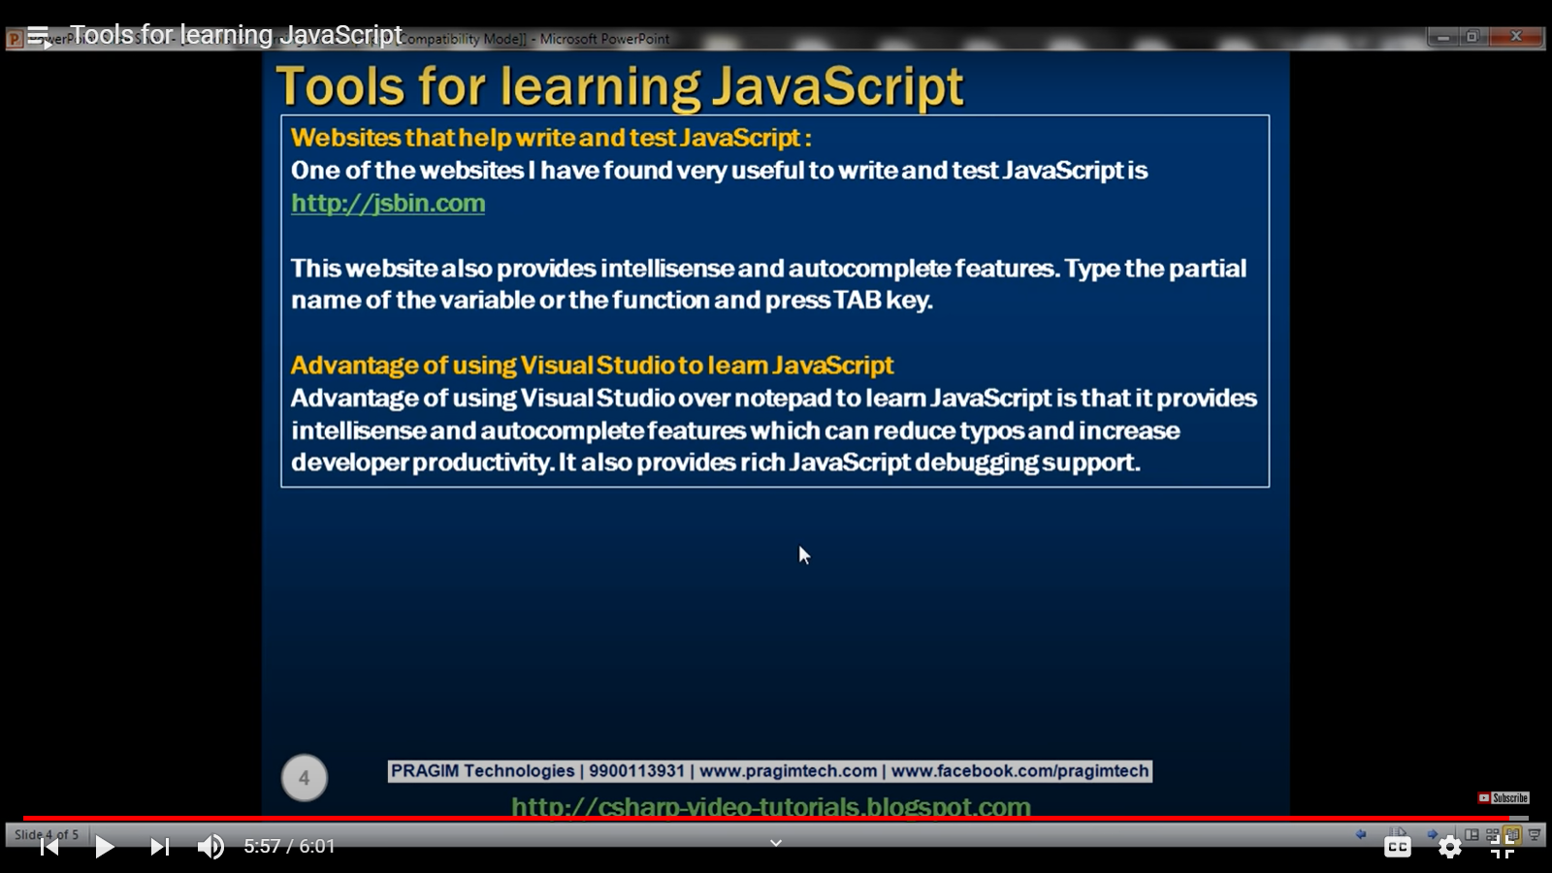

Js is case-sensitive. Ex: alert vs Alert()

Data types in JavaScript ------ > Numbsers, Boolean, String.

Assigned using var. We do not need to do int x =5; hence it is loosely typed.

Also we can later do x = “string”. Jabscript will automaticlly change the type for it.

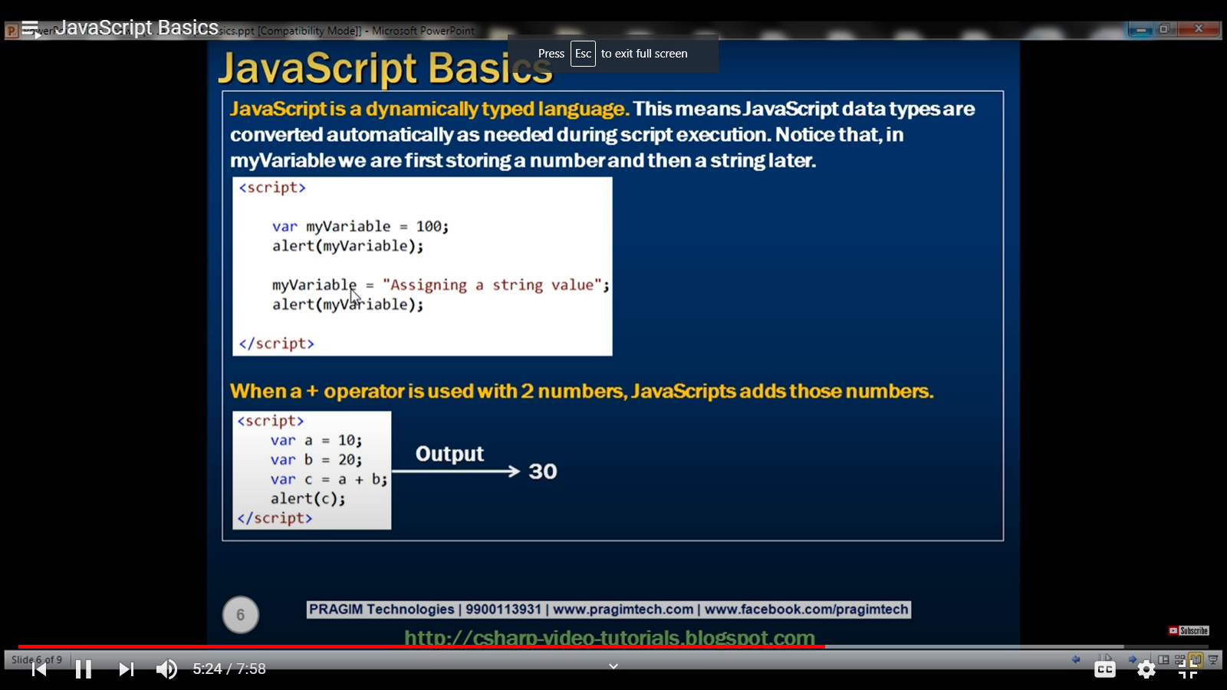

**“50” + 10 ======🡺 5010**

**“50” - 10 ======🡺 40**

Document.getElementById().value -------- > value property of textbox returns a string and not a number. Use **parseInt()** =======🡺 converts string to integer.But decimal cannot be added here. So, **use parseFloat()** ------🡪 converts string to float.

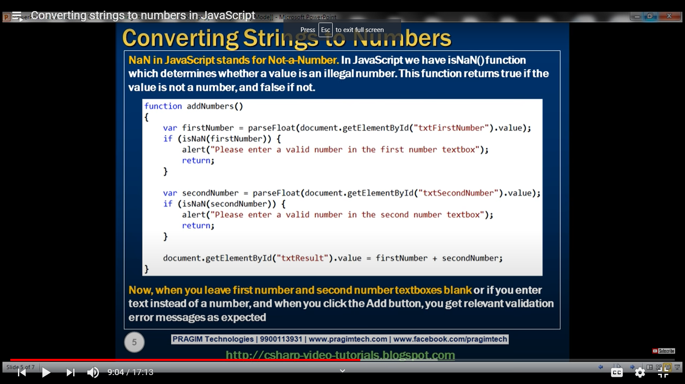

Remove whiteSpace from the ends of a string -------- > **trim()**

**str.replace(a,b)** ------- > replaces ‘a’ word in str with ‘b’.

Regular expressions are written between forward slashes.

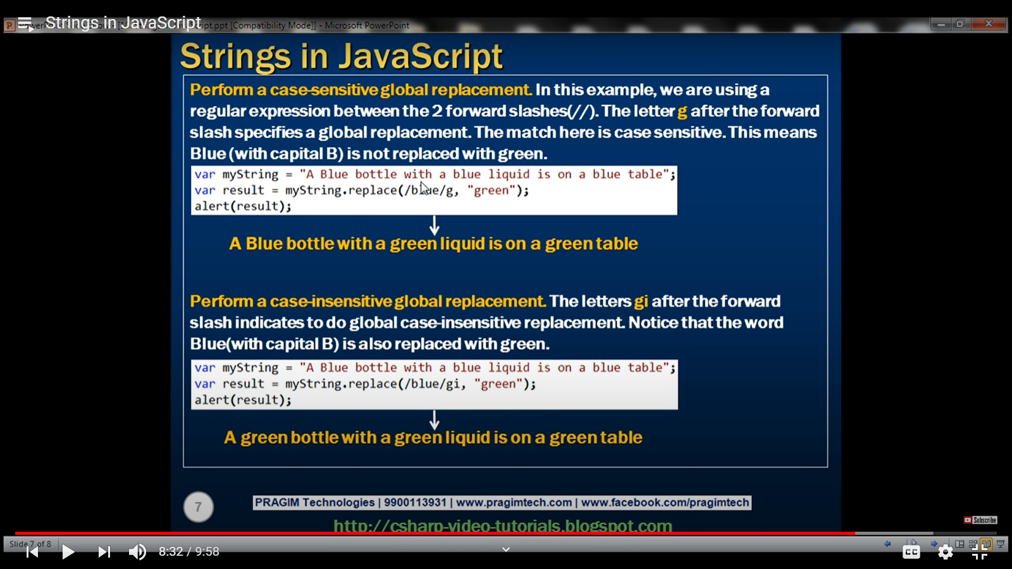

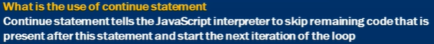

To add an element to an array, we use push(), but the element is added to the end of the array. To add element at the start, we use **unshift().**

Similarly as pop() removes the last element of the array, to remove first element, we use **shift().** We also have **contains(), lastIndexOf() and indexOf()** methods.

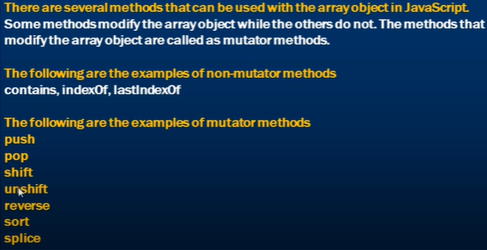



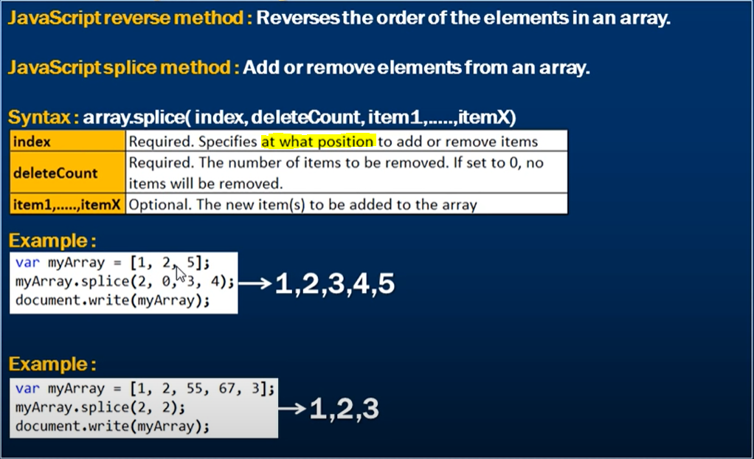

**ARRAY FILTER Methods**

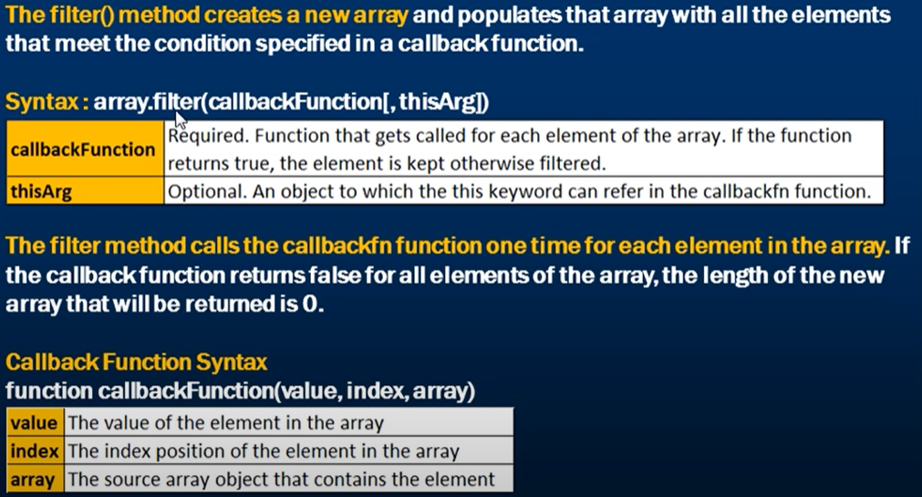

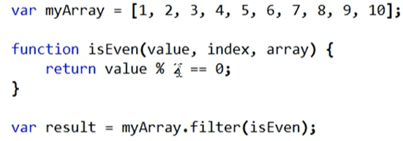

We can create the callback function as an anonymous function directly in the filter method where it is required.

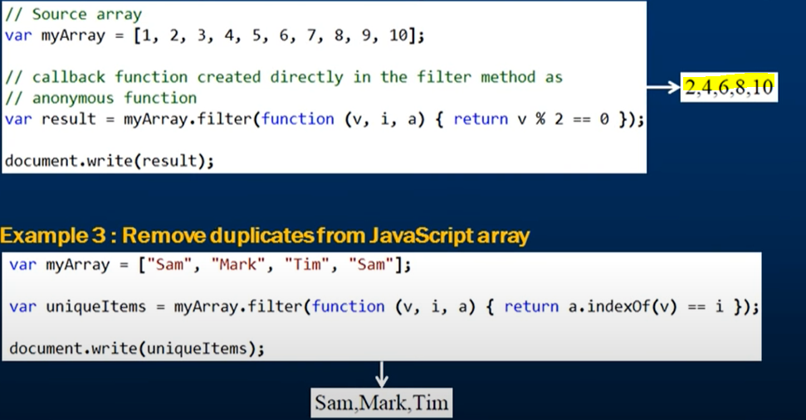

**IndexOf will return us the index of the first occurance of the element.**

Two Dimensional Arrays In JavaScript:

JavaScript does not have a special syntax for creating multidimensional arrays. Instead we create an array of arrays.

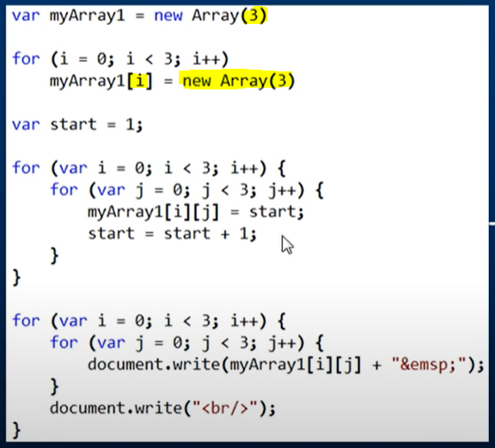



**Functions**:

Functions allows us to write and reuse code.

In JS, functions are defined using functon keyword.If the function is called without parameters, the values will be set as undefined.

If you call a function with too many parameters, the rest parameters will be ignored. A function not having a return statement returns undefined.

Functions can be defined using

1. Standard way
2. Declared as an expression

**Function Hoisting:** By default, JavaScript moves all the function declarations to the top of the current scope. This is called function hoisting. This is the reason JavaScript functions can be called before they are declared.

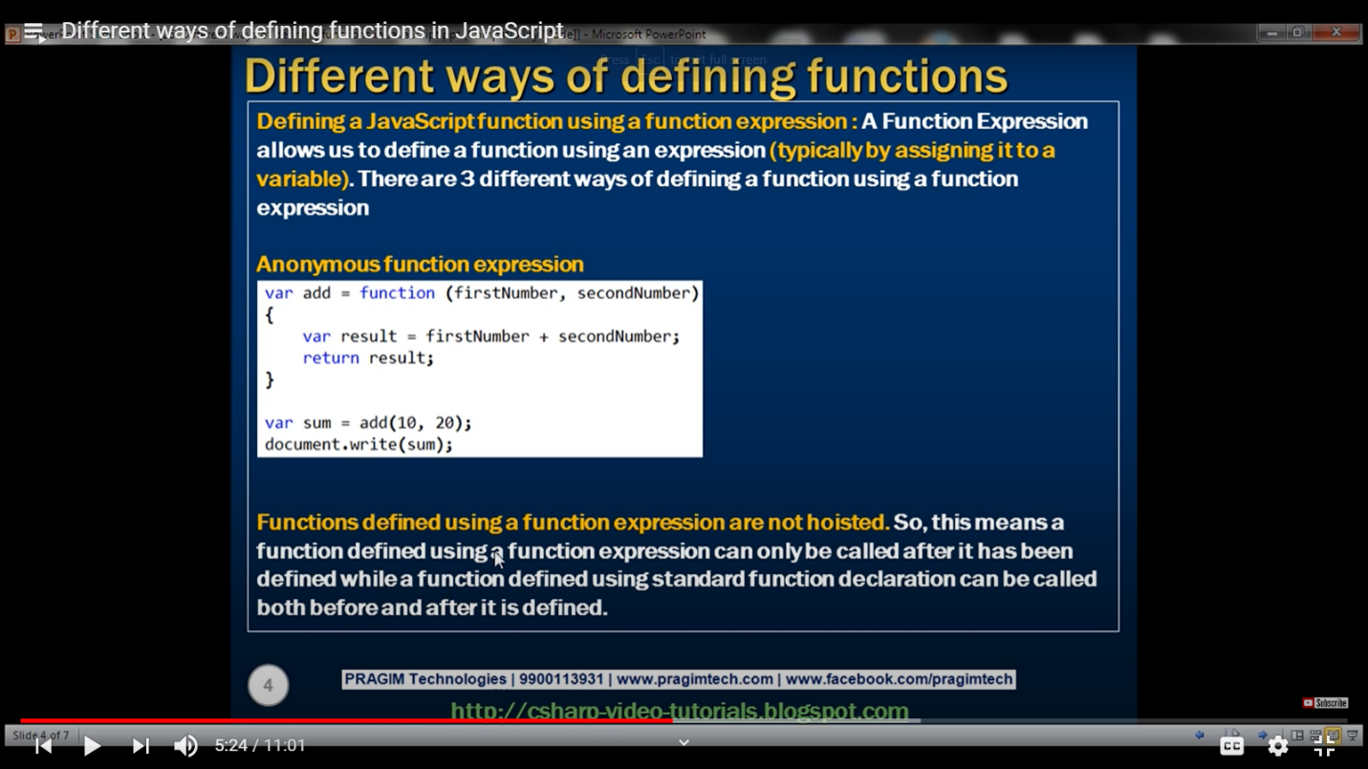

Using **break** in nested loops

In a nested loop, a break statement only stops the loop it is placed in. Therefore, if a break is placed in the inner loop, the outer loop still continues. However, if the break is placed in the outer loop, all of the looping stops.

**Named Function Expression:**

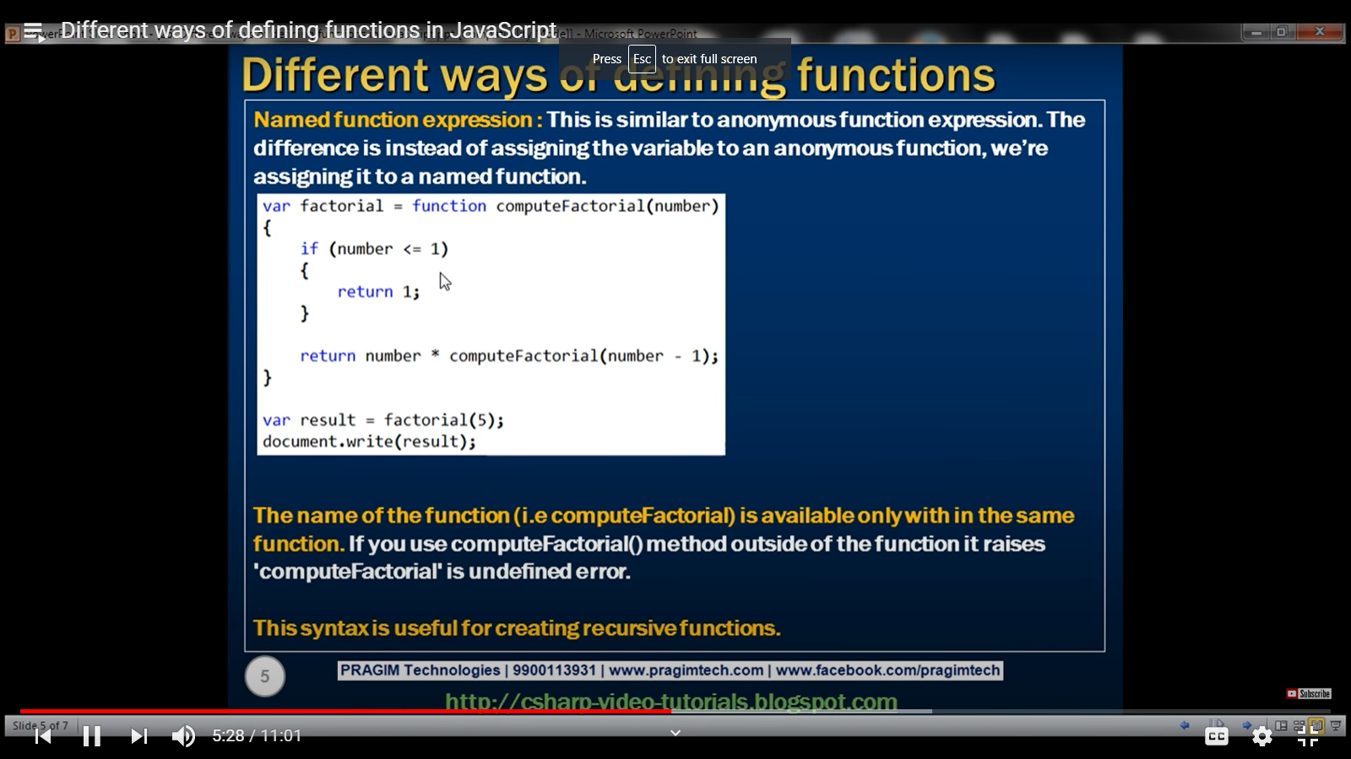

A named function expression also does not get hoisted.

**Local and Global variables in JavaScript:**

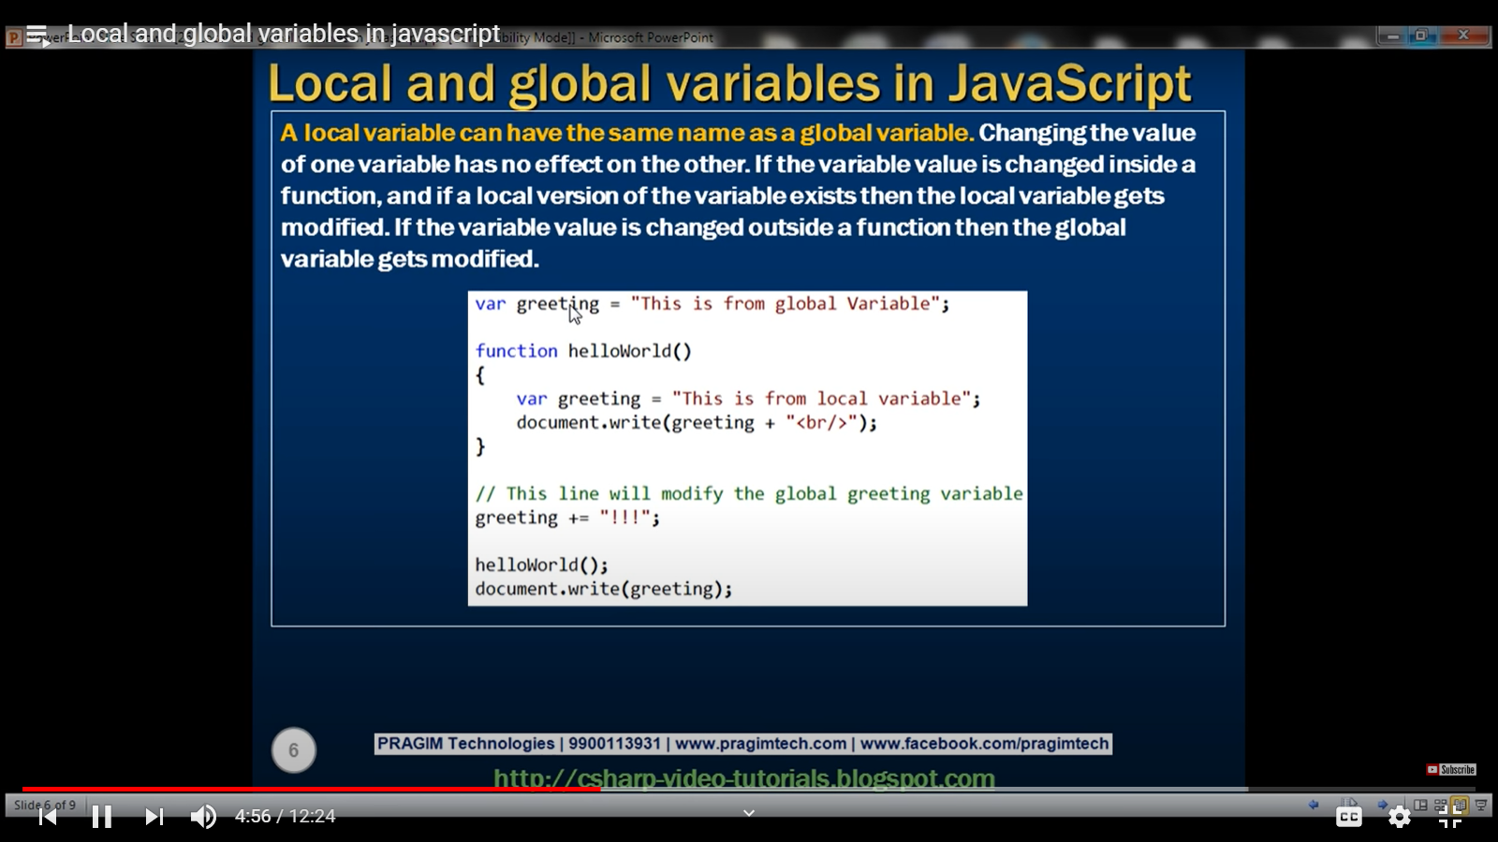

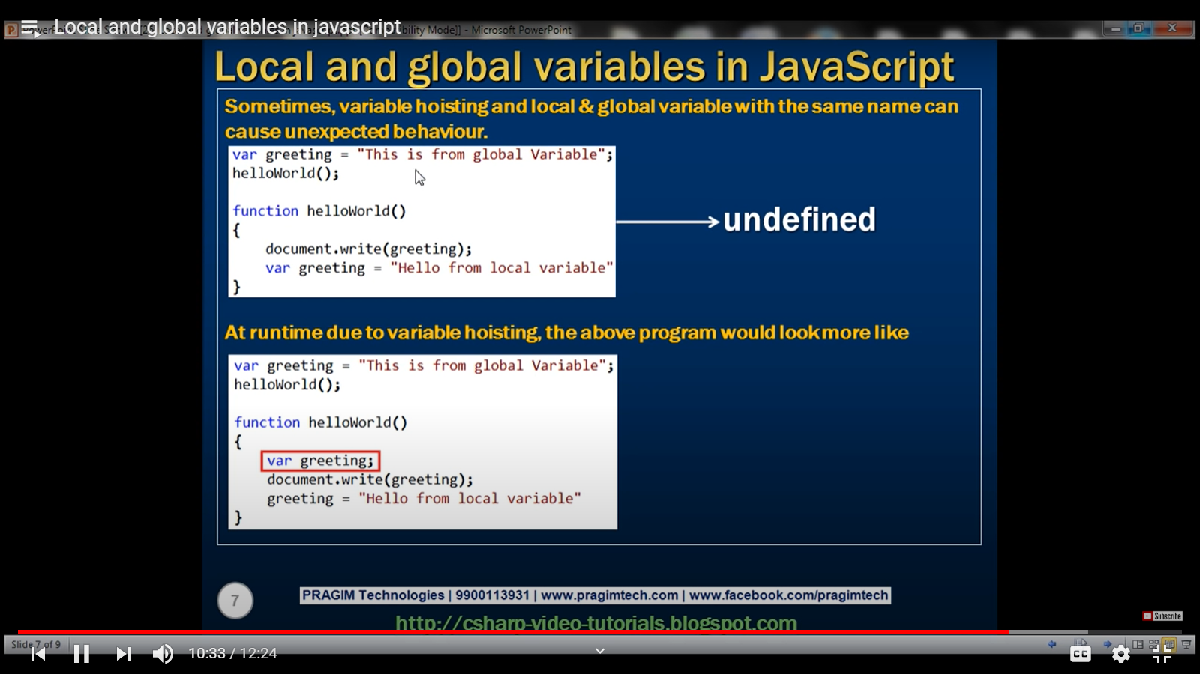

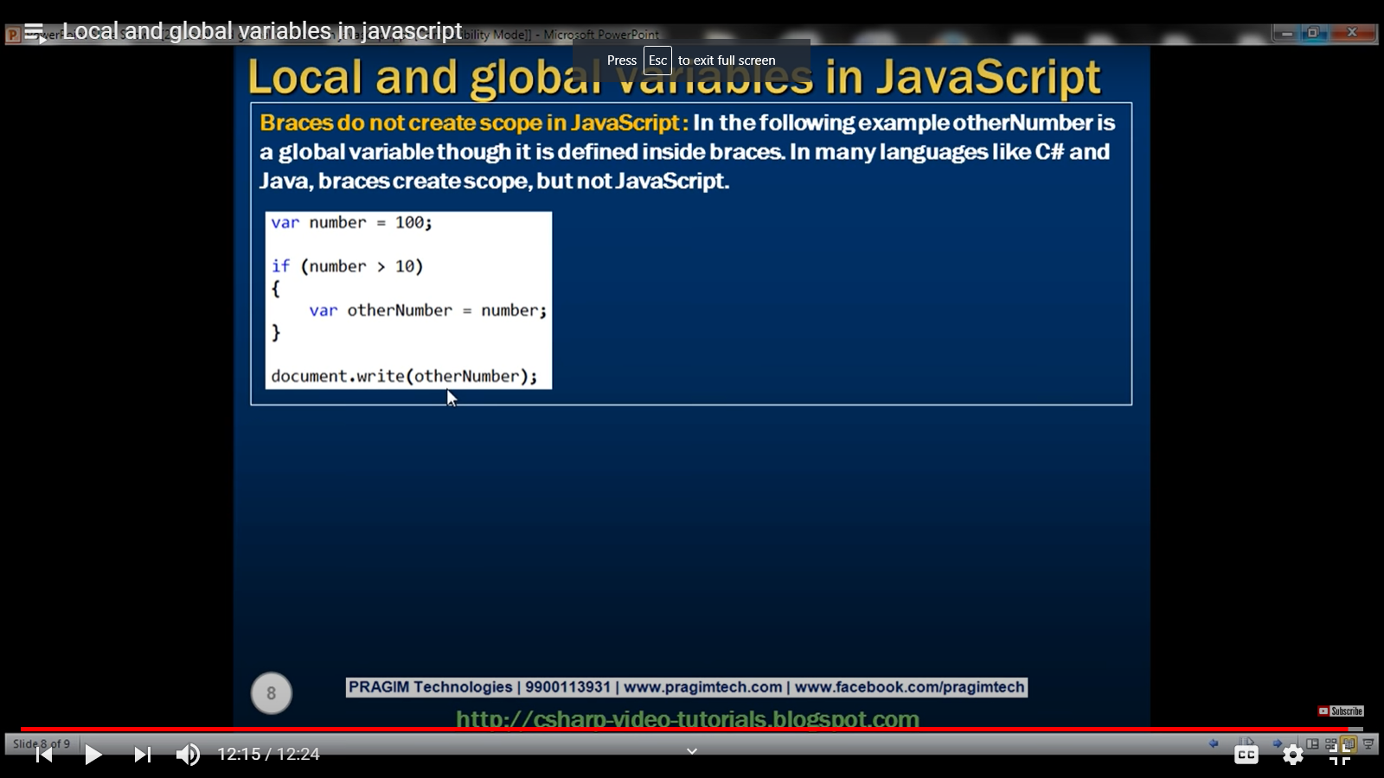

**CLOSURE:**

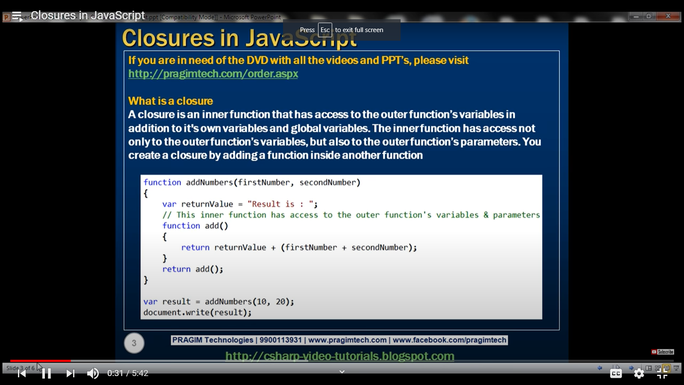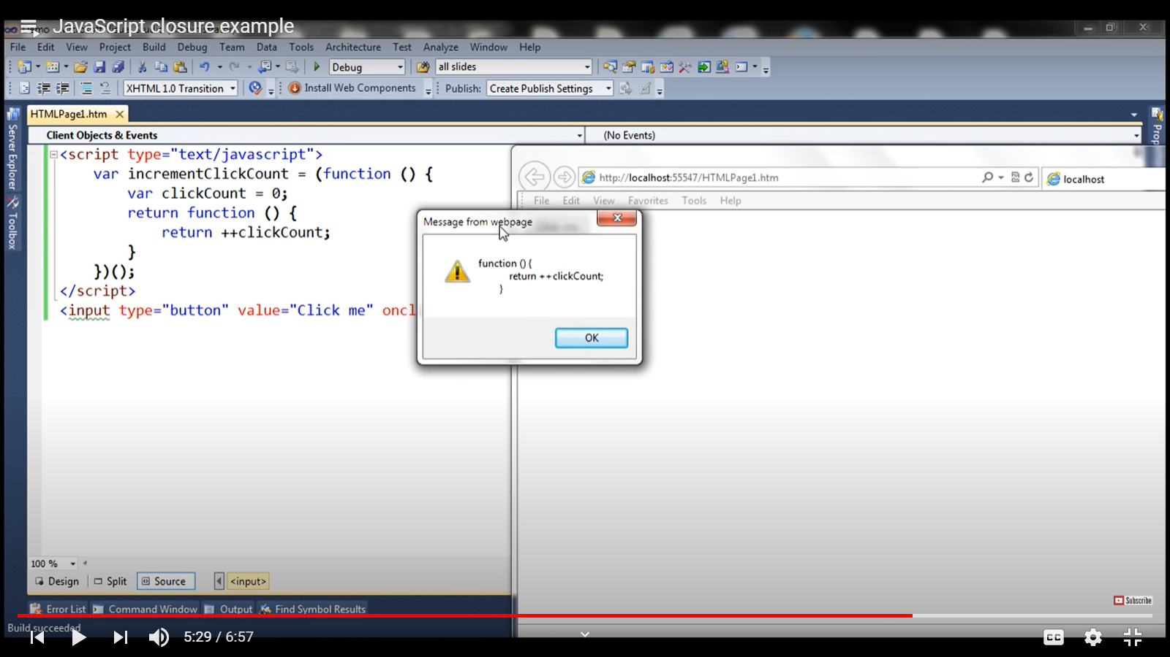

Returns the value of clickCount -------------🡪 Onclick=”incrementClickCount()”

Returns the function as shown in popup-------- > Onclick=”incrementClickCount”

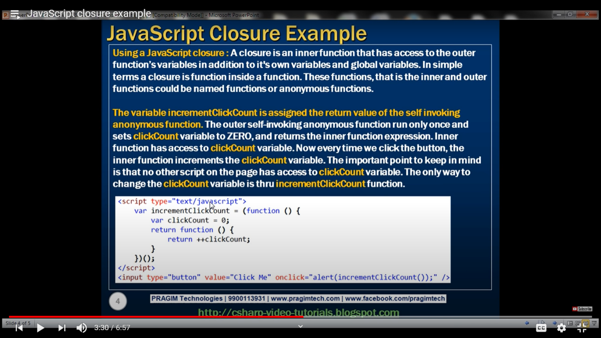

An **IIFE** (Immediately Invoked Function Expression) is a [JavaScript](https://developer.mozilla.org/en-US/docs/Glossary/JavaScript) [function](https://developer.mozilla.org/en-US/docs/Glossary/function) that runs as soon as it is defined. So, the incrementClickCount will store the anonymous function and each time it is called, the anonymous function will be executed. Here the click count will not be available for others

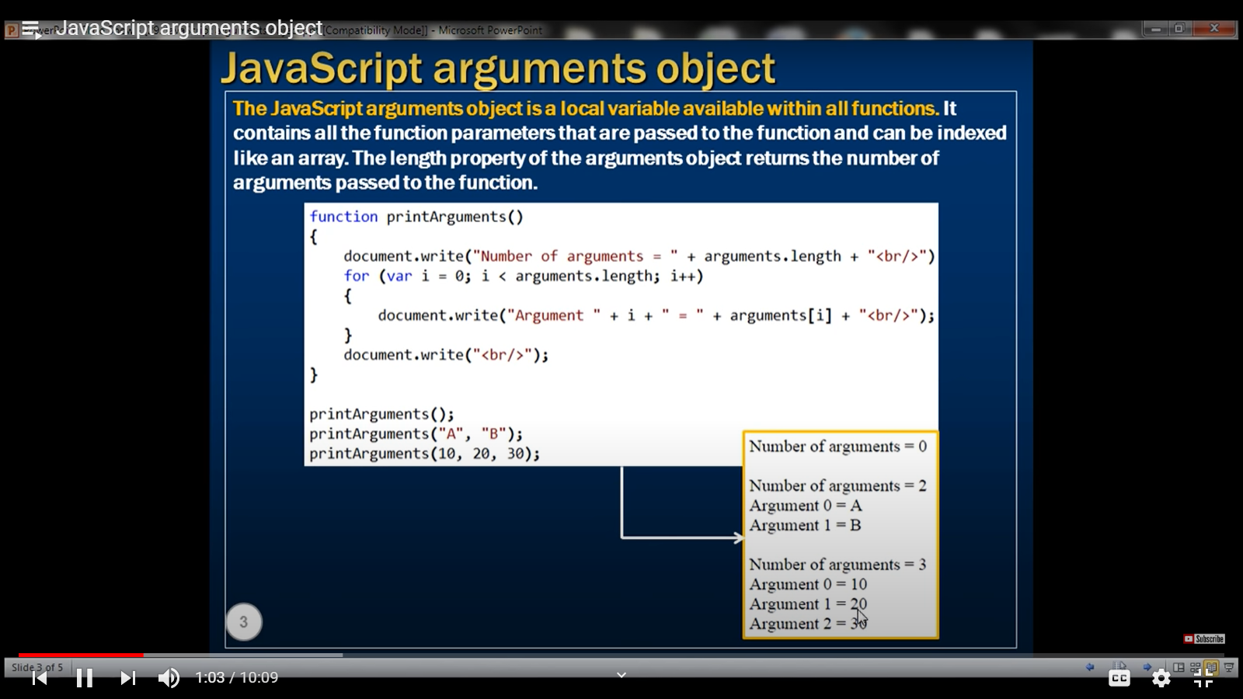

We can pass any number of parameters to a JavaScript method and then use the arguments object inside to access the parameters by indexing.

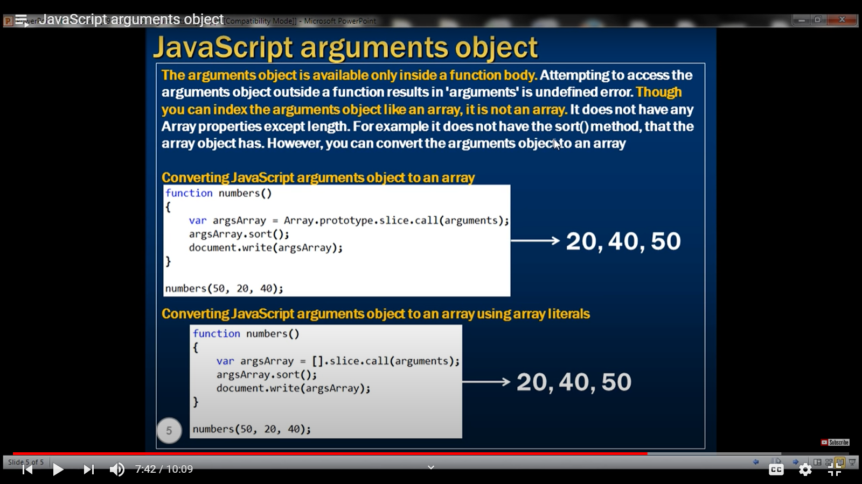

**Error Handling in JavaScript:**

Try / catch / finally are used for exceptions like if a method is not declared and called.

They cannot be used to handle syntax errors like alert(“Hello”;

The catch block will not be called here.

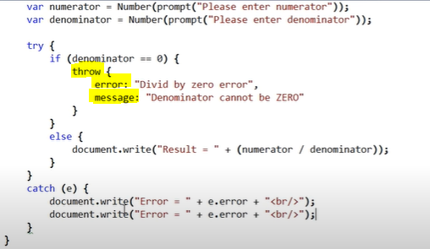

Custom exception has two properties 🡪 error and message.

If the error is handled by a try/catch statement, then the **onerror event** is not raised. onerror event is raised only when there is an unhandled exception.

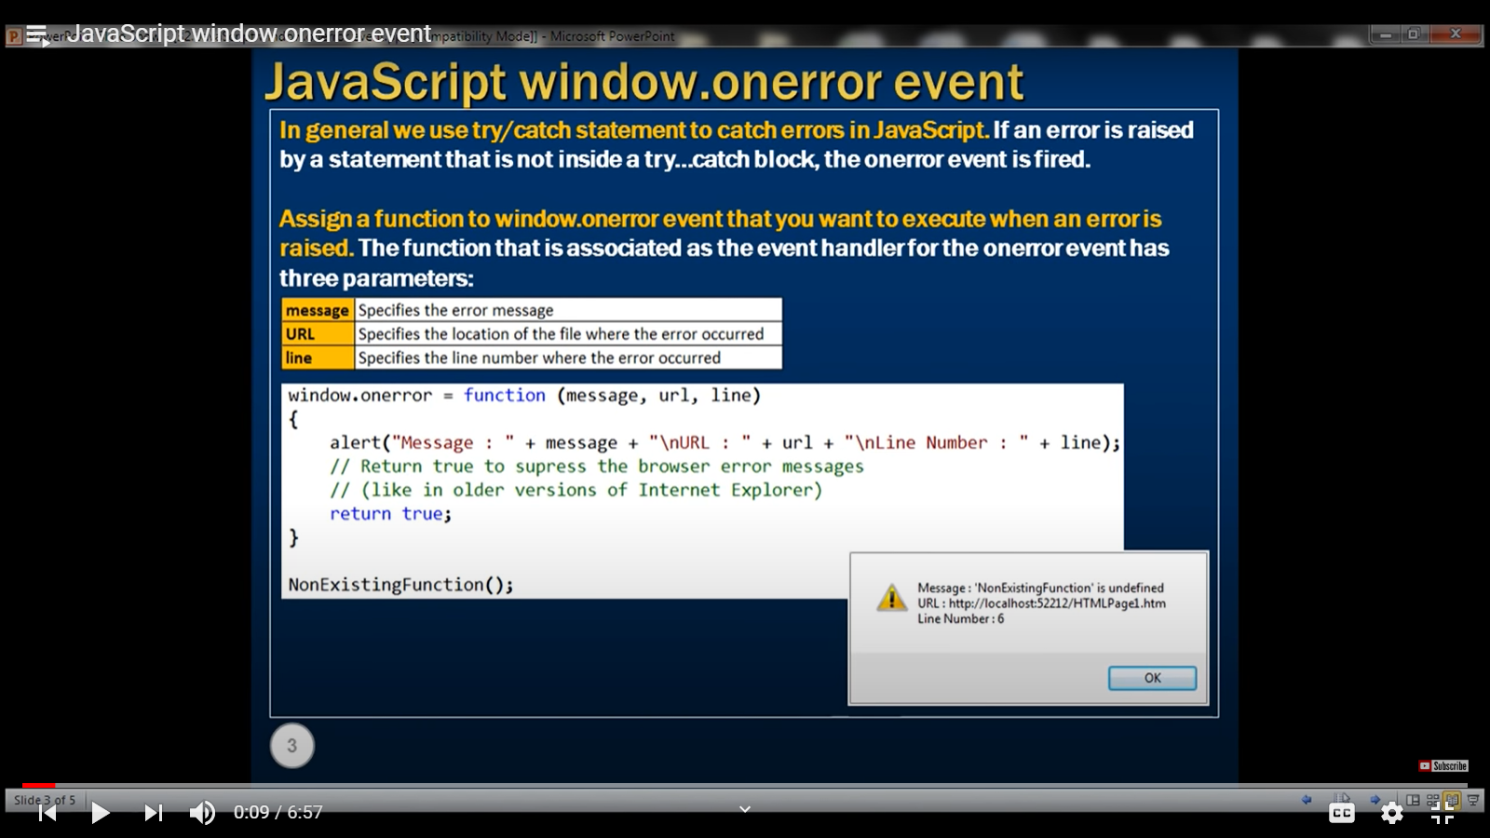

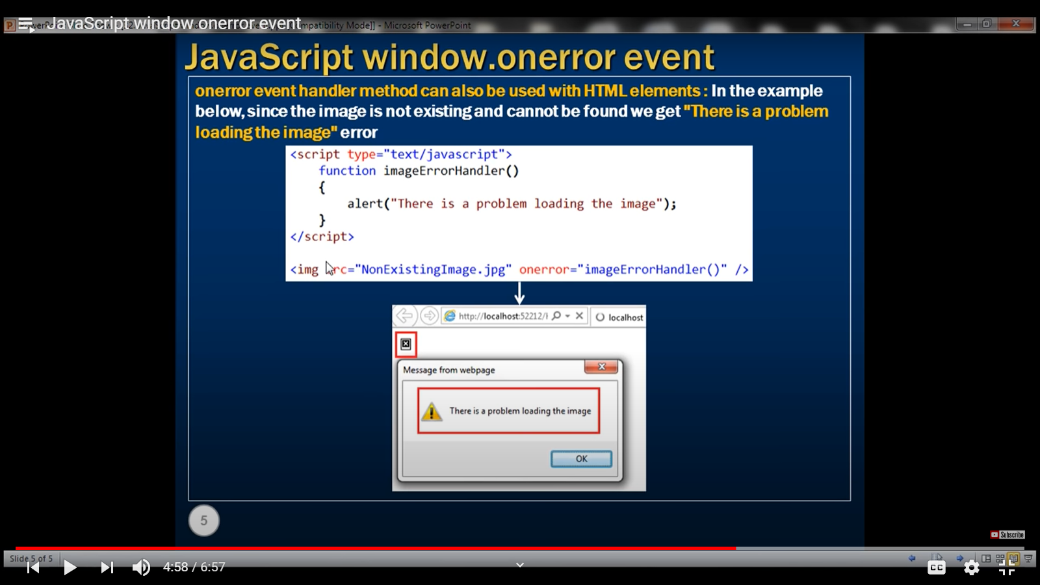

**Events :** **onkeyup** and **onblur** ---- > (fired when a controller looses focus)

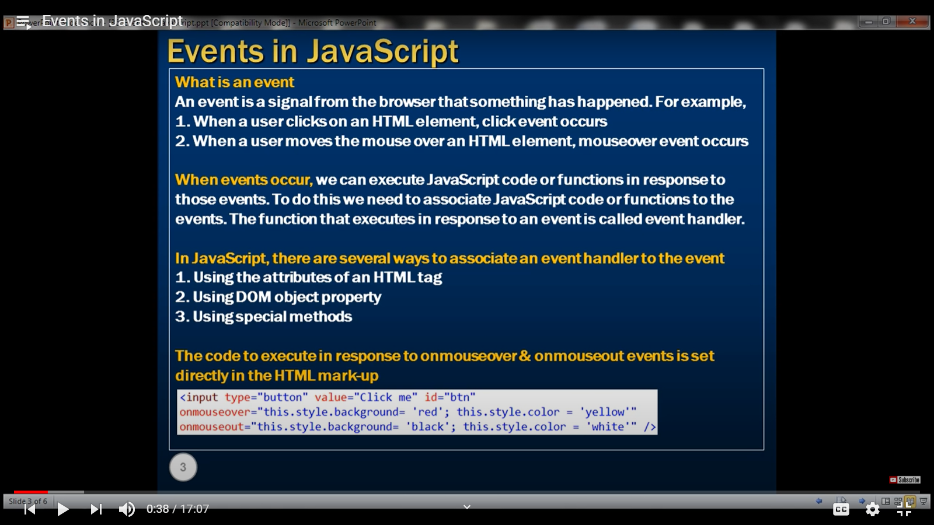

When an event occurs, we can either call a hander or assign the changes needed inside the element only. i.e. onmouseout =”this.style.backgroungcolor = ‘red’”. This here refers to the element.

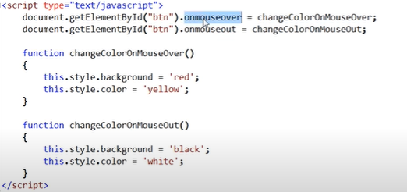

OR

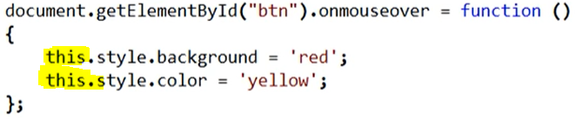

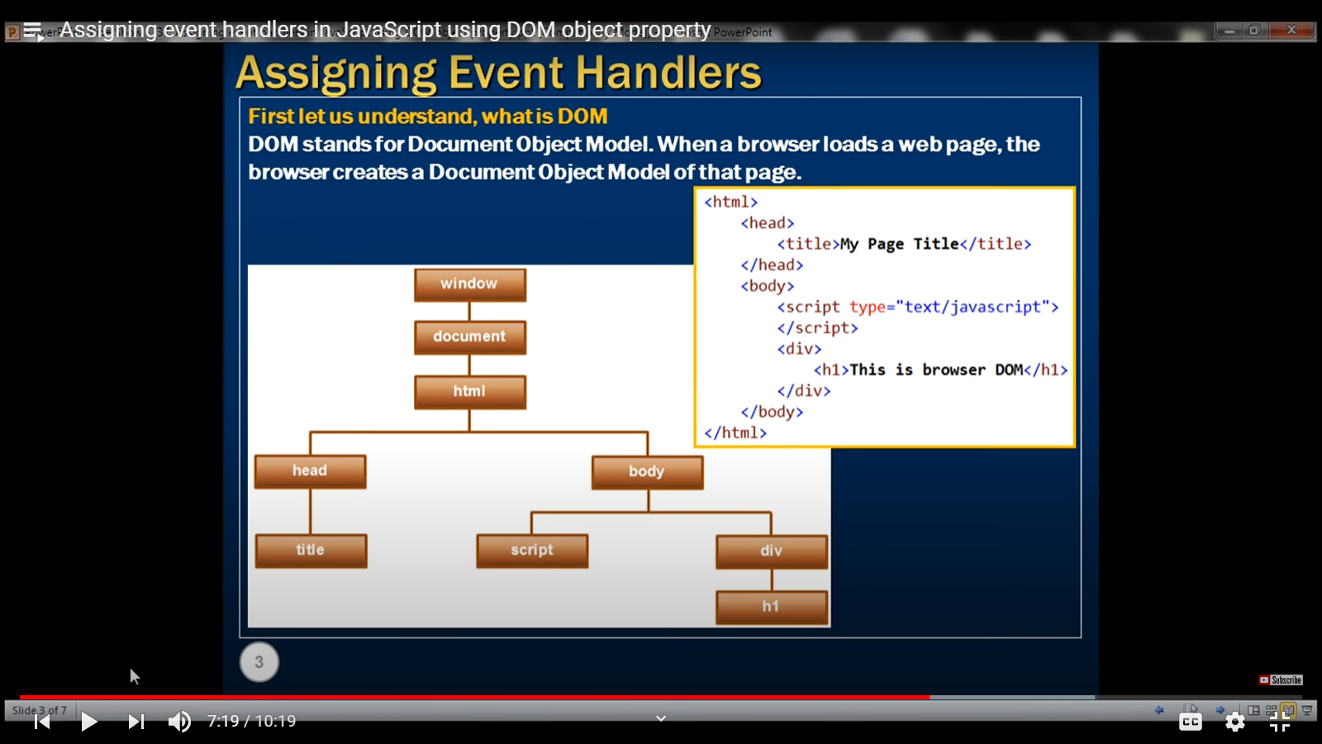

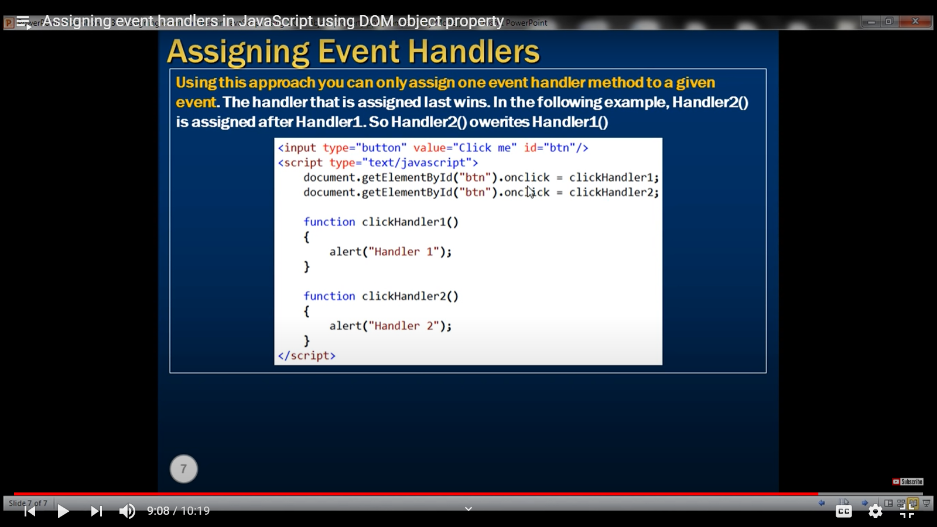

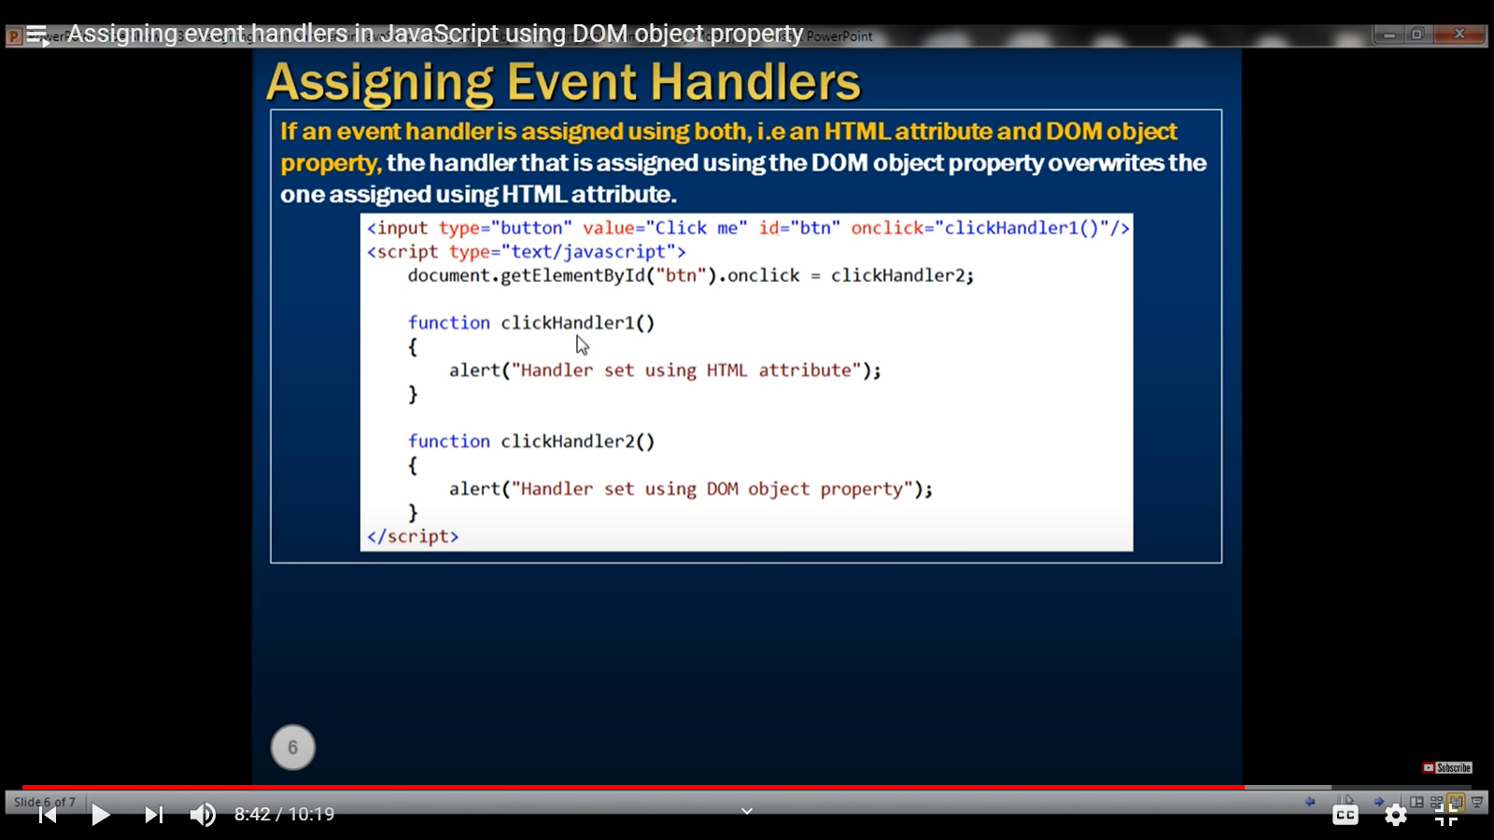

**Event Handlers using special methods:**

**addEventListener(event, handler, phase)** (for earlier browsers ------ > attachEvent)

**removeEventListener(event, handler, phase)** (for earlier browsers ------ > detachEvent).

The third parameter is optional in both the above methods. Generally set to false if not used.

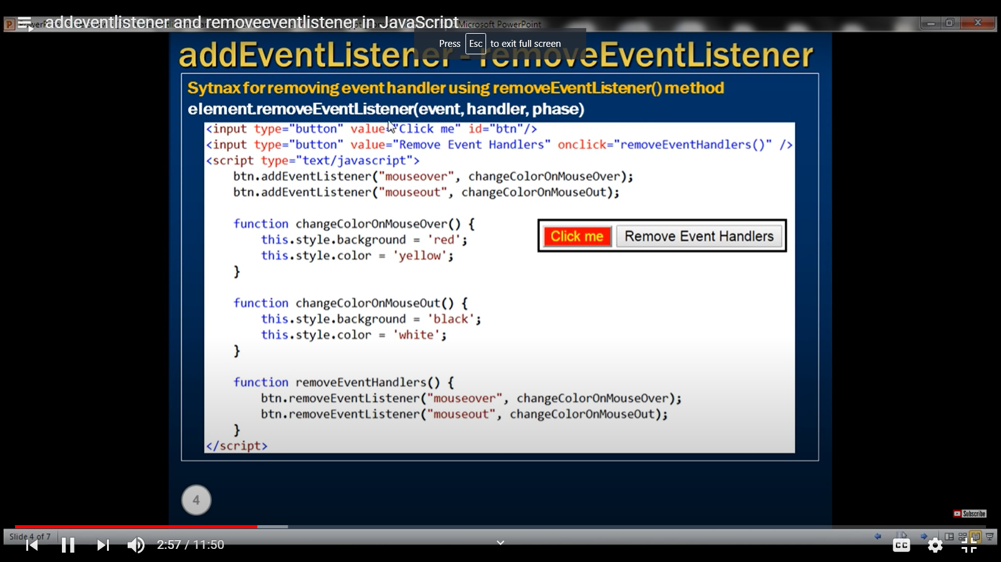

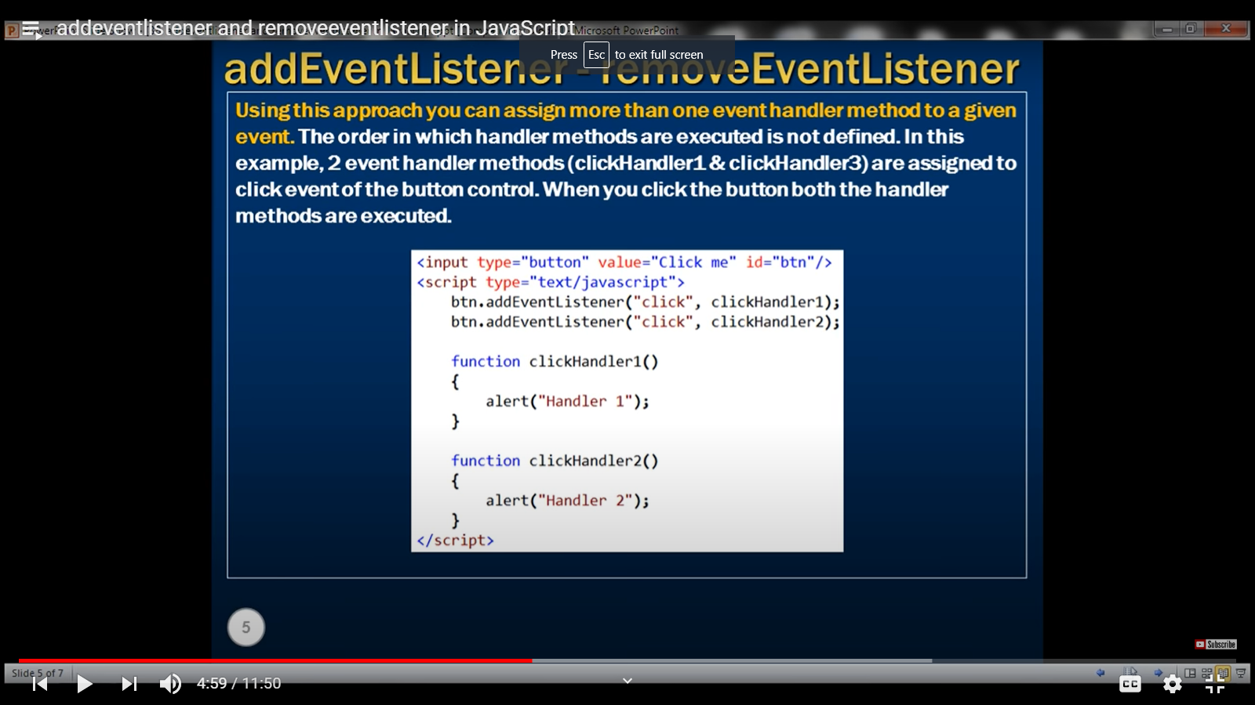

**Event Object**

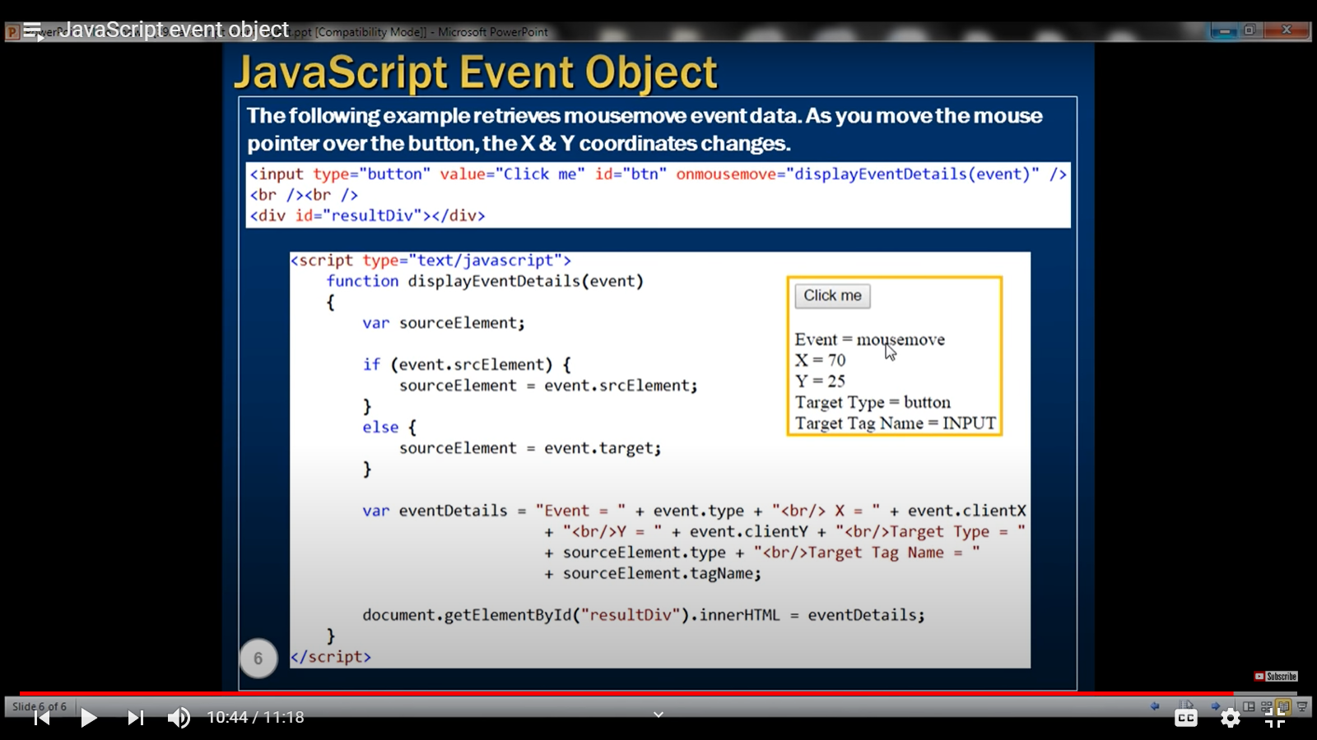Target property is not supported in earlier IE versions. So, used if-else with srcElement.

In JavaScript regular expressions can be used with the following string methods.

1. **match ()** string.match(/\d+/g)

2. **replace ()** string.replace(/\d+/g, "XXX")

3. **split ()** string.split(/\d+/)

4. **search ()**

Search () method returns the index of the match, or -1 if the search item is not found. Search () method returns the index of the first matching item only.

/\d/ -------- > returns a digit /\d+/ ----------- > returns number with one or more digits

/\d+/g ----------- > returns number with one or more digits globally

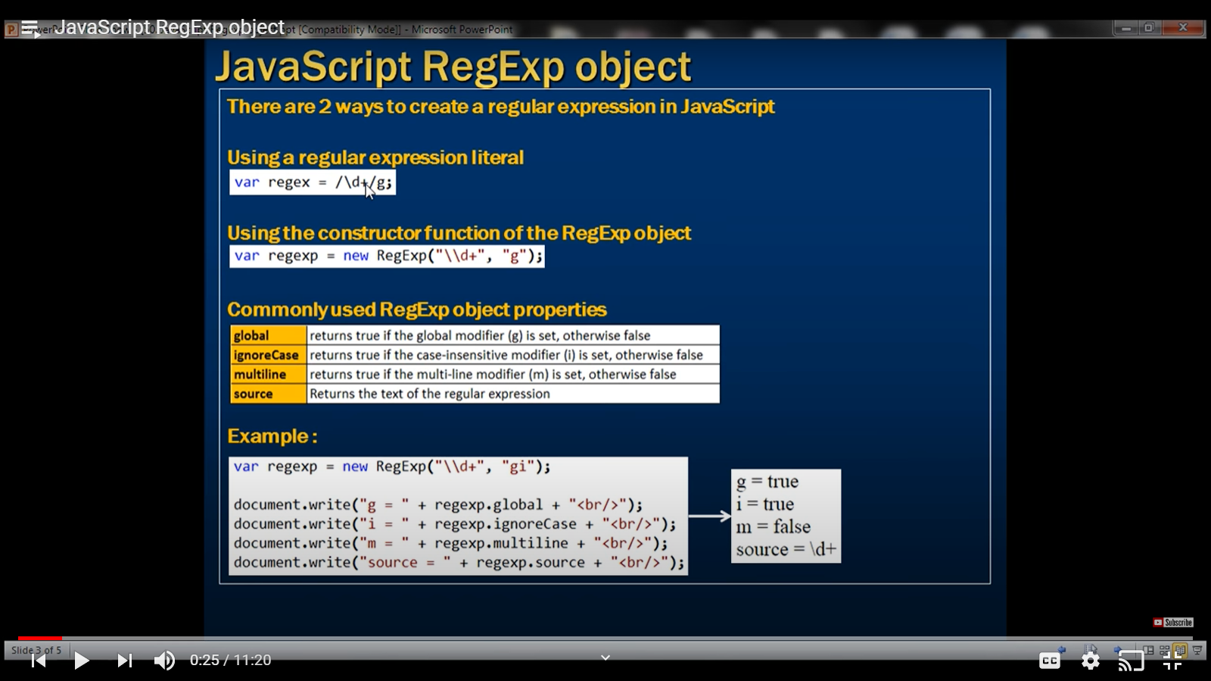

There is a test () method of the Reg Exp object to check for a string. Also applicable for literal. It returns true or false.

**JavaScript** is a prototype-based object-oriented language, which means it doesn't have classes rather it defines behaviors using constructor function

**In Java, we create a custom class and then create an instance from it. But in JS, we can create object using two ways:**

1. Constructor function
2. Literal Notation

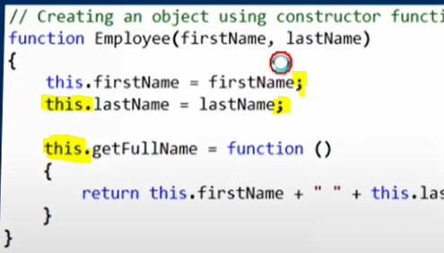 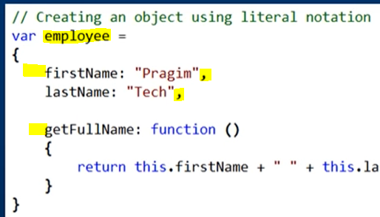

What is the difference between creating an object using constructor function and literal notation.

1. In the constructor function the properties and their values separated using an equal-to sign (=) whereas in the literal version, they are separated using a colon (**:**)

2. In constructor function at the end of each property you can have a semi-colon (;) whereas in the literal version properties must be separated with a comma (,)

3. With literal notation you have already created an object, so to access firstName value you simply use employee.firstName. With the constructor function you have to first create an instance and then use the created instance and the property name separated by DOT.

So, when to use one over the other? If you need multiple instances of the object use constructor function where as if you need just one instance of the object then use literal notation.

Since, objects created using object literals are singletons. This means when a change is made to the object, it affects that object across the entire script.

Ex: var newEmployee = employee. A change made in newEmployee will reflect in employee.

**GLOBAL NAMESPACE POLLUTION**: (code pollutes the global scope)

<https://www.youtube.com/watch?v=Mj9kDbweZ8k&list=PL6n9fhu94yhUA99nOsJkKXBqokT3MBK0b&index=55>

Occurs when there is function with same name.

JavaScript does not support function overloading and as a result, the customer () constructor function with 3 parameters simply overwrites the customer () constructor function with 2 parameters due to the script file of customer function having 3 parameters written later.

The reason, one of the customer () constructor function got overwritten is because we have already polluted the global scope. Let's understand what we mean by this.

1. window is the Global object in JavaScript so the function will be added to it. A function declared globally will be associated with window object.

2. When TeamA.js script file is loaded, the customer () function in TeamA.js file is added to the global namespace

3. When TeamB.js script file is loaded, the customer () function in TeamB.js file is added to the global namespace. Since 2 functions with the same name cannot exist in the global namespace, the customer () function in TeamB.js overwrites the customer () function in TeamA.js. As a result, we cannot use the customer () function in TeamA.js file.

4. In JavaScript if you declare a variable or a function second time, it simply overwrites the one you created earlier.

JavaScript does not raise any errors like C# or Java if you redefine a variable or a function. Here is the summary. Polluting global namespace causes name collision. This is especially true in large projects where you may be using several JavaScript libraries (both internally developed as well as third party libraries). That's why it is very important not to add everything to the global namespace. If someone else use the same variable or function names it can lead to name collision.

**Namespaces to avoid pollution in global scope.**

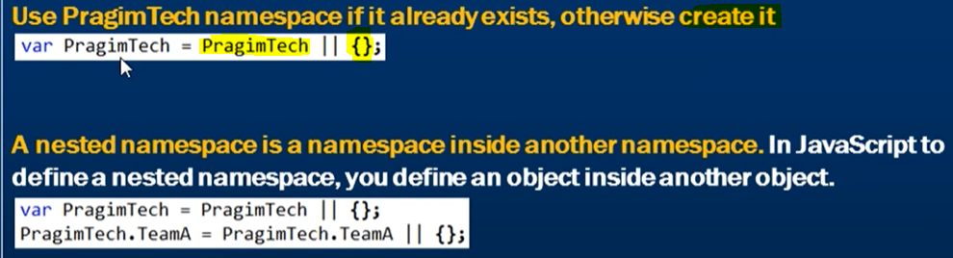

The second line is the nested namespace.

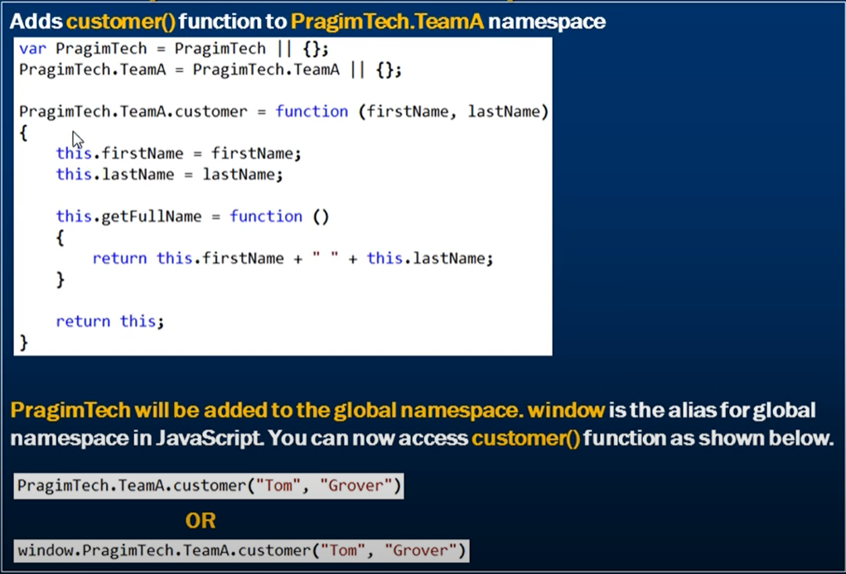



Do similar for teamB.

<https://www.youtube.com/watch?v=9p-uDkWqqKU&list=PL6n9fhu94yhUA99nOsJkKXBqokT3MBK0b&index=56>

Just as we have private methods in class in Java, we also have **private methods in JS.**

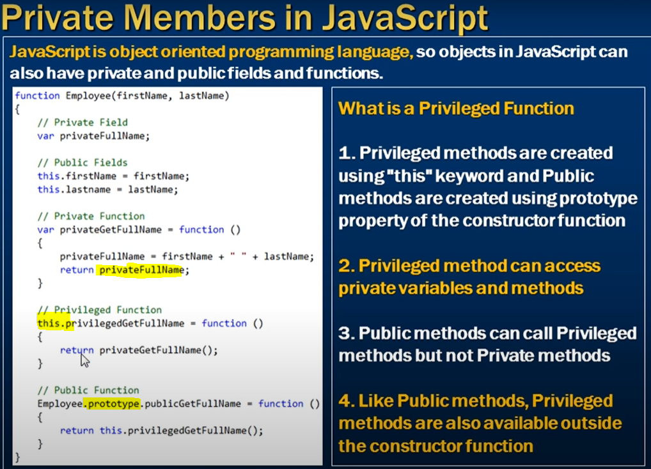

A function inside a function becomes private if it is not declared using this or prototype. Above is a function inside constructor function.

privateFullname is a private variable, So, we cannot see this in the function definition and also cannot access it. But if we try to change the value of the variable, JS creates a new public variable inside the employee object.

**employee.privateFullName = "ABC";**

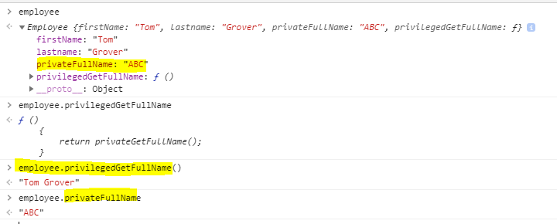

The privateFullname inside the employee object is the public variable and not the private one.

**Properties inside JavaScript:**

Read/Write, read only, write only i.e. getters and setters in JAVA.

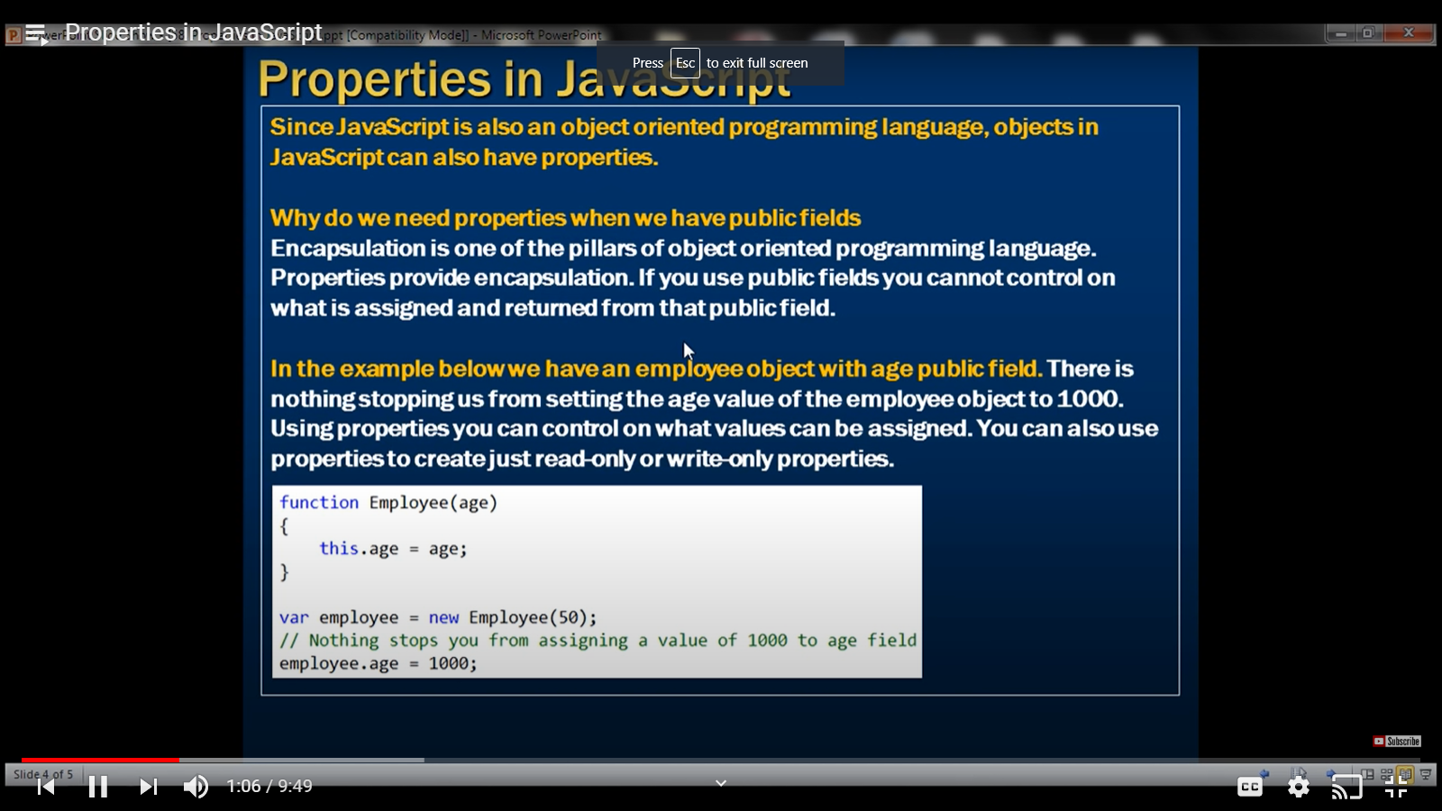

**To define a property, we use defineProperty (object, property name, methods i.e. get and set) of Object. We can do the validations there in the methods.**

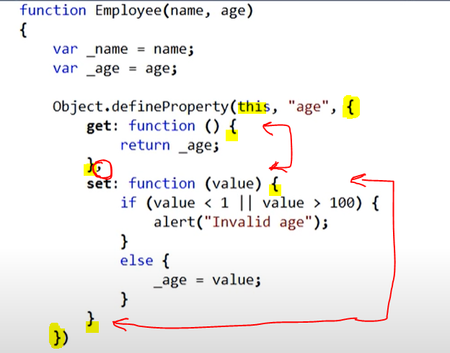

**Static members in JS:** In Java we had static variables and methods inside classes. All the objects of the classes share a single copy of the static variable. So, if you want a member to be shared by all instances then make it a static member otherwise make it an instance member.

Points to remember

1. Define a static member using the name of the constructor function.

2. To invoke a static member use the name of the constructor function.

3. To invoke an instance member use the instance of the constructor function.

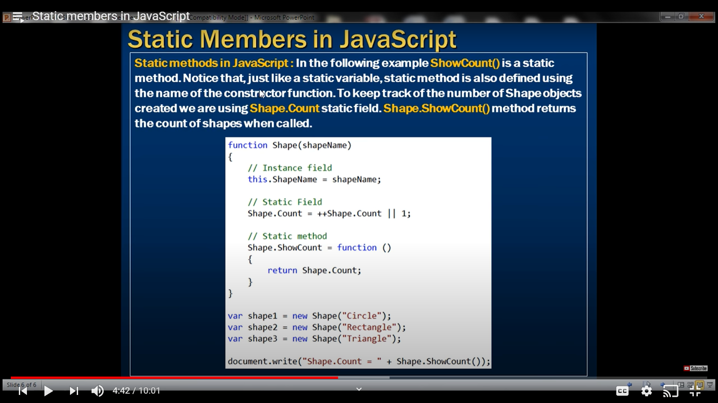

**Prototypes:**

Adding everything to prototype becomes public and accessed by all.

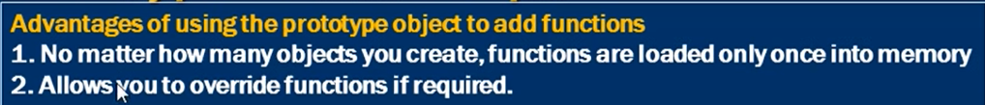

Inheritance is JS is said to be prototype based.

**Event Bubbling:**

A click on the button, causes a click event to be fired on the button. The button click event handler method handles the event. The click event then bubbles up to the button element parent (span element), which is handled by the span element event handler method. The click event then bubbles up to the span element parent (div element). This is called event bubbling.

Hence, even if a child element does not have an event handler, it will be handled in the parent if it has a handler.

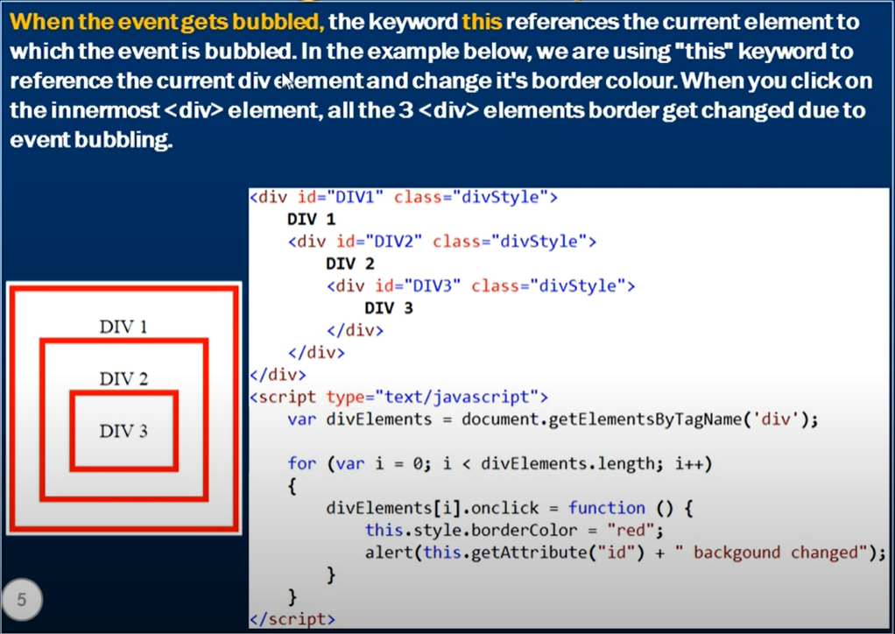

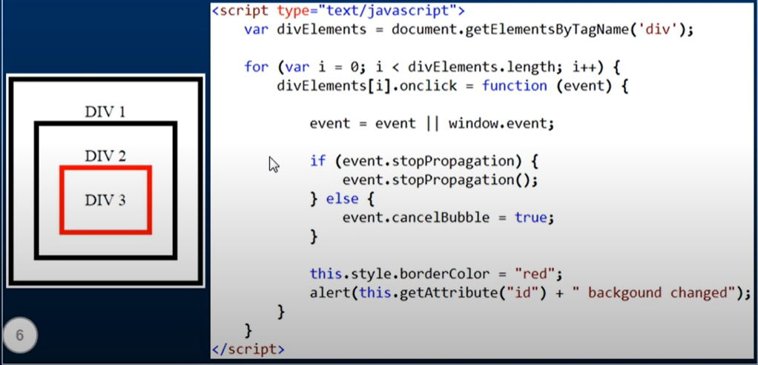

With Internet Explorer 9 (and later versions) & all the other browsers event.stopPropagation()

**USE CASE:**

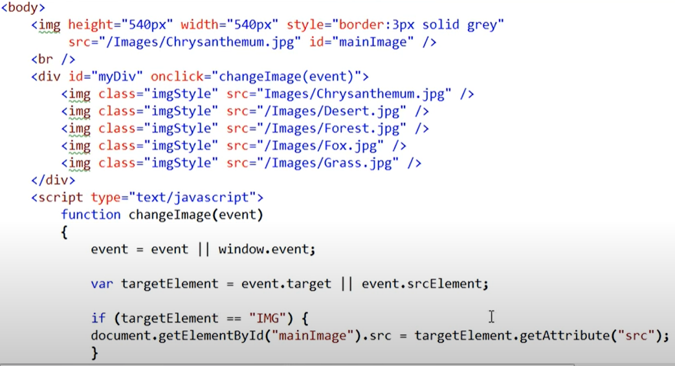

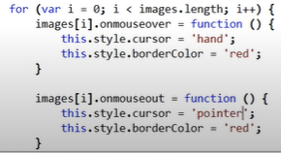

**Event Capturing:**

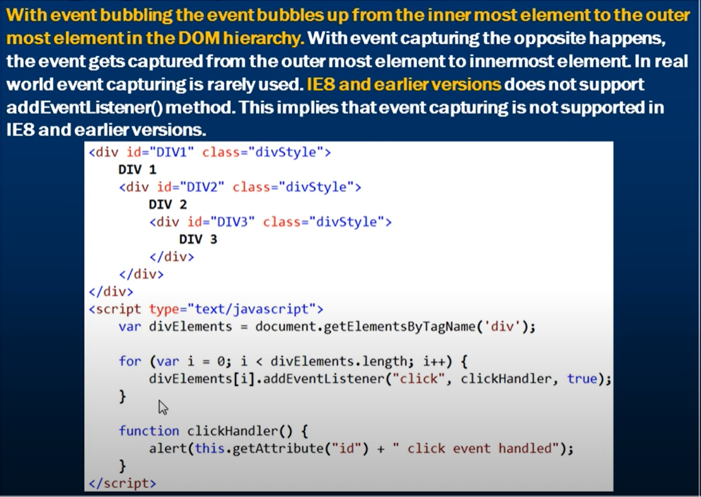

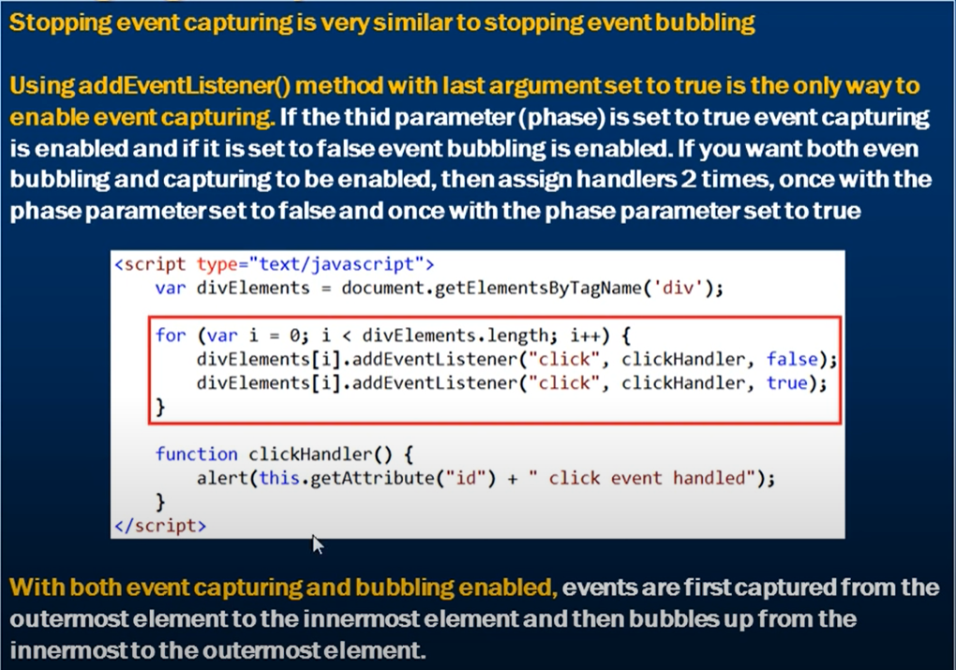

**Prevent Browser Default Action:**

In some situations, you may want to prevent these default actions of the browser. For example, some of the websites prevent you from right clicking on the page. Disabling right click is annoying users. Many people say they disabled right click for security, because they do not want their content to be copied. But if you disable JavaScript in the browser, you will still be able to right click and copy the content. So, you are achieving nothing by disabling right click.

On right click - > **oncontextmenu** event is triggered. We can return false in that.

This is the other way. **document.oncontextmenu** gets triggered on right click.

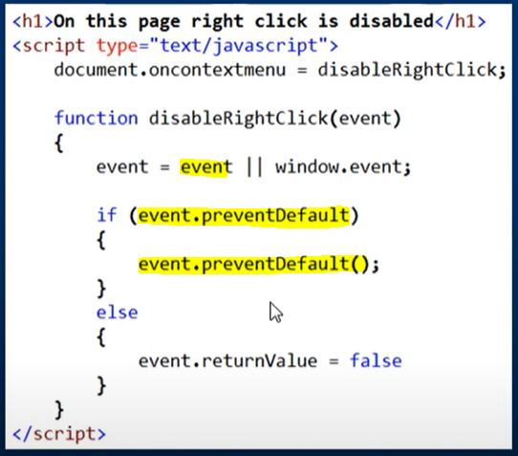

For hyperlink disabling, we can either set “return false” as a value for onclick attribute or assign a handler disableRightClick ();

**MOUSE BUTTON CLICK:**

Depending on the browser, event.button (IE8 and below) or event.which properties of the event object are used to determine which mouse button is clicked.

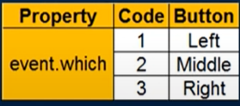

**Mouse Events:**

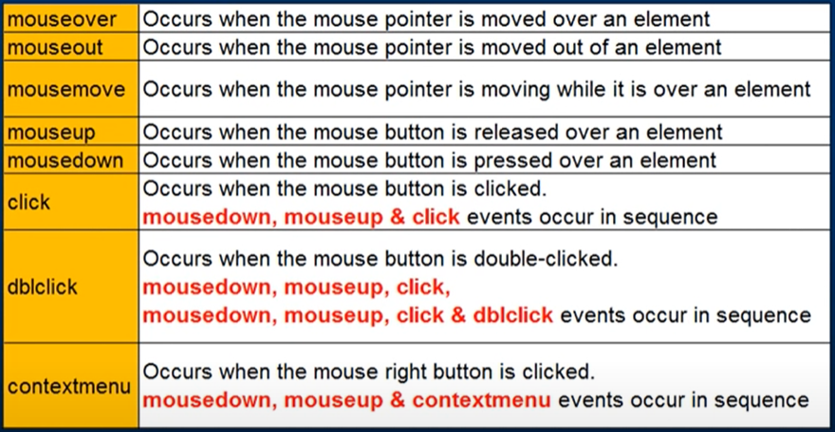

**JAVASCRIPT POP-UP WINDOW:**

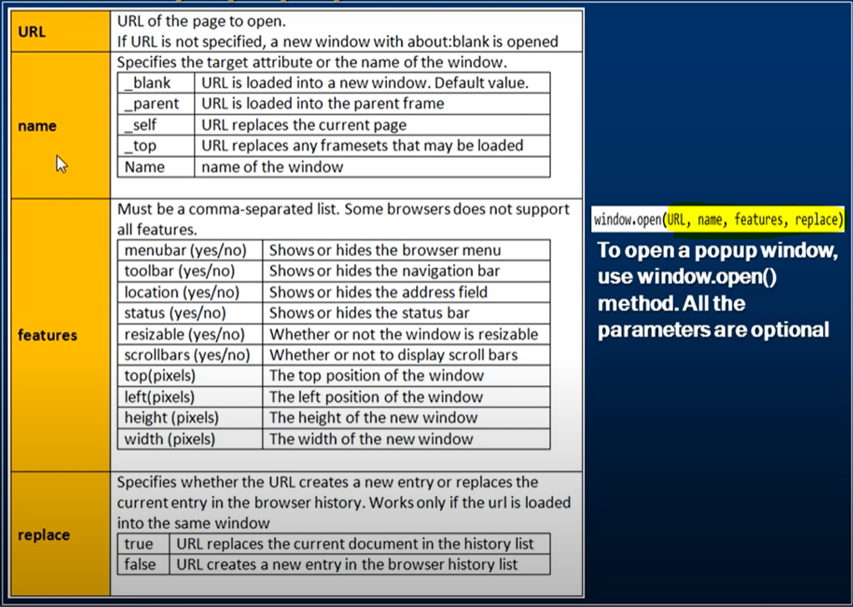

We can open the pop up in a new window. But this workaround may not work in all the browsers. It also depends on user’s browser preferences. Ex: The end user can configure their browsers to open in new tab instead of new window and if it is configured so, you cannot change it using JavaScript.



Window.close() 🡨--------- to close popup

**JavaScript Minification**:

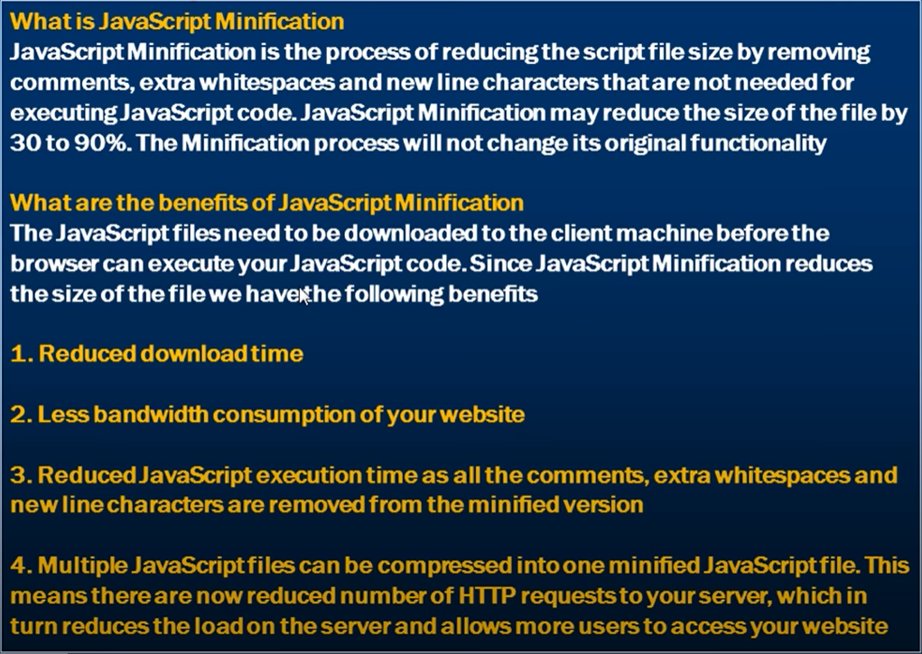

What are the disadvantages of JavaScript Minification

Readability is lost and debugging can be difficult as comments, extra whitespaces and new line characters are removed. However, if there is a production issue, use the non-minified version of the script file for debugging. So, in **production environment use minified version** for performance and in development environment use non-minified version for readability and debugging.

There are also several websites that provide online JavaScript minification. The following is one such website [http://marijnhaverbeke.nl/uglifyjs](https://www.youtube.com/redirect?q=http%3A%2F%2Fmarijnhaverbeke.nl%2Fuglifyjs&v=7128a9SoV0M&event=video_description&redir_token=nqcHlorH9U1k6AfPvRKnUA-iKDN8MTU5MzA1ODk3NUAxNTkyOTcyNTc1)

**Data and time in JS**

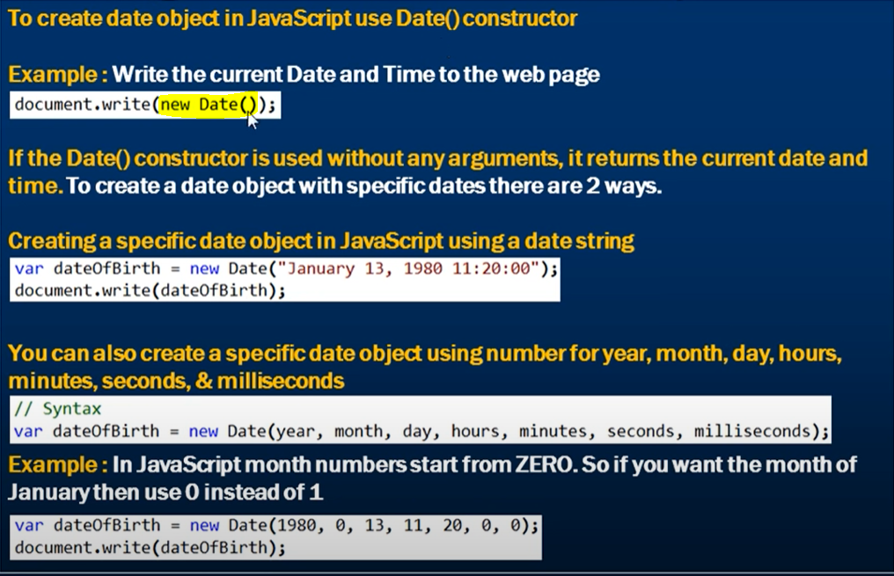

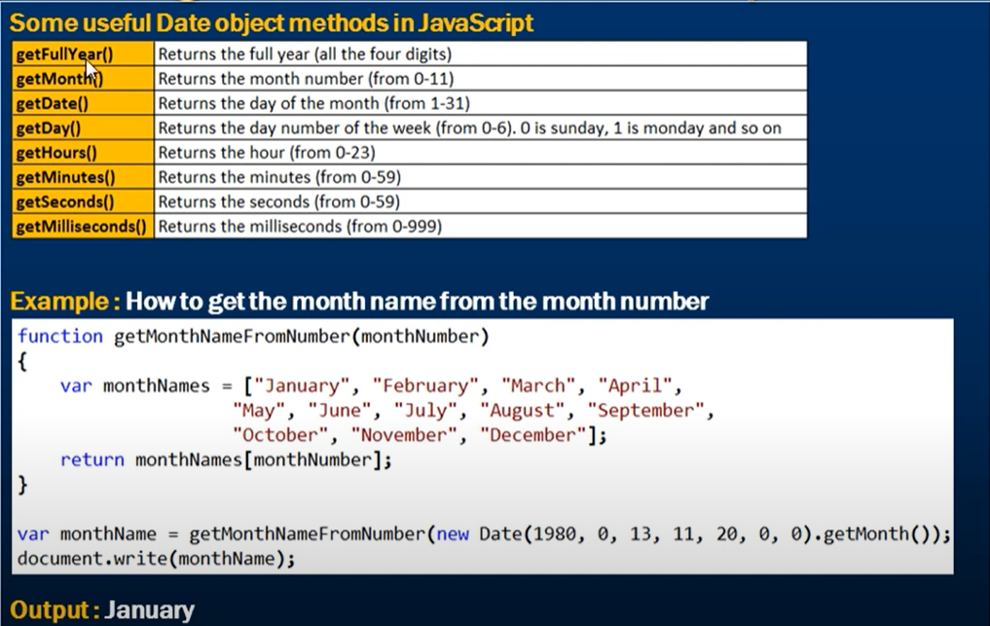

We always get date in format ----- > **Sun Jan 13 1980 11:20:00 GMT+0530 (India Standard Time)**

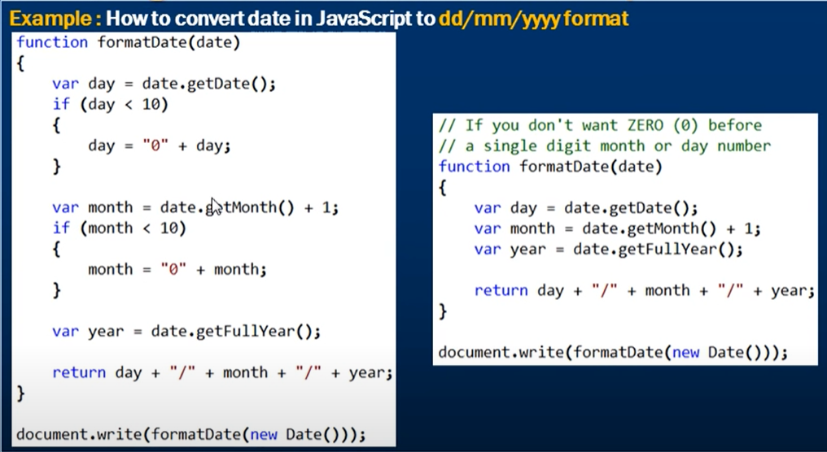

**JavaScript Timing Events:**

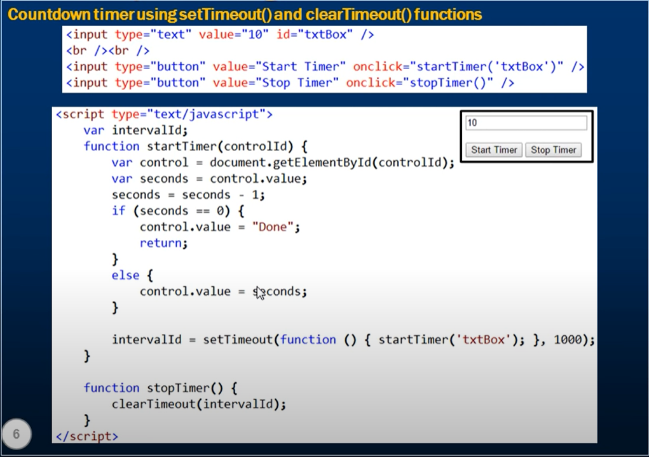

A [function](https://developer.mozilla.org/en-US/docs/Web/JavaScript/Reference/Global_Objects/function) to be executed after the timer expires specified in setTimeout.

The **global window object** has the following 2 methods that allow us to execute a piece of JavaScript code at specified time intervals - > setTImeout and setInterval

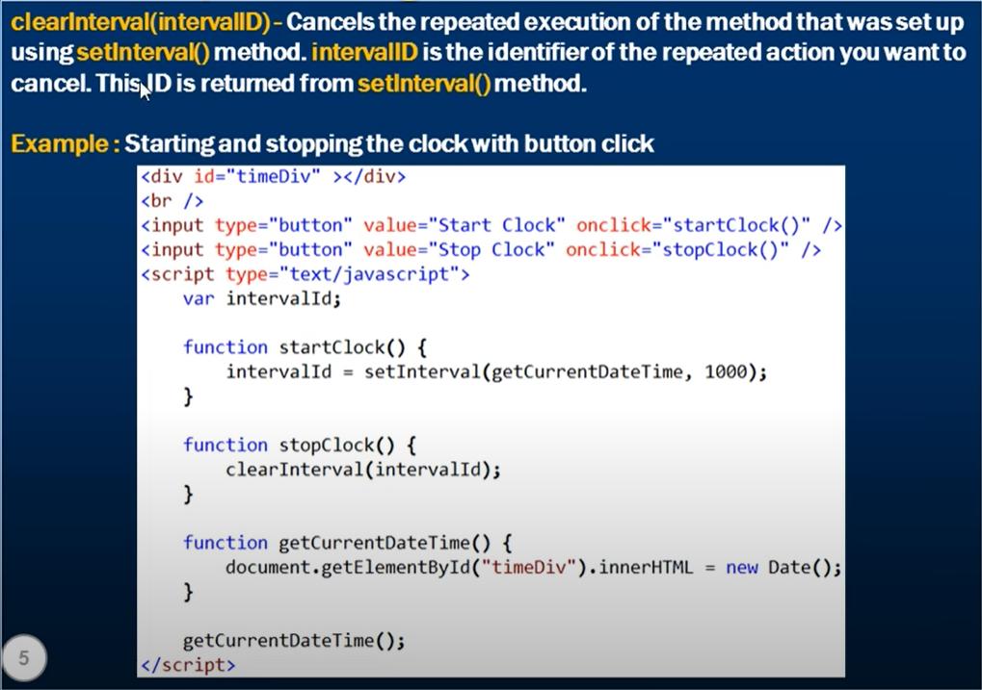

<https://www.youtube.com/watch?v=jAYjisNyhgc&list=PL6n9fhu94yhUA99nOsJkKXBqokT3MBK0b&index=35>

Substrings in JS: The following are the 3 methods in JavaScript that can be used to retrieve a substring from a given string. **substring() substr() slice()**

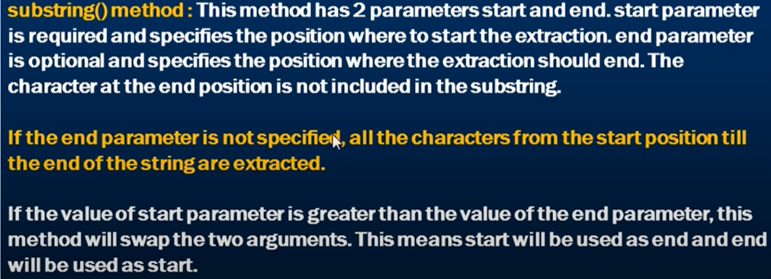

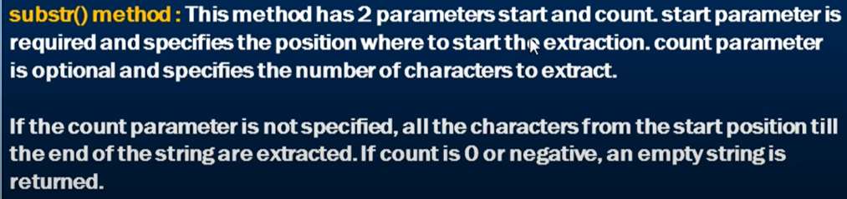

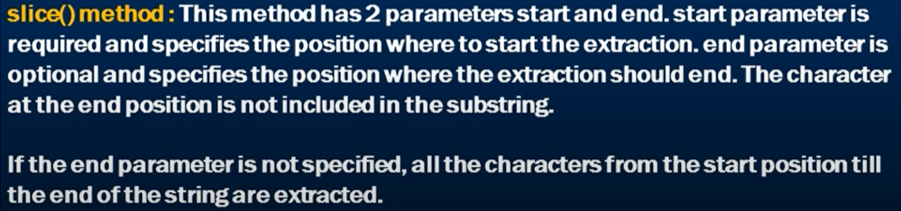

**We have indexOf () and lastIndexOf () methods too to get the index values.**

**What is the difference between preventDefault and return false???**

The main difference between preventDefault () and return false; is that preventDefault just prevents the default action from happening whereas return false prevents that event from propagating (or "bubbling up") through all the ancestors along with preventing the default action from happening.

<https://www.youtube.com/watch?v=nNqr71JA9qs>

**Escape Characters:**

The backslash (\) allows you to insert special characters in JavaScript strings. It allows you to insert special characters which otherwise would be difficult to insert.

**Backslash character included with character representation is called escape sequence.**

**The backslash causes it to escape out of its normal working mode. Hence called escape sequences**

**\ --- > JS thinks as an escape sequence is starting.**

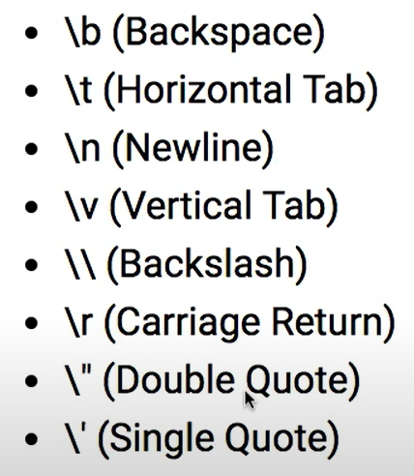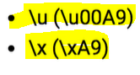**Unicode and HexaDecimal chars**

**The \ followed by a new line is not a character escape seq, but a Line Continuation**.

**Escape sequences are used to obfuscate or hide JavaScript code. Here is the link to hide code. If you are working with client and you do not need them to see your code.**

<https://javascriptobfuscator.com/Javascript-Obfuscator.aspx>



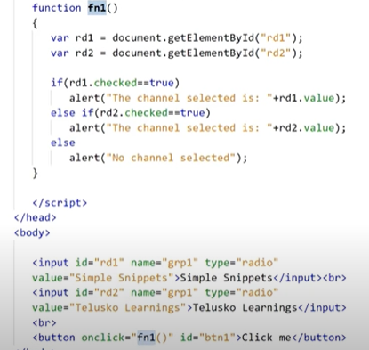

Checked is a property of input tag of type radio. Here the name is same in both the buttons which will ensure that only one of the radio buttons gets selected.

**document. getElementByTagName(“div”)** gives us the array of all the div tags present in the document while **document.getElementById** only gives us the tag having that particular Id. We can do changes on the array using indexing only.

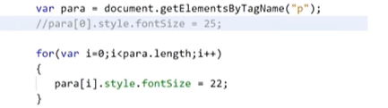

document.getElementById().style.visible

document.getElementById().src

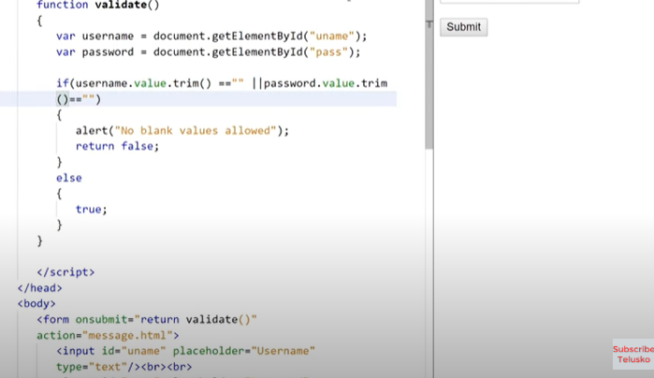

**onsubmit** => when submit is clicked

**action** attribute => what to call or navigate on true condition.

**trim()** removes the whitespaces in it.

Validate is called onsubmit inside the form tag and not button because in form tag it has an extra feature to disable the event using a return value. Action attribute in form tag tells us where the page should land. If validate called in button, it will redirect to the message html page even if there is noting entered.

A regular expression is an object in JavaScript. Hence it has various methods on it.

Var regex = **/[sdp]imple/** 🡨 start should be s or d or p and for range use [a-x] or [a-xA-X]. Space can be present or absent, both works. For exclusion of some chars [^1abc] and for range [^a-x].

Start of an expression is denoted by **^** but if used **inside [] it indicates exclusion**. End denoted by **$** and repetition by {5}. So, for mob no, expression is **/^[7-9][0-9]{9}$/.**

**\d** - Match any digit

**\w** - Match any word char (equal to (a-z or A-Z or 0-9 or _))

**\s** - Match any whitespace char (spaces / tabs)

**\t** - Match any tab only

When we want to group regex in parts use, (). Now ‘.’ Use means any char inserted ex: **a.b** implies any char can be inserted in a and b. But if we want a ‘.’ to be used write **a\.b**

{2-30} implies min 2 chars but max 30 but a ‘+’ indicates 1 or more than 1 time.

We can access the properties of objects using the dot or bracket notation.

**Async Await**

To create an async function all we need to do is add the async keyword before the function definition. The one thing you need to know about async functions is that; **they always return a promise**.

The await keyword **can only be used within an**async**block**, otherwise it'll throw a syntax error.

**When do we use it?** If we have an asynchronous function inside of an async block. So let's say we need to fetch some data from our server and then use that data within our async block. We will use await to pause the function execution and resume after the data comes in.

Await is simply a more elegant way to write a promise **within an async function**. It improves readability immensely and hence the reason we use it.Let's assume we have a couple of asynchronous functions within our async block. Instead of chaining promises we could do await, which is much cleaner.

<https://www.youtube.com/watch?v=V_Kr9OSfDeU>

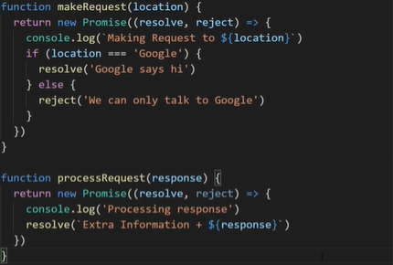

Things to keep in mind while using async/await:

1. Async functions return a promise.
2. Await can only be used inside an async block.
3. Await waits until the function("promise") resolves or rejects.

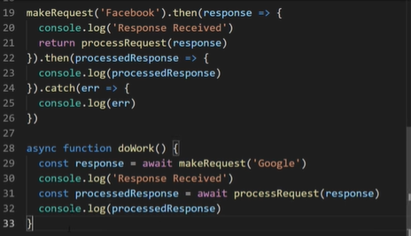

Await keyword tells that makeRequest() should wait until it is finished completely.

**Arrow Functions**

Arrow function are always anonymous. Has smaller syntax compared to others. Here there is no need to write the function keyword and the function name. Spaces btw () and => is ignored but not line break.

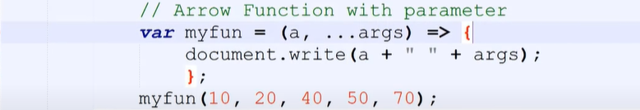

Arrow function with rest parameters.

Arrow function do not redefine **‘this’** keyword inside them as compared to other functions.

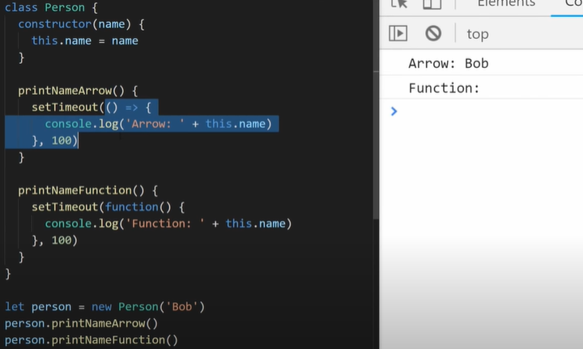

Normal functions define this on the basis of where it is called. Here it is not defined in the global scope.

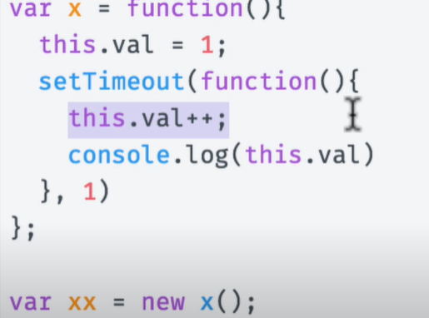 **output: NAN**

this inside inner function refers to ‘this’ keyword of inner function. But fat arrow does not have its own ‘this’ and so it uses its parent’s ‘this’.

So, if you are inside any object, this refers to that object. But a this inside function, it is not able to read this. So, we have to use call ().

**Immediately Invoked Functions:**

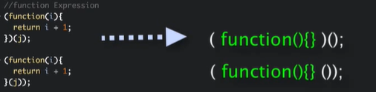

**WEB WORKERS**

JavaScript is a single thread application. If you want to do some DOM manipulation and also perform some complex calculation at the same time. Web worker provider mechanism to spawn (to grow or start) separate script in background where you can do complex calc without affecting the UI.

Send message using- **postmessage()**

Receive message using- **onmesage()**

A web worker is a JavaScript running in the background, without affecting the performance of the page.

When executing scripts in an HTML page, the page becomes unresponsive until the script is finished.

A web worker is a JavaScript that runs in the background, independently of other scripts, without affecting the performance of the page. You can continue to do whatever you want: clicking, selecting things, etc., while the web worker runs in the background.

Web worker has **no** access to-

1. Window object
2. Parent Object
3. Document object

It has access to navigator object, XMLHttpRequest.

window.worker ----------- > to check if worker is there.

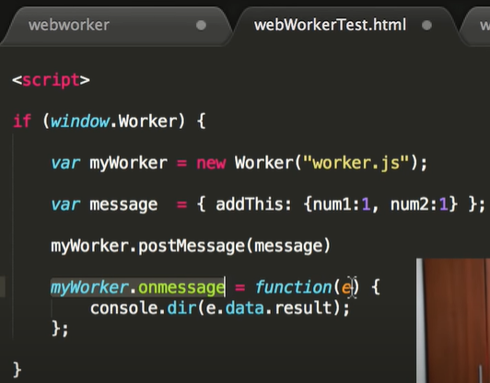

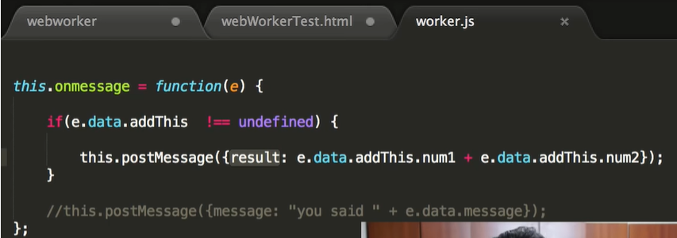

From one worker you can spawn other workers. Delegate some work to others.

Worker is a constructor having 2 event listeners. onerror and onmessage.

If you need to shut down a worker you can call the **self.close( )** method from within the worker or the **worker.terminate( )** method from the initiating script.

Window is not available in workers because DOM access is not available in workers. This is because DOM API is not thread safe.

<https://www.youtube.com/watch?v=2yD1gkRf4Vk>

**Event Bubbling and Capturing in JavaScript**

**When an event happens on an element, it first runs the handlers on it, then on its parent, then all the way up on other ancestors.**

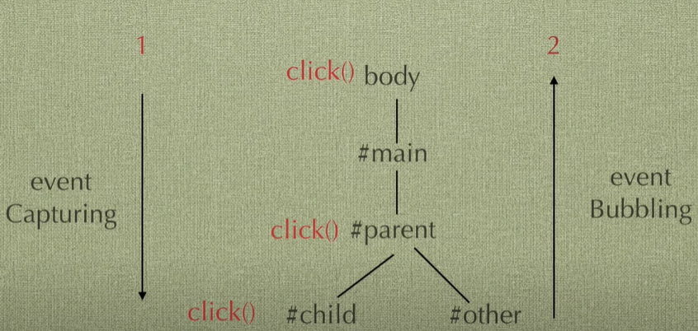

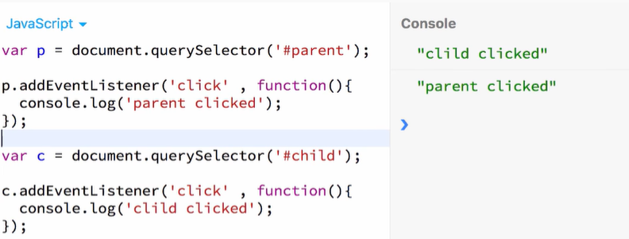

In the method addEventListener which is looking for click events, we can pass a third variable/ argument which is the **useCapture**. If it is true, it follows the capturing phase else bubbling phase.

<https://javascript.info/bubbling-and-capturing>

<https://medium.com/@vsvaibhav2016/event-bubbling-and-event-capturing-in-javascript-6ff38bec30e>

Note the differences from this (= event.currentTarget): and event.target

Every object in Js is created from the master object 🡪 ‘Object’.

**Template String**

Back ticks are used to write templates easily.

Back ticks can also be used to do interpolation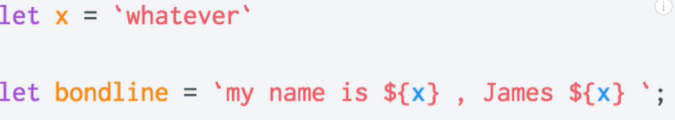

Also converts any other type to string type.

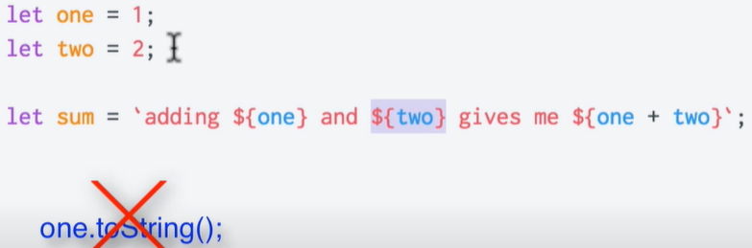

No need to use **toString** to explicitly convert to string.

**Tagged templates** basically transforms template strings by placing functions name before the string template.

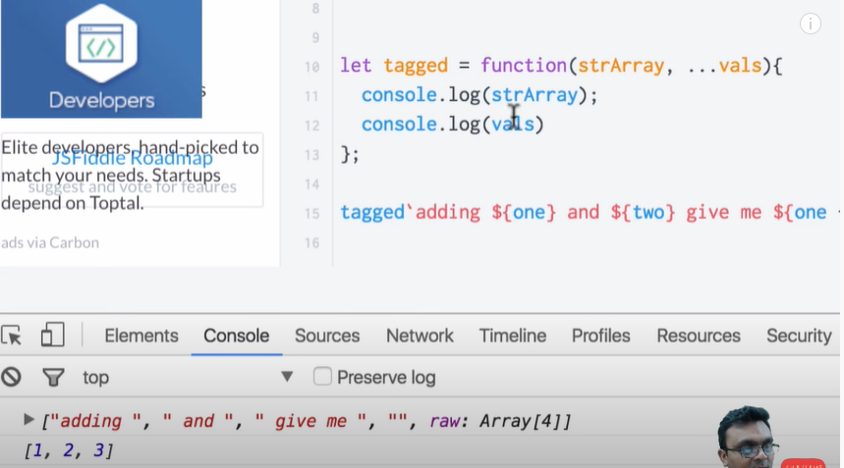

Some ES6 string functions:

‘Hello World’.**startsWith**(‘Hel’);

‘Hello World’.**endsWith**(‘Hel’);

‘Hello World’.**includes**(‘Hel’);

‘Hello World’.repeat(3); 🡨 repeats 3 times

Console.log (**String.raw**`Not a new line: /n`); 🡺 Not a new line: /n

Console.log(**String**`Not a new line: /n`); 🡺 Not a new line.

ES6 introduces a new kind of string literal syntax called template strings. They look like ordinary strings, except using the backtick character ` rather than the usual quote marks ' or ". In the simplest case, they really are just strings.

<https://wesbos.com/tagged-template-literals>

<https://developer.mozilla.org/en-US/docs/Web/JavaScript/Reference/Template_literals>

<https://flaviocopes.com/javascript-template-literals/>

**JavaScript Decorators**

**MODULES in JavaScript**

A module is just a file. One script is one module.

Modules can load each other and use special directives export and import to interchange functionality, call functions of one module from another one.

As modules support special keywords and features, we must tell the browser that a script should be treated as a module, by using the attribute <script type="module">.

The object import.meta contains the information about the current module.Its content depends on the environment. In the browser, it contains the url of the script, or a current webpage url.

[Module scripts are deferred](https://javascript.info/modules-intro#module-scripts-are-deferred)

<https://javascript.info/modules-intro#in-a-module-this-is-undefined>

<https://developer.mozilla.org/en-US/docs/Web/JavaScript/Guide/Modules>

**Pass by Value and Reference:**

Array is treated as an Object with a special property **length**and constructor name property as “Array”**.**

<https://medium.com/swlh/call-by-value-call-by-reference-in-javascript-c5738600d9cd>

<https://medium.com/nodesimplified/javascript-pass-by-value-and-pass-by-reference-in-javascript-fcf10305aa9c>

MIXINS

Mixin is a way properties are added to objects without using inheritance. Object.assign is used to copy the values of properties from one or more objects to the desired object.

Mixins can also be applied to classes in JavaScript.

**Data Structures in Js: WeakMap and Maps**

In JavaScript, we have objects which allows us to map keys to values and keys are noting but string. Map is used to associate a key to a value irrespective of the datatype such as strings, numbers, objects etc.

**WeakMap**accepts only objects but not any primitive values (strings, numbers)

## Differences between Map and WeakMap

The functional mechanism of Map and WeakMap is same but they have little differences.

1) A **WeakMap**accepts only objects as keys whereas a **Map**,in addition to objects, accepts primitive datatype such as strings, numbers etc.

2) **WeakMap**objects doesn't avert garbage collection if there are no references to the object which is acting like a key. Therefore there is no method to retrieve keys in **WeakMap**, whereas in **Map**there are methods such as Map.prototype.keys() to get the keys.

3) There is no size property exists in **WeakMap**.

Delete all the elements => **map / weakmap.clear()**

You can initialize a map passing some params, like this:

let map = new Map([[ 1, 'one' ],[ 2, 'two' ],[ 3, 'three' ]]);

console.log(map.size); // output 3  
map.clear();  
console.log(map.size); // output 0

Or chaining set methods:

let map = new Map()  
 .set(1, 'one')  
 .set(2, 'two')  
 .set(3, 'three');

One problem with Map object is you cannot map or filter over it.The solution is convert the map into an array of [key,value] pairs, filter the array and convert the result back to a map:

1. <https://medium.com/@leonardobrunolima/javascript-tips-map-and-weakmap-f38f9c4ed2b6>
2. <https://developer.mozilla.org/en-US/docs/Web/JavaScript/Reference/Global_Objects/Map>

JavaScript objects supports only 1 key object. If I do multiple , it remembers only the last line.

Methods: **map.delete(obj);**

Map to array => **let array = […map];**

If key of map is removes, it still retains it, i.e. it does not allow garbage collected.

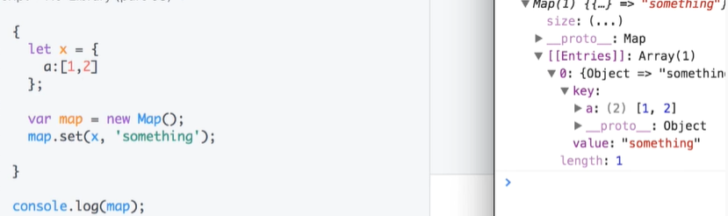

**Sets and Weak-Sets**

Thread safety is a computer programming concept applicable in the context of multi-threaded programs. A piece of code is thread-safe if it functions correctly during simultaneous execution by multiple threads. In particular, it must satisfy the need for multiple threads to access the same shared data, and the need for a shared piece of data to be accessed by only one thread at any given time.

There are a few ways to achieve thread safety:

**Reentrancy:**

Writing code in such a way that it can be partially executed by one task, reentered by another task, and then resumed from the original task. This requires the saving of state information in variables local to each task, usually on its stack, instead of in static or global variables.

**Mutual exclusion:**

Access to shared data is serialized using mechanisms that ensure only one thread reads or writes the shared data at any time. Great care is required if a piece of code accesses multiple shared pieces of data—problems include race conditions, deadlocks, live locks, starvation, and various other ills enumerated in many operating systems textbooks.

**Thread-local storage:**

Variables are localized so that each thread has its own private copy. These variables retain their values across subroutine and other code boundaries, and are thread-safe since they are local to each thread, even though the code which accesses them might be reentrant.

**Atomic operations:**

Shared data are accessed by using atomic operations which cannot be interrupted by other threads. This usually requires using special machine language instructions, which might be available in a runtime library. Since the operations are atomic, the shared data are always kept in a valid state, no matter what other threads access it. Atomic operations form the basis of many thread locking mechanisms

eval() is a function property of the global object.

# Using window.location to Redirect to a Different URL with JavaScript

<https://www.developintelligence.com/blog/2016/04/javascript-redirect-how-to-redirect-a-web-page-with-javascript/>

The round() method rounds a number to the nearest integer.

**Note:** 2.49 will be rounded down (2), and 2.5 will be rounded up (3).

<a href="javascript:void(0);" onclick="alert('testing')">

**BASICS**

1. JavaScript ignores multiple spaces. You can add white space to your script to make it more readable.
2. Semicolons separate JavaScript statements.The JavaScript syntax defines two types of values: Fixed values and variable values. Fixed values are called literals. Variable values are called variables.
3. Hyphens are not allowed in JavaScript. They are reserved for subtractions.
4. All JavaScript identifiers are case sensitive.Multi-line comments start with /* and end with */

NaN is a number: typeof NaN returns number:

Infinity is a number: typeof Infinity returns number.

Normally JavaScript numbers are primitive values created from literals:

var x = 123;

But numbers can also be defined as objects with the keyword new:

var y = new Number(123);

## How to Recognize an Array

A common question is: How do I know if a variable is an array?

The problem is that the JavaScript operator typeof returns "object":

The typeof operator returns object because a JavaScript array is an object.

To solve this problem ECMAScript 5 defines a new method Array.isArray()

Or use array instanceof Array;

Array indexes start with 0.

Array.forEach() array.length array.push() array.concat(arr2).

The concat() method does not change the existing arrays. It always returns a new array.

The concat() method can take any number of array argument.

**Associative Arrays**

Many programming languages support arrays with named indexes.

Arrays with named indexes are called associative arrays (or hashes).

JavaScript does not support arrays with named indexes.

In JavaScript, arrays always use numbered indexes.

WARNING !!

If you use named indexes, JavaScript will redefine the array to a standard object.

After that, some array methods and properties will produce incorrect results.

## The Difference Between Arrays and Objects

In JavaScript, arrays use numbered indexes.

In JavaScript, objects use named indexes.

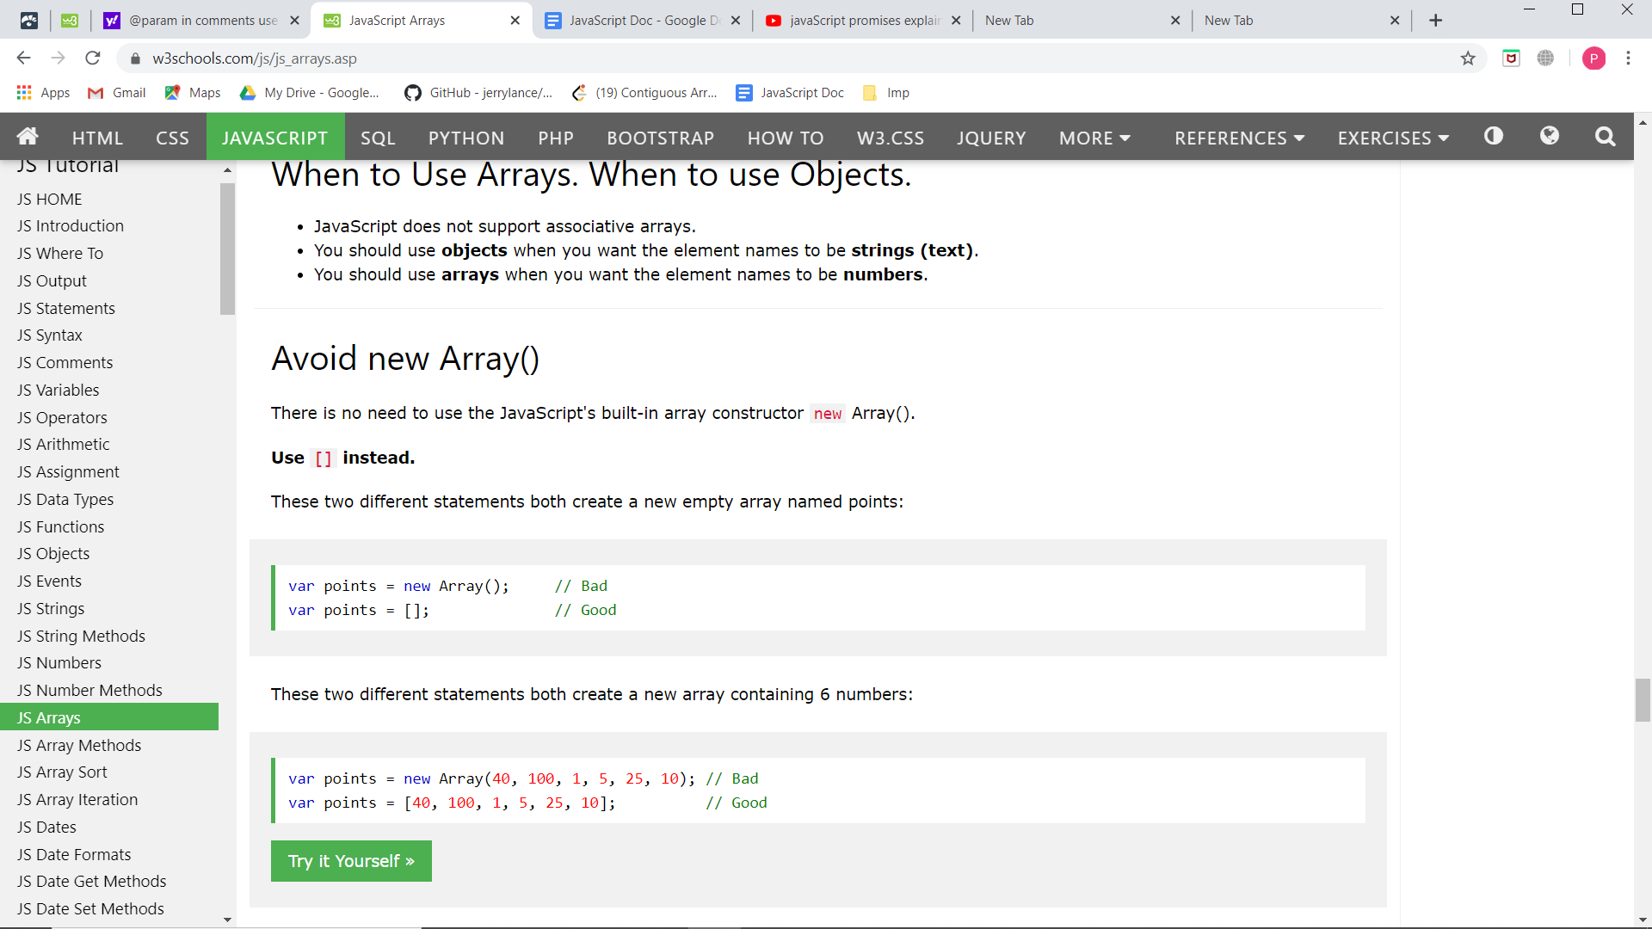

The JavaScript method toString() converts an array to a string of (comma separated) array values.

The join() method also joins all array elements into a string.It behaves just like toString(), but in addition you can specify the separator. array.join(“*”)

The shift() method removes the first array element and "shifts" all other elements to a lower index.

The unshift() method adds a new element to an array (at the beginning), and "unshifts" older elements. array.unshift("Sanket");

Since JavaScript arrays are objects, elements can be deleted by using the JavaScript operator delete delete array[2]

Using delete may leave undefined holes in the array. Use pop() or shift() instead.

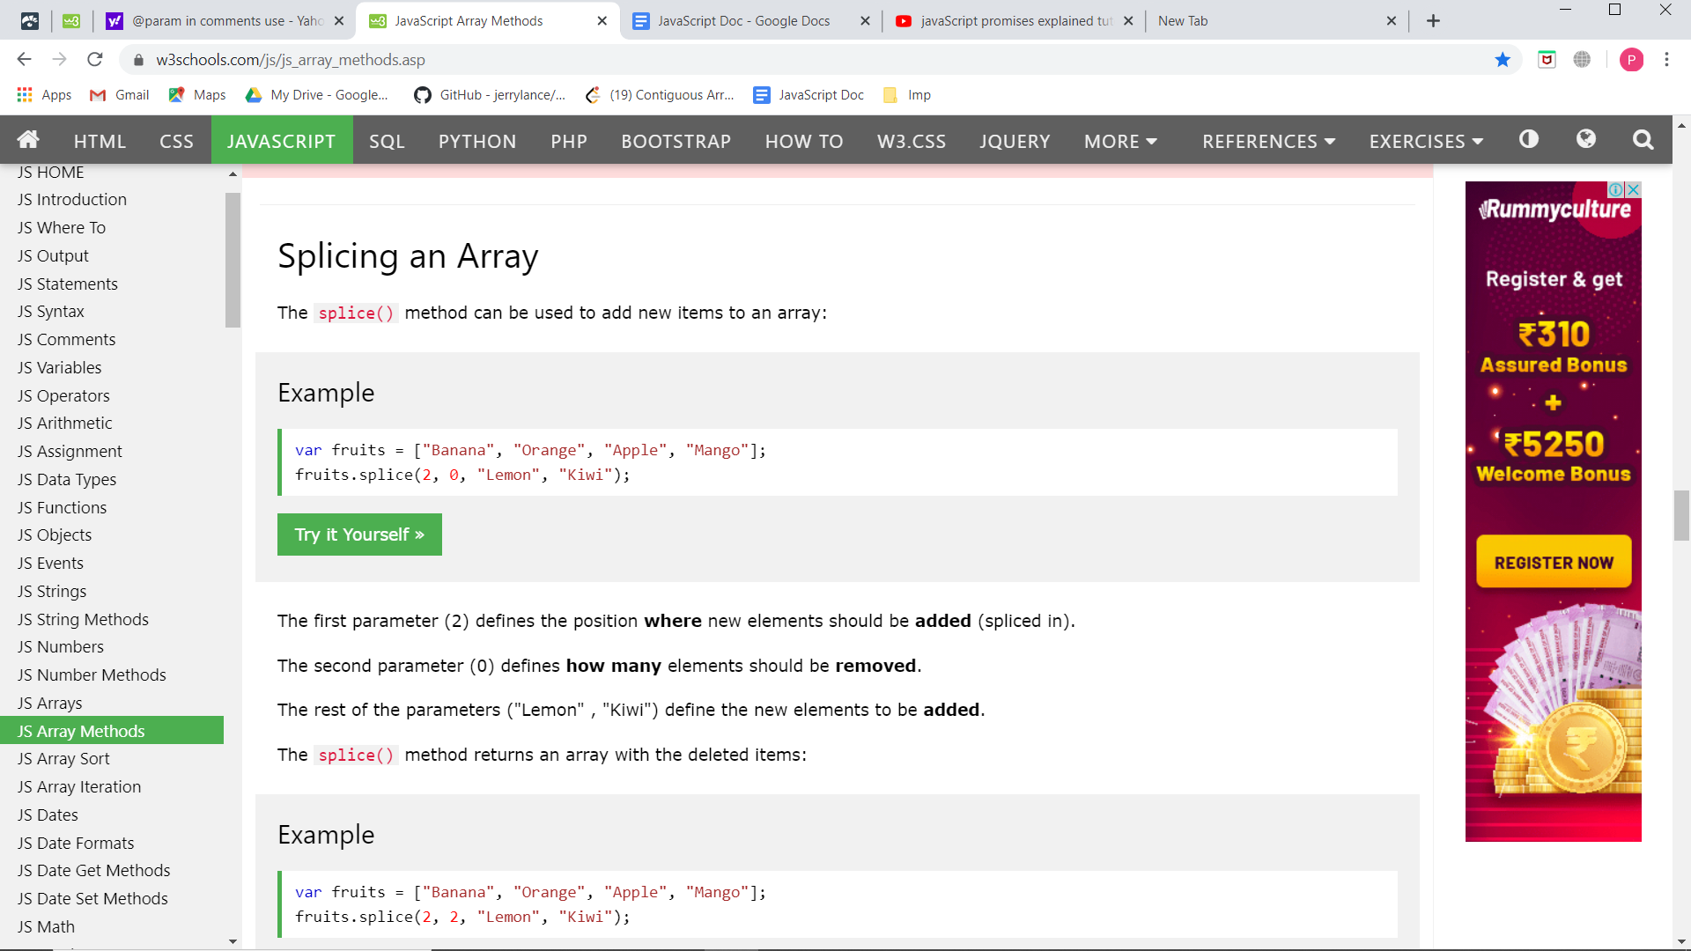

For removing an element use fruits.splice(0,1). Rest parameter can be omitted.

The slice() method creates a new array. It does not remove any elements from the source array.

array.slice(6) #Removes the first 6 elements.

array.slice(1,5) #Specify the start and end argument.

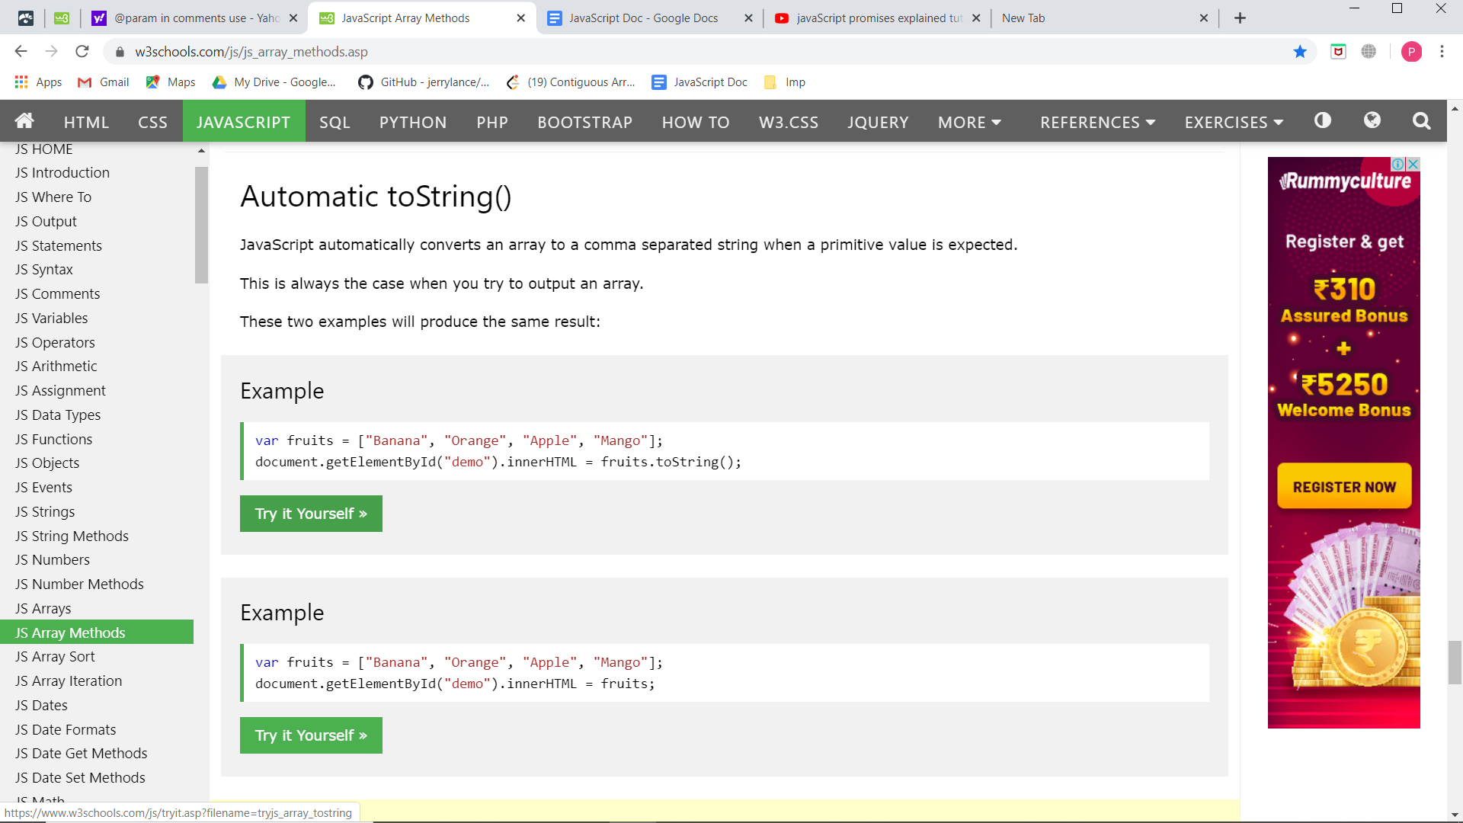

sort() reverse()

## Numeric Sort

By default, the sort() function sorts values as strings.

This works well for strings ("Apple" comes before "Banana").

However, if numbers are sorted as strings, "25" is bigger than "100", because "2" is bigger than "1".

Because of this, the sort() method will produce incorrect results when sorting numbers.

You can fix this by providing a compare function:

var points = [40, 100, 1, 5, 25, 10];

points.sort(function(a, b){return a - b});

You can use Math.max.apply to find the highest number in an array:

Math.max.apply(null, arr); Math.min.apply(null, arr);

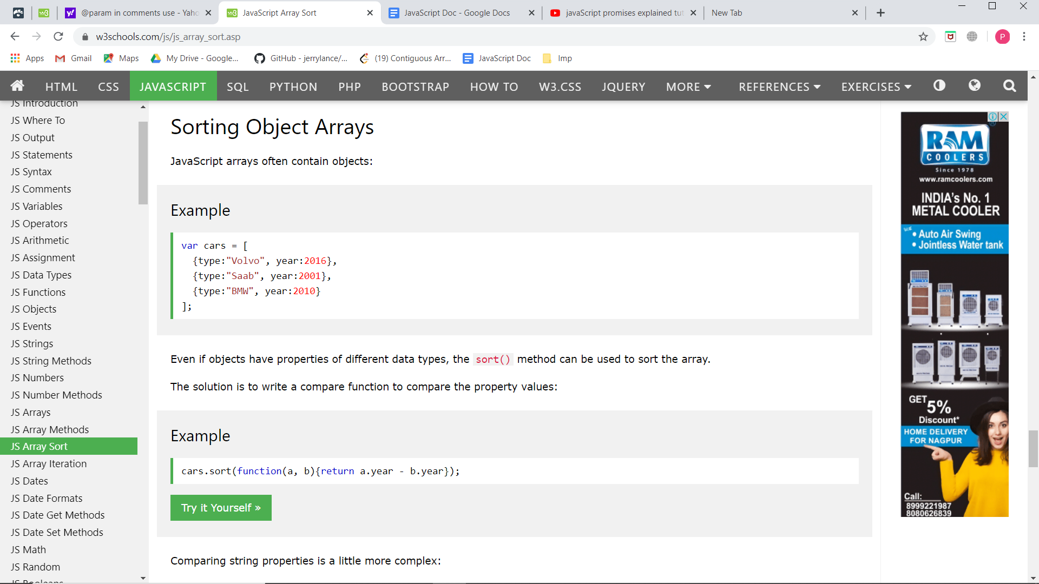

**The compare Function**

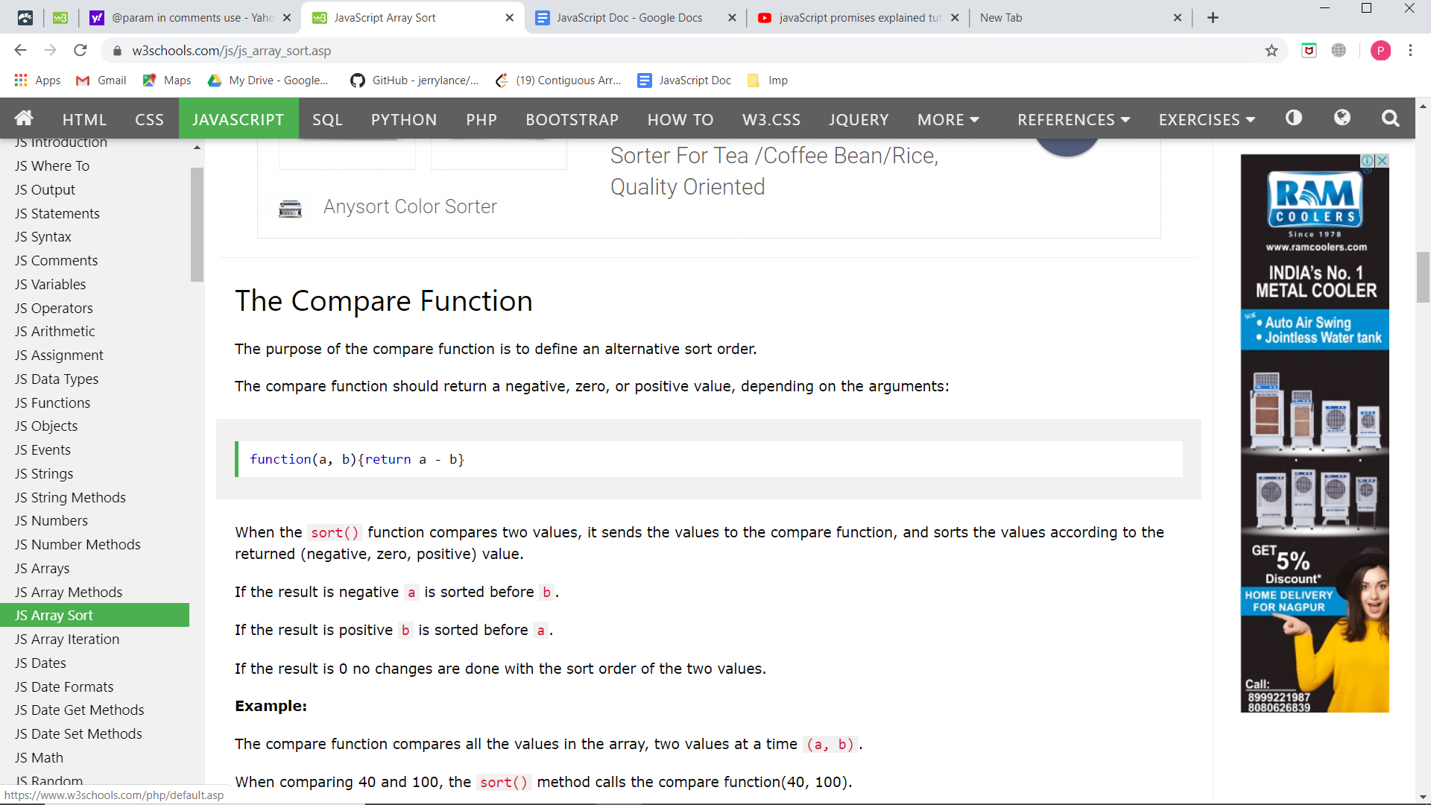

Array Iteration:

The forEach() method calls a function (a callback function) once for each array element.

The map() method creates a new array by performing a function on each array element.The map() method does not execute the function for array elements without values.The map() method does not change the original array.

The filter() method creates a new array with array elements that passes a test.

The reduce() method runs a function on each array element to produce (reduce it to) a single value.The reduce() method works from left-to-right in the array. See also reduceRight().The reduce() method does not reduce the original array.

The reduceRight() works from right-to-left in the array.

The every() method check if all array values pass a test.The some() method check if some array values pass a test.

The indexOf() method searches an array for an element value and returns its position

.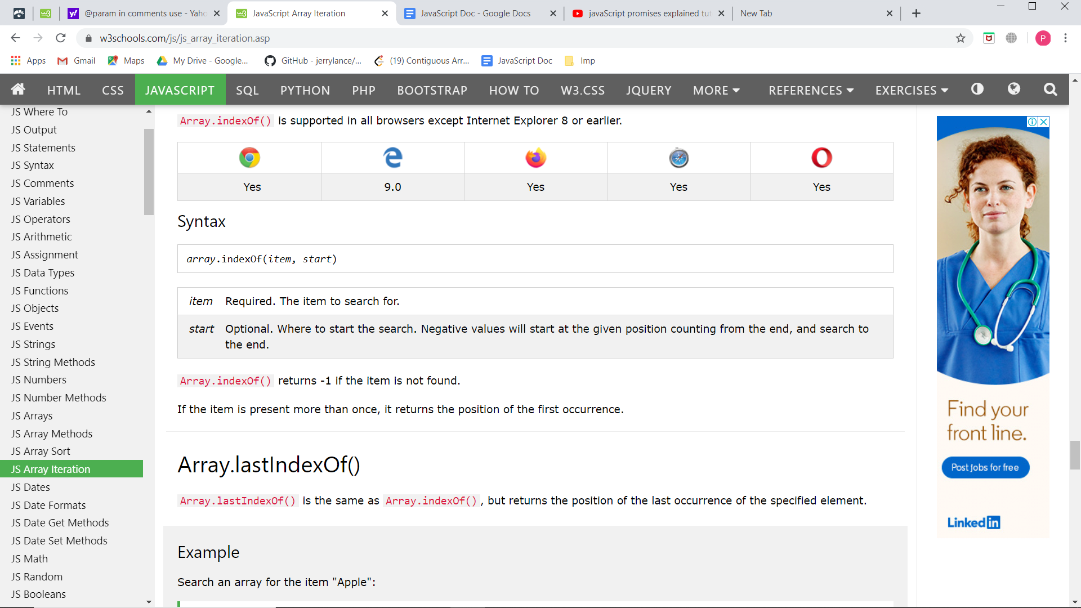The find() method returns the value of the first array element that passes a test function.he findIndex() method returns the index of the first array element that passes a test function.

Do not create Boolean objects. It slows down execution speed.

Comparing two JavaScript objects will always return false.

The break statement "jumps out" of a loop.

The continue statement "jumps over" one iteration in the loop.

With a label reference, the break statement can be used to jump out of any code block:

JS can also be used on the server side to make dynamic web applications. One is nodeJs(used for server side web development). ElectronJs.

document is a byDefault object given in JS that represents the entire DOCUMENT.

If the script code is big, it is kept at the bottom after the html closing tag as it takes a lot of time as it goes line by line so that it renders the document first.

PLUGIN of VS Code: Live Server : Makes ur changes reflectred in the browser without the need to save it .

Loosely types: we do not have to declare the datatype for creating variabels. Like in Jva we do int a=5 or string a = ”sanket”; but here we do var a = 5; and hence it is dynamic programming language. Ie: by initialising the value to the variable the datatype is set or it changes. Ex a= 5 / 5.0 / “sanket” / true. The data type of variable changes on what value you pass.

First char should be a letter or _ or $. Variables are case-sensitive

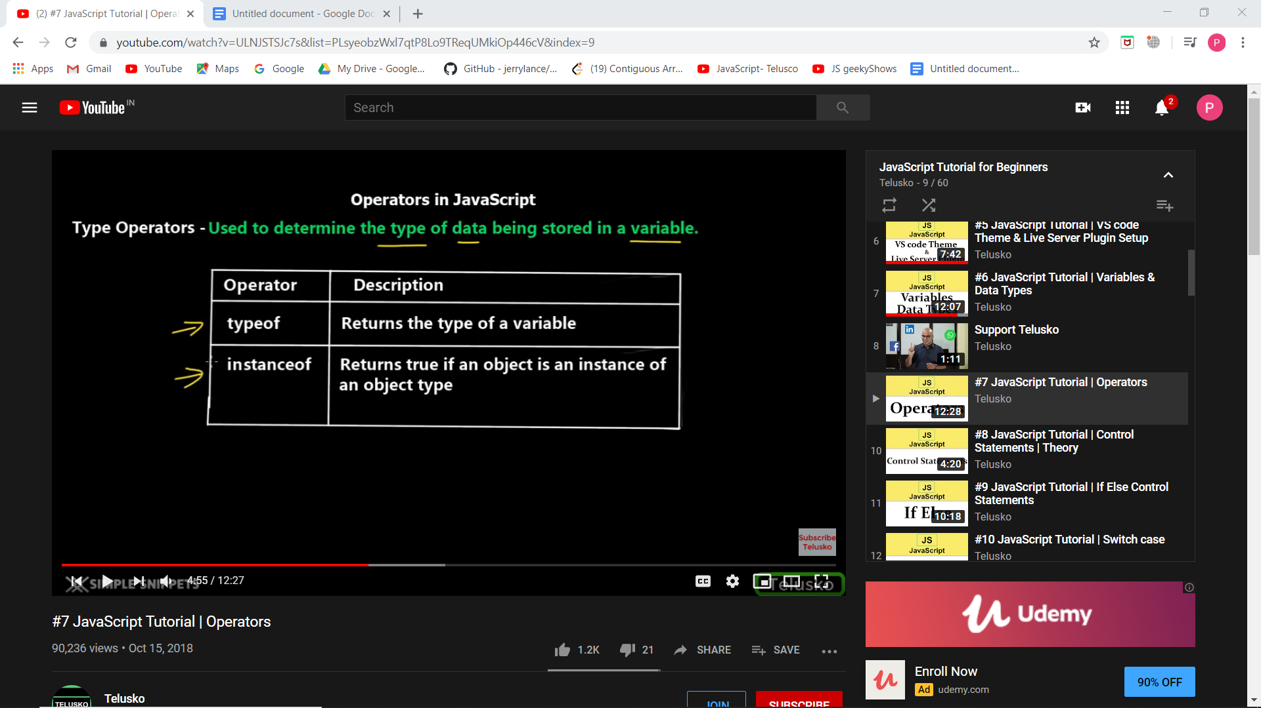

Certain operators have a r8 to left ehile some hav left to right associativity.

Dynamic Programming: Similarly as for variables, for functions, we do not need to define the return type. For function, we need the function keyword and just return the value.

Local variable memory will be destroyed after the function ends.

We can also create variables without the use of var keyword. But in that case the variable becomes by default global.

ARRAYS can be created using.

var arr = [“audi”, “bmw”, ”volvo”, 3,6,8]; or using the new keyword

var arr = new Array(“audi”, “bmw”, ”volvo”);

Arrays are dynamic in nature. We can add extra value in array at runtime. It is not a fixed size array. Arrays are different types of objects. Hence they have some methods along with them.

Also array can hold/store different data types values.

JS is an object oriented programming language.

Creating objects in javascript:

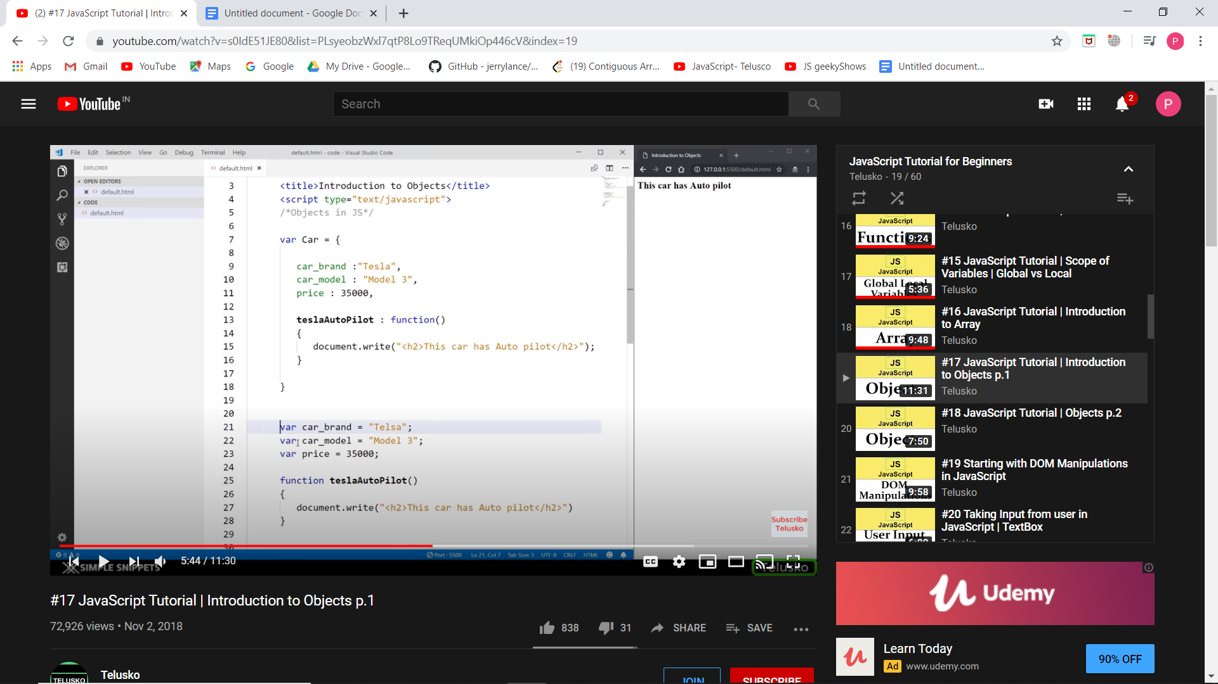

Functions declared inside of an object are called methods.

But in case if we need many objects, we will create an object constructor. In newer versions og JS, classes are supported. Here is the old school way.

Here is the constructor function:-

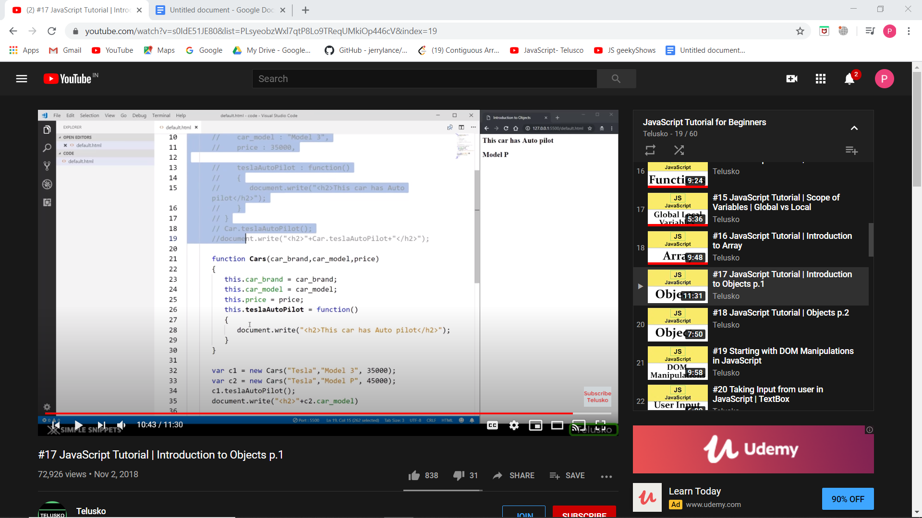

This keyword here refers to the properties of the object

The basic data types boolean, string and numbers can also act as objects if declared using the new keyword. Dates , Maths and regular expressions are always objects.

Example: var str = new String(); check it using typeof(str).

Now we have made an object say CAR. And after a lot of lines, we need to add one more property to the object. We can do it by:

CAR.propertyName = “value”;

Similarly we can also add a method to the object.

Delete CAR.propertyName; // to delete property from the object

**document.getElementById()** gives a reference to that particular element.

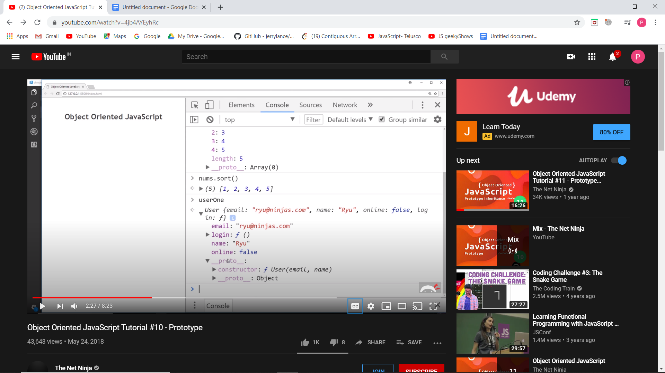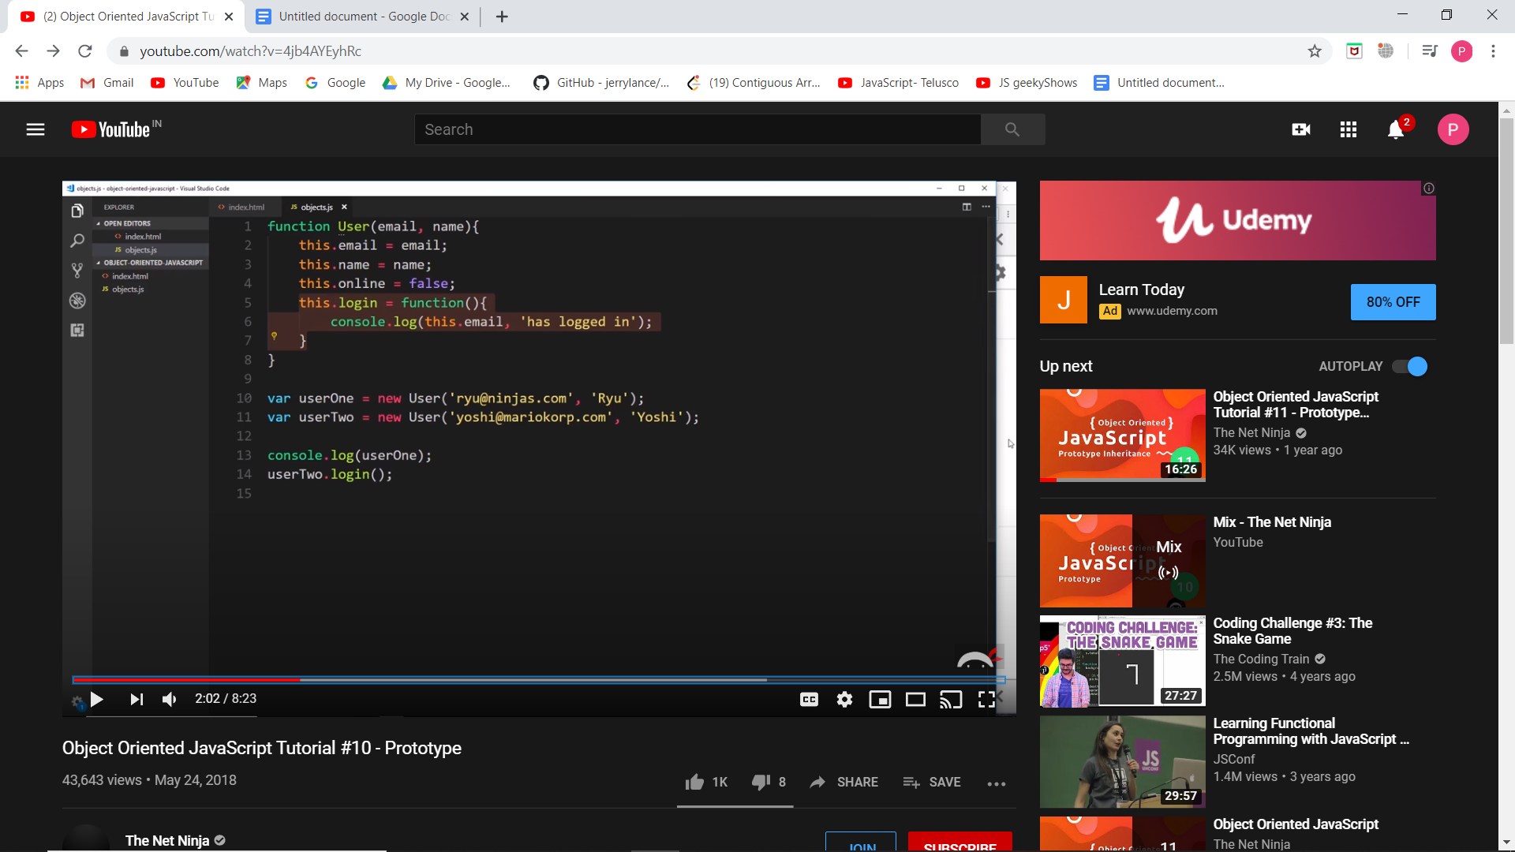Anything inside the proto property, we can directly access on the object. This is for any object created.

When we use/add the method in the constructor function, we cannot see the methods inside the proto property, but they are directly inside the object itself. This is bcoz we have attached the function to the User constructor and not the proto property. So now what is prototype property. And why we need to attach the function to it. So any object or class(here constructor fn) we try to emulate has a prototype property. O this prototype of each different type in JavaScript is like a map for the object type. It contains the different functionality ie diff methds for that object type. And for any object created for that type, the proto property ie: the __proto__ property will point to that prototype and will use that methods.So this way the methods are not repeated in each instance created but they are defined once in a prototype and accessed using the proto property. So if we create an object, the variable are created inside it but the methods, we are borrowing them from the prototype and using them.

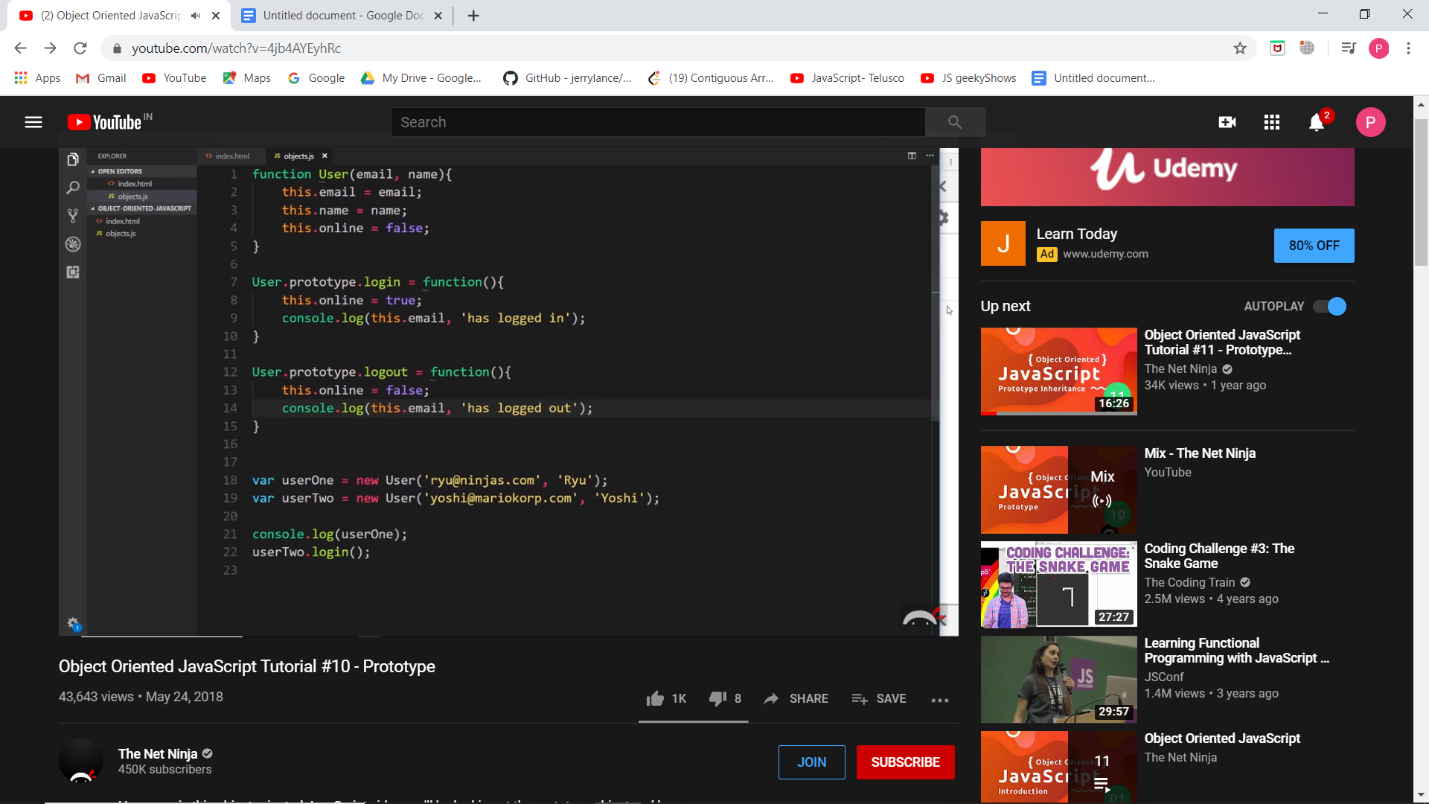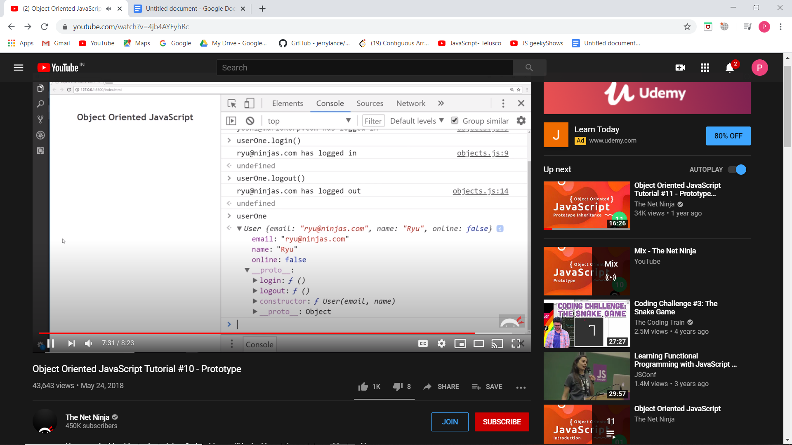

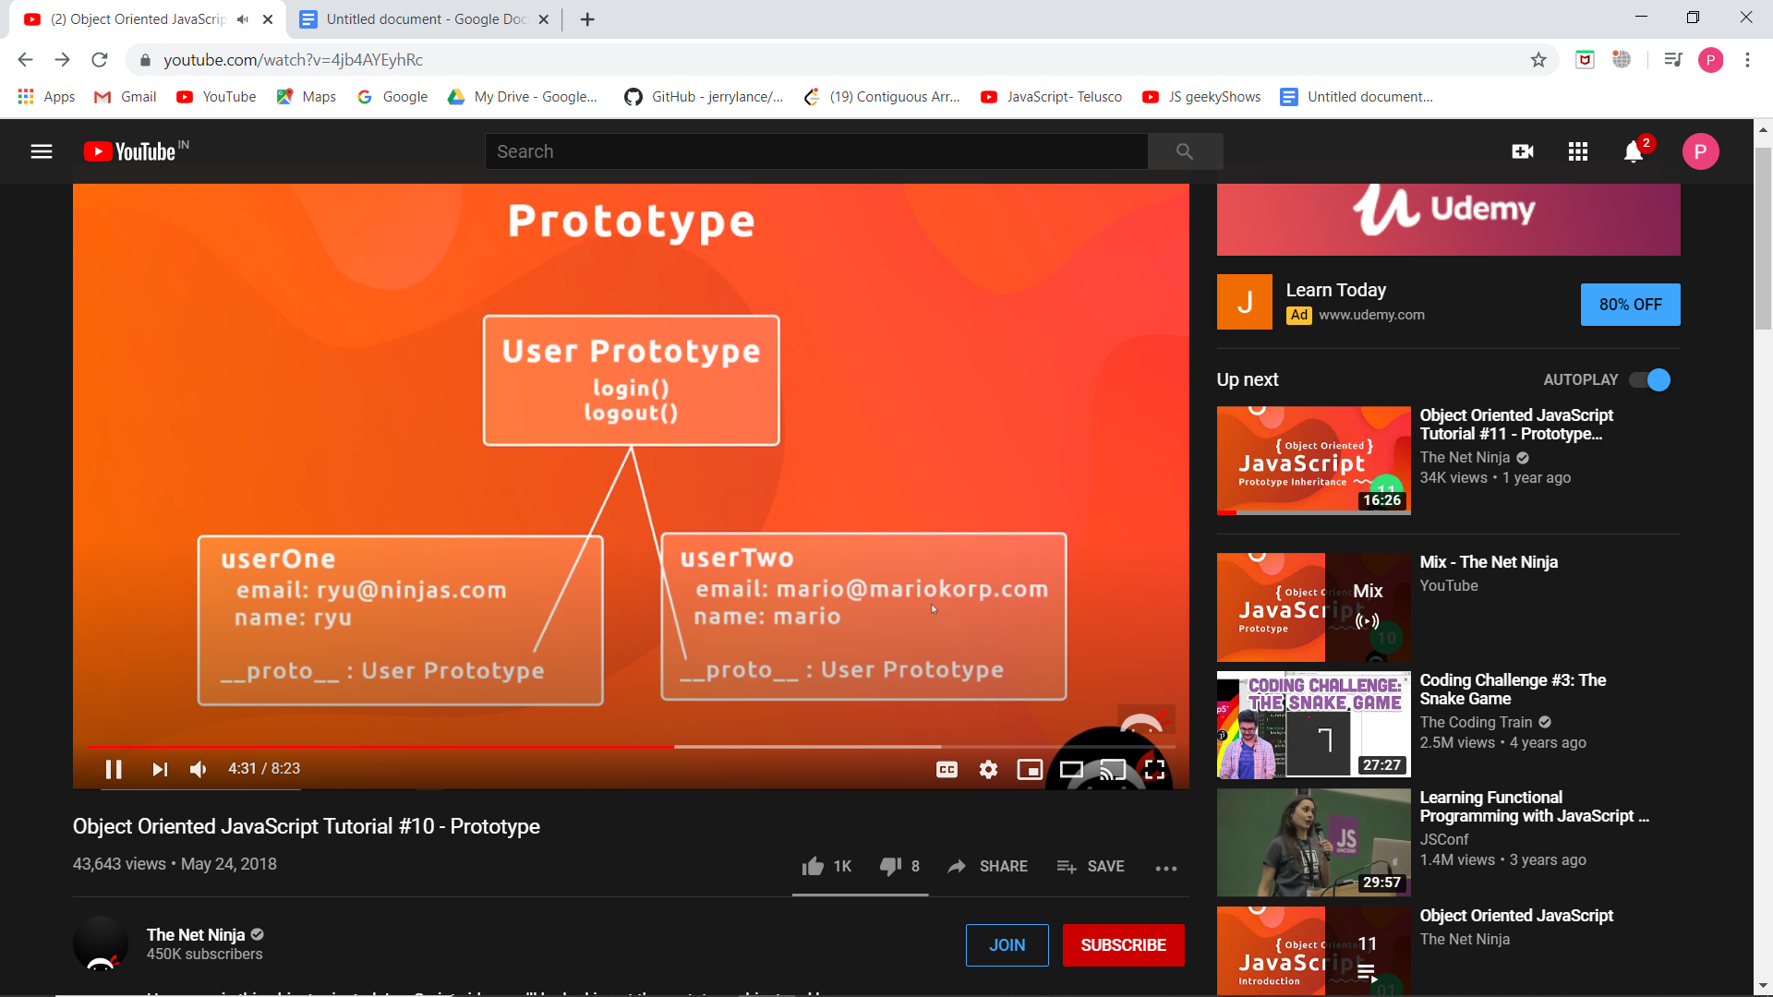

The difference is that apply lets you invoke the function with arguments as an array; call requires the parameters be listed explicitly. A useful mnemonic is *"****A*** *for* ***a****rray and* ***C*** *for* ***c****omma."*

Pseudo syntax:

theFunction.apply(valueForThis, arrayOfArgs)

theFunction.call(valueForThis, arg1, arg2, ...)

By default every function has a property called prototype and it is empty initially. We can add methods and properties to it.

JavaScript has prototype based inheritance. Like in Java you create class and create objects from it, in JS , we create constructors directly and create objects from it.

console.dir(obj) -- gives us a detailed info of the object

A function (constructor function) is created from a function object which in turn is created from a master object.

**__proto__ means PARENT or CREATOR**

If you look for a method and if it is not present, then it will look in its higher parent (function object) and if it is not found there also , it will look in the master object. This is called prototype chaining.

**Inheritance in prototype object**

Now for inheritance, we first create a constructor function and then create an object passing the values and in the constructor we call the parent constructor function. But the prototype methods are not inherited by default. We need to explicitly inherit them.

...args will take the parameter as an array. ‘this’ inside a constructor function refers to object of that function.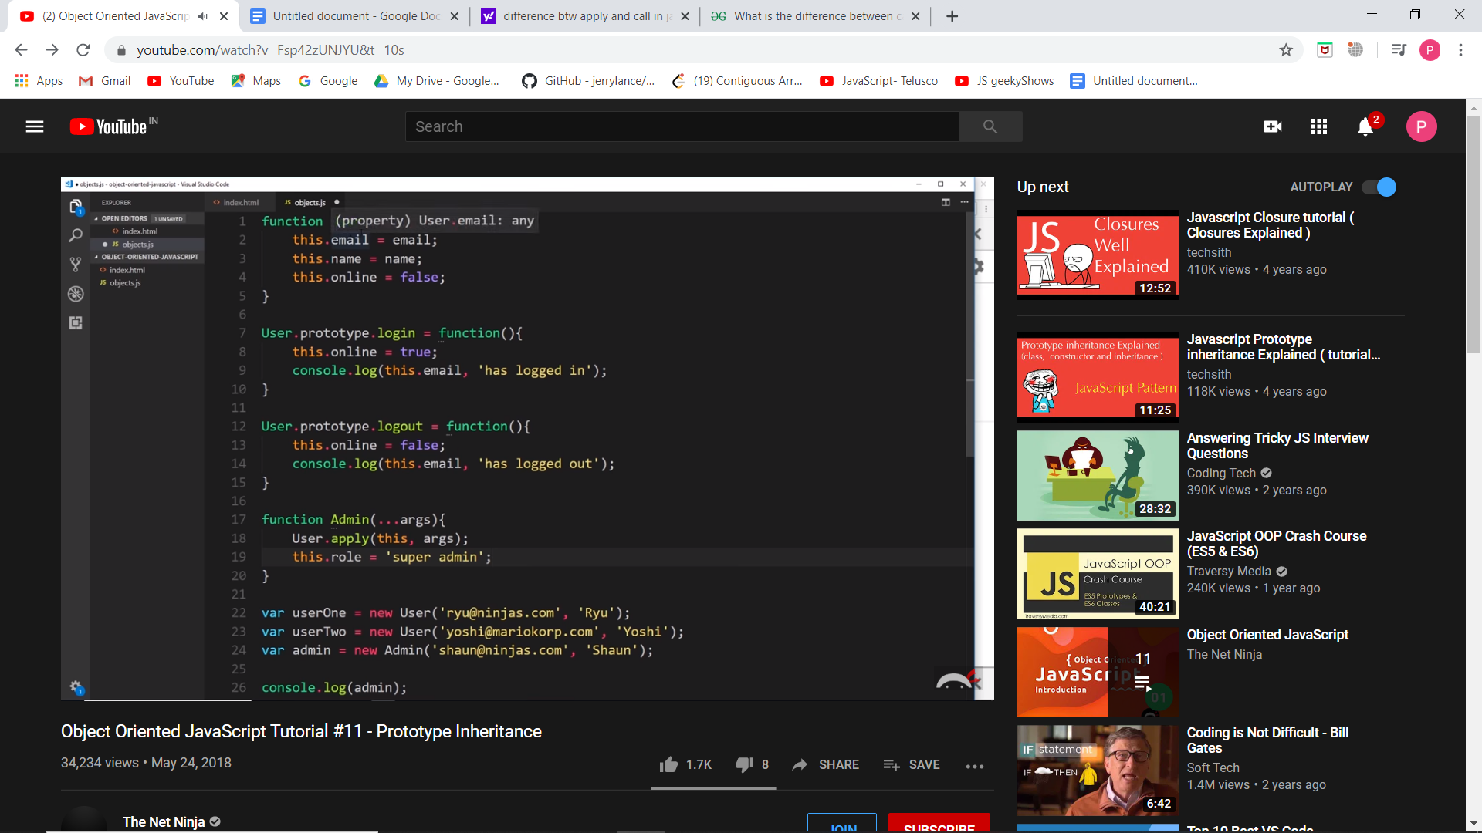

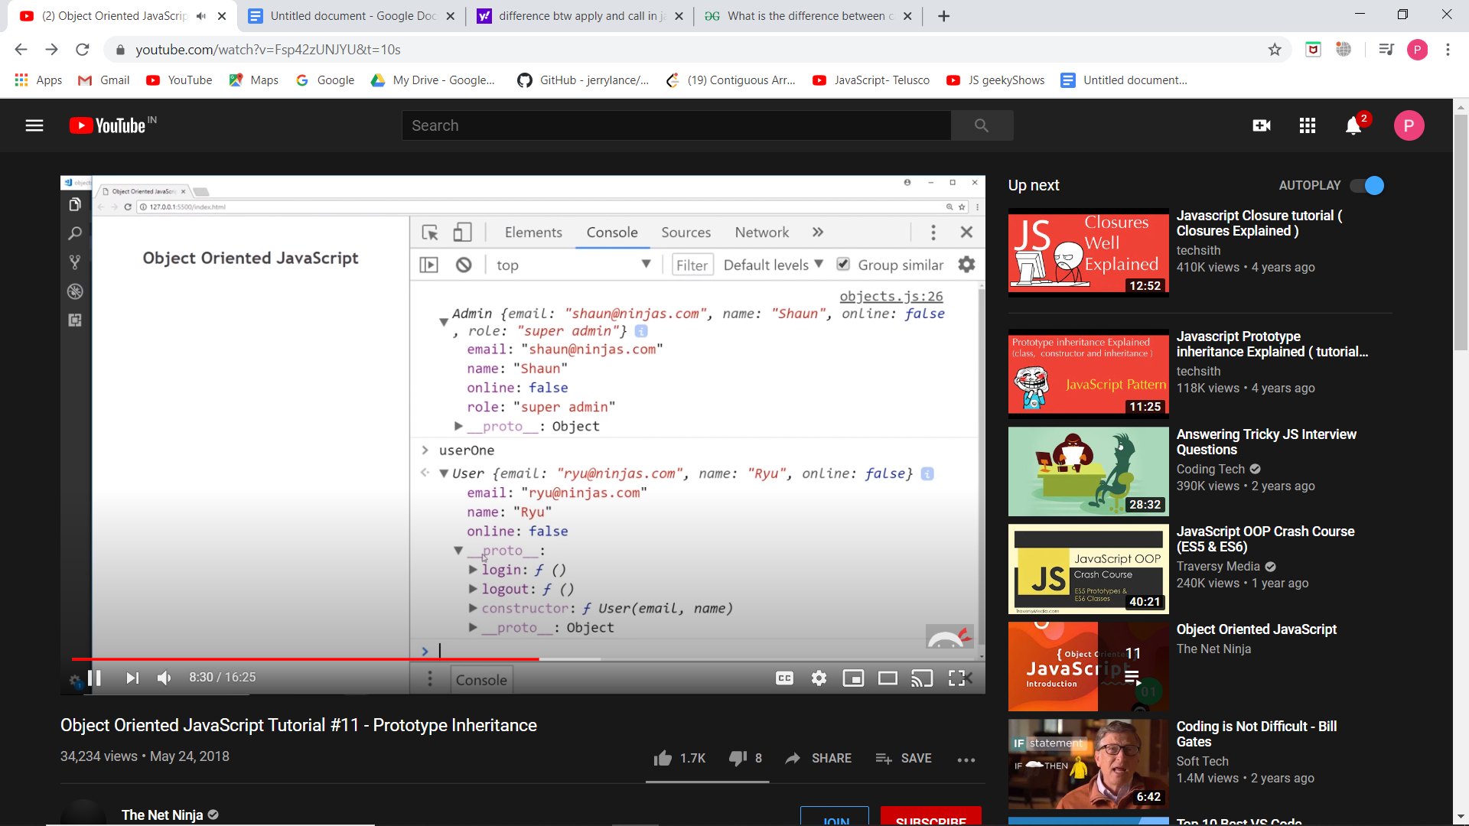 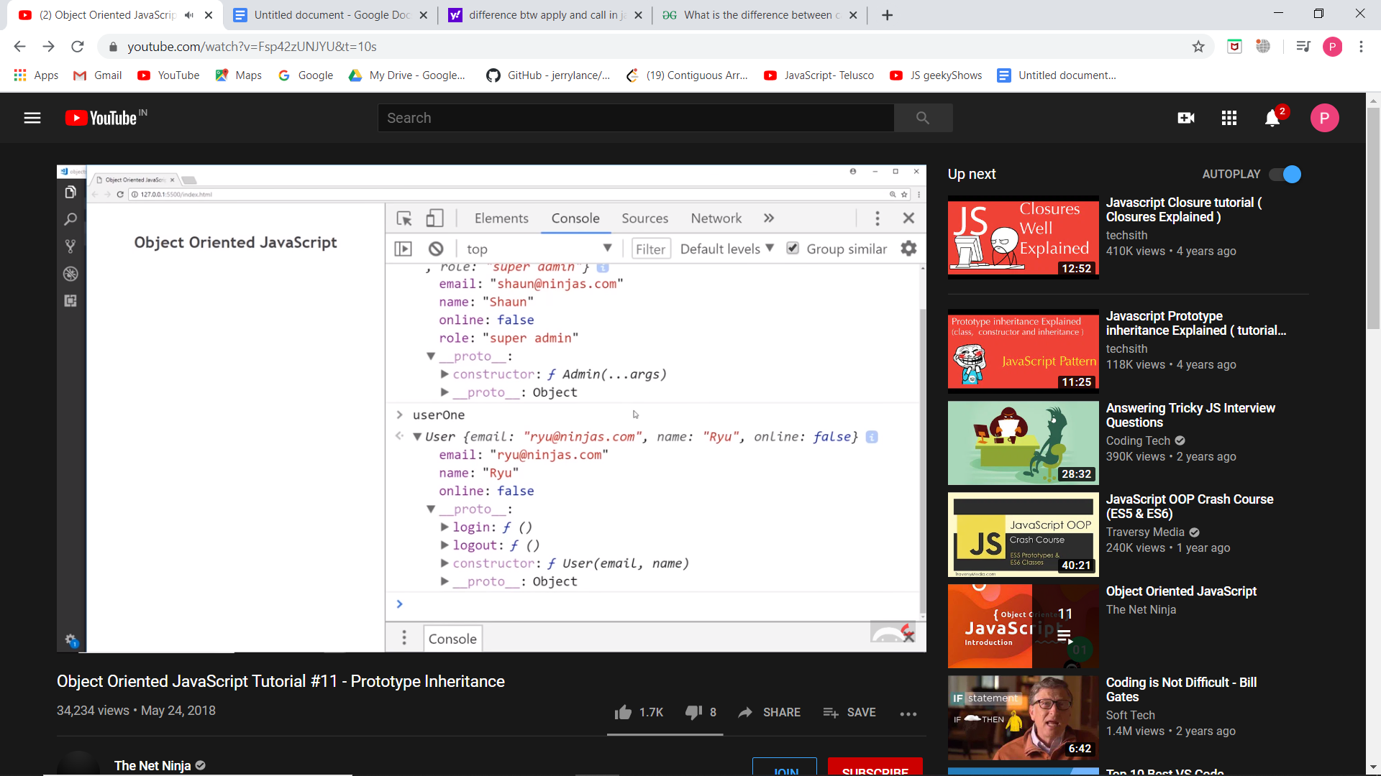

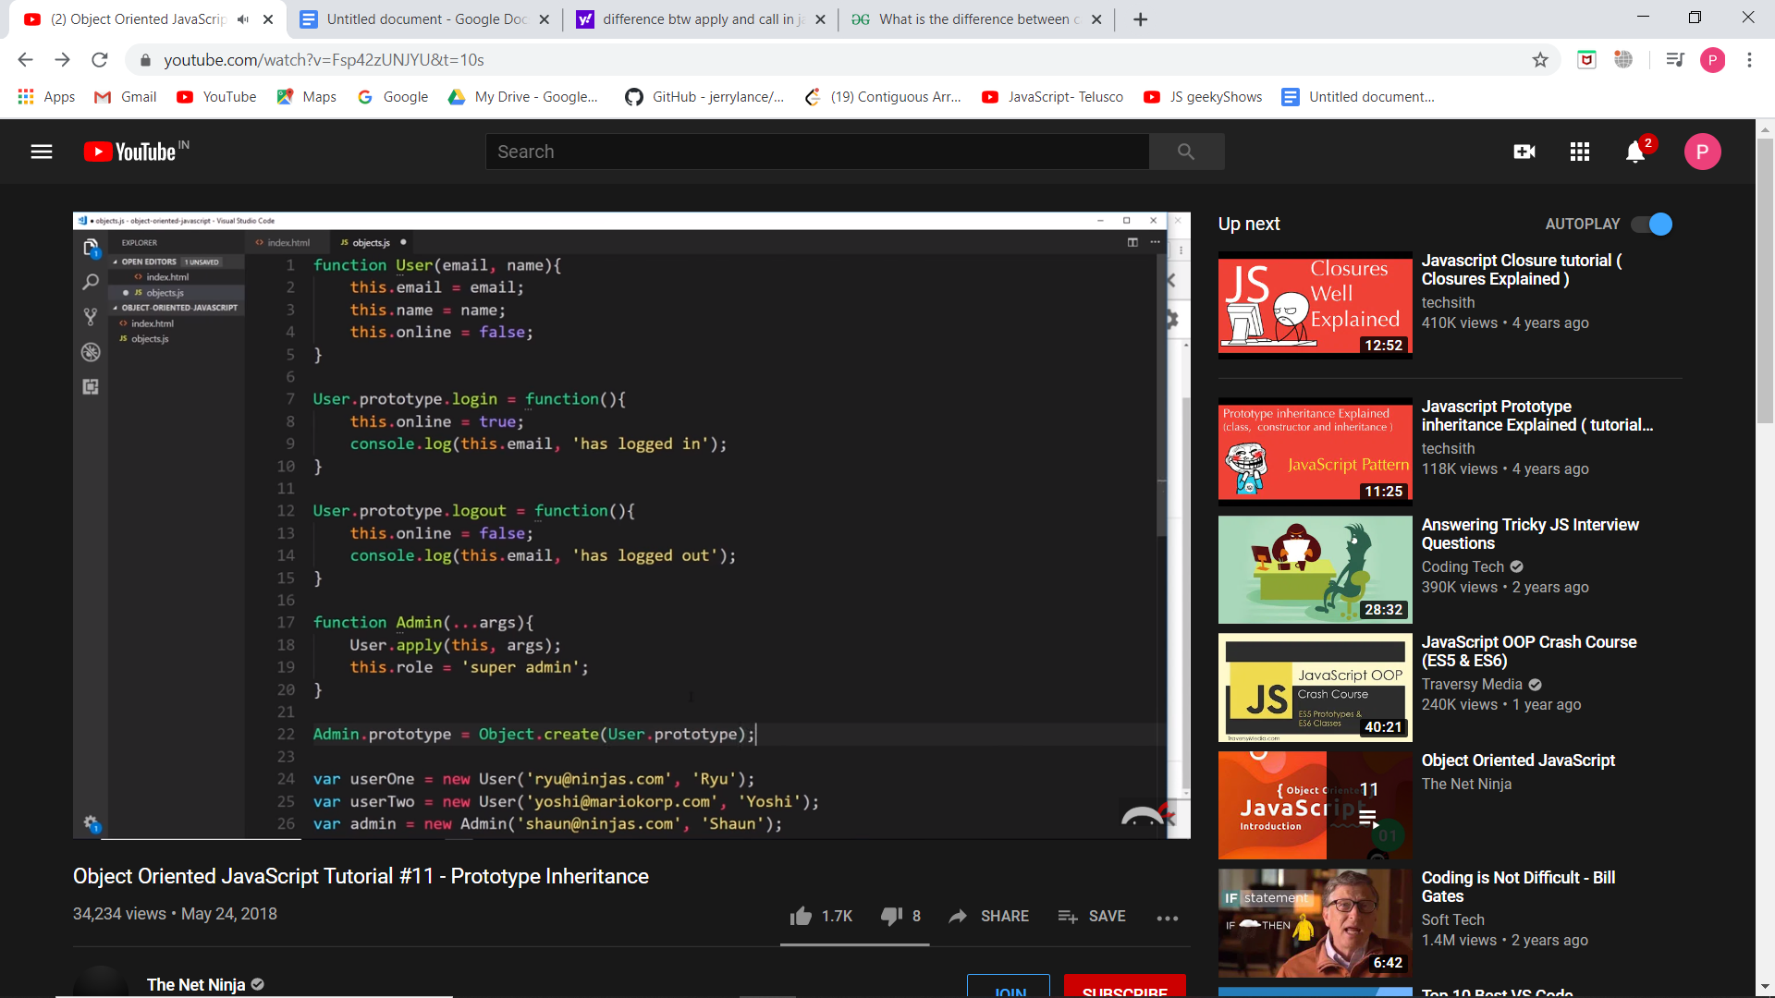

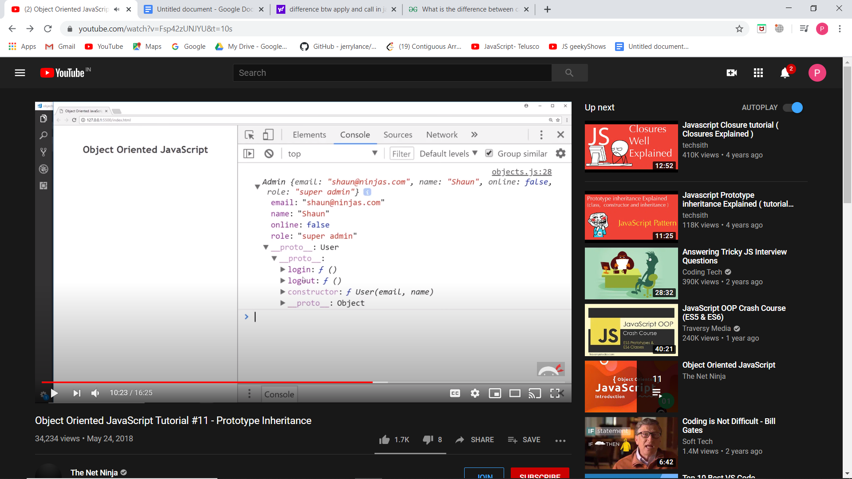

Hence we can see that the admin inherits from User object which in turn has Master object.

**Regular vs COnstructor mode of calling functions:**

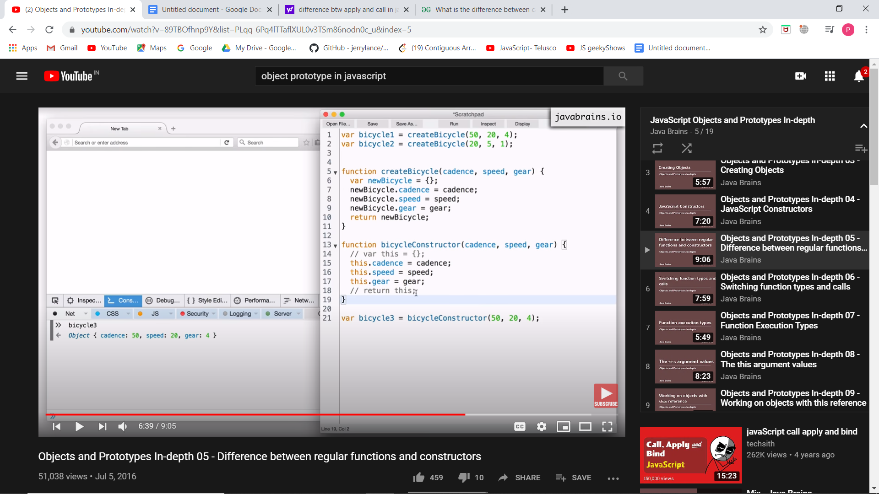

In above, the function is called in normal mode in which an obj newBicycle is made and returned. But constructor mode is called by giving a new keyword and in this we assume that an object named this is formed though it is not actually formed. This in any constructor refers to an object of that constructor.

Using the .call() , we can call functions of an object from other functions or any other object.

Prototype is a concept which lets you build objects using a blueprint or template.

Javascript objects do not own methods. They just have properties and properties may include functions. Functions written inside a constructor function causes the constructor to create a new function every time a new object is made.

In Java every object is associated with the class and hence own all its properties and functions but in JavaScript, new functions and properties are created for every object created using a constructor function.

**encodeURI** assumes that the input is a complete URI that might have some characters which need encoding in it. **encodeURIComponent** will encode everything with special meaning, so you use it for components of URIs such as

var world = "A string with symbols & characters that have special meaning?"; var uri = 'http://example.com/foo?hello=' + encodeURIComponent(world);

encodeURI() will not encode **A-Z a-z 0-9 ; , / ? : @ & = + $ - _ . ! ~ * ' ( ) #**. Use it when your input is a complete URL like '<https://searchexample.com/search?q=wiki>'. encodeURIComponent() will not encode **A-Z a-z 0-9 - _ . ! ~ * ' ( )** Use it when your input is part of a complete URL e.g const queryStr = encodeURIComponent(someString)

*** var and let are both used for variable declaration in javascript but the difference between them is that var is **function** scoped and let is **block** scoped.

It can be said that a variable declared with var is defined throughout the program as compared to let. <https://stackoverflow.com/questions/762011/whats-the-difference-between-using-let-and-var>

**Call Function:**

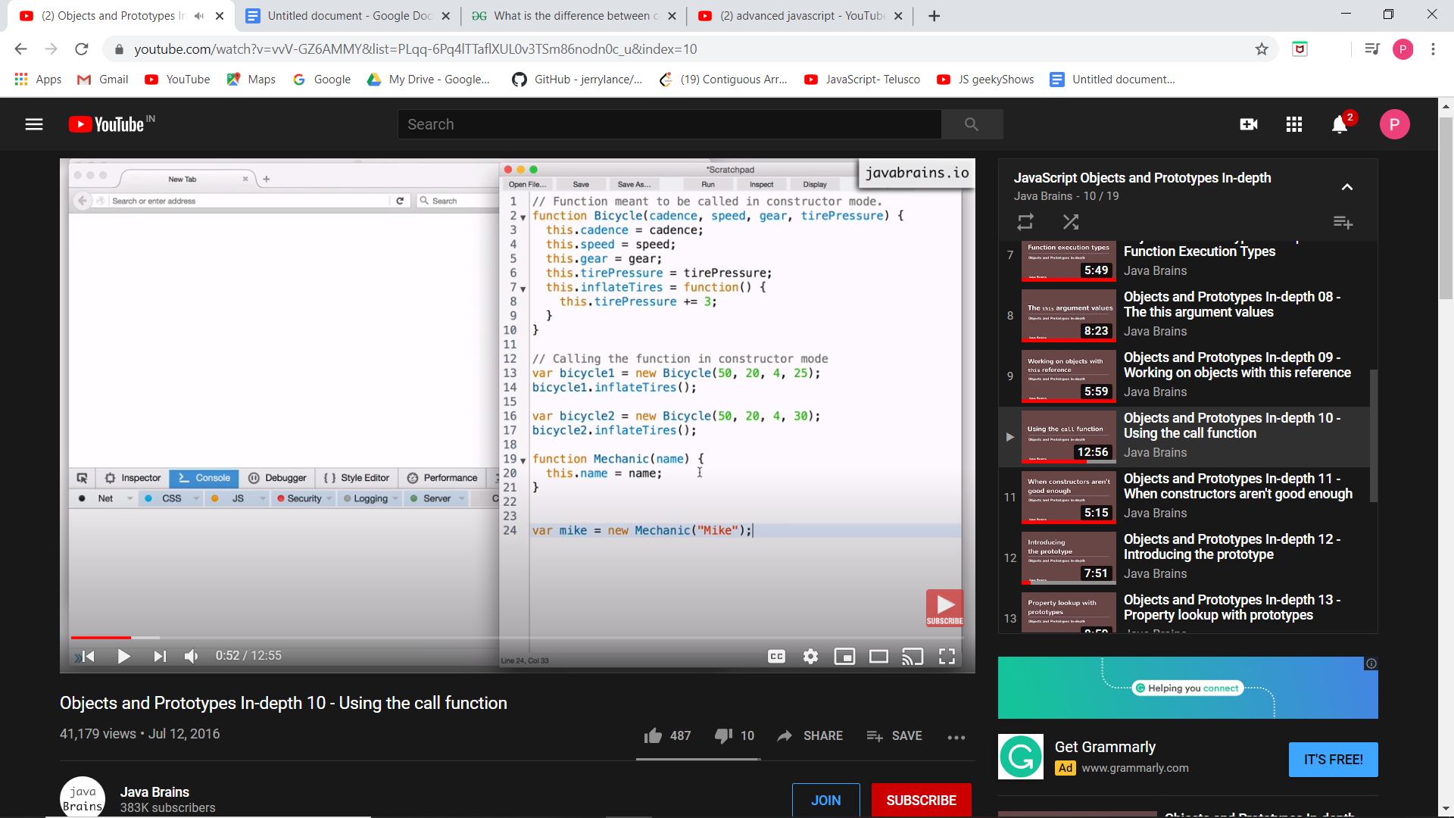

Now I want mike to give access to the inflateTyre functionality. So we can give a function to mike using mike.inflateTyre = bicycle.inflateTyre. Now on calling mike.inflateTyre(), then function having this reference should point to the mike object. But mike does not have a property tirePressure.

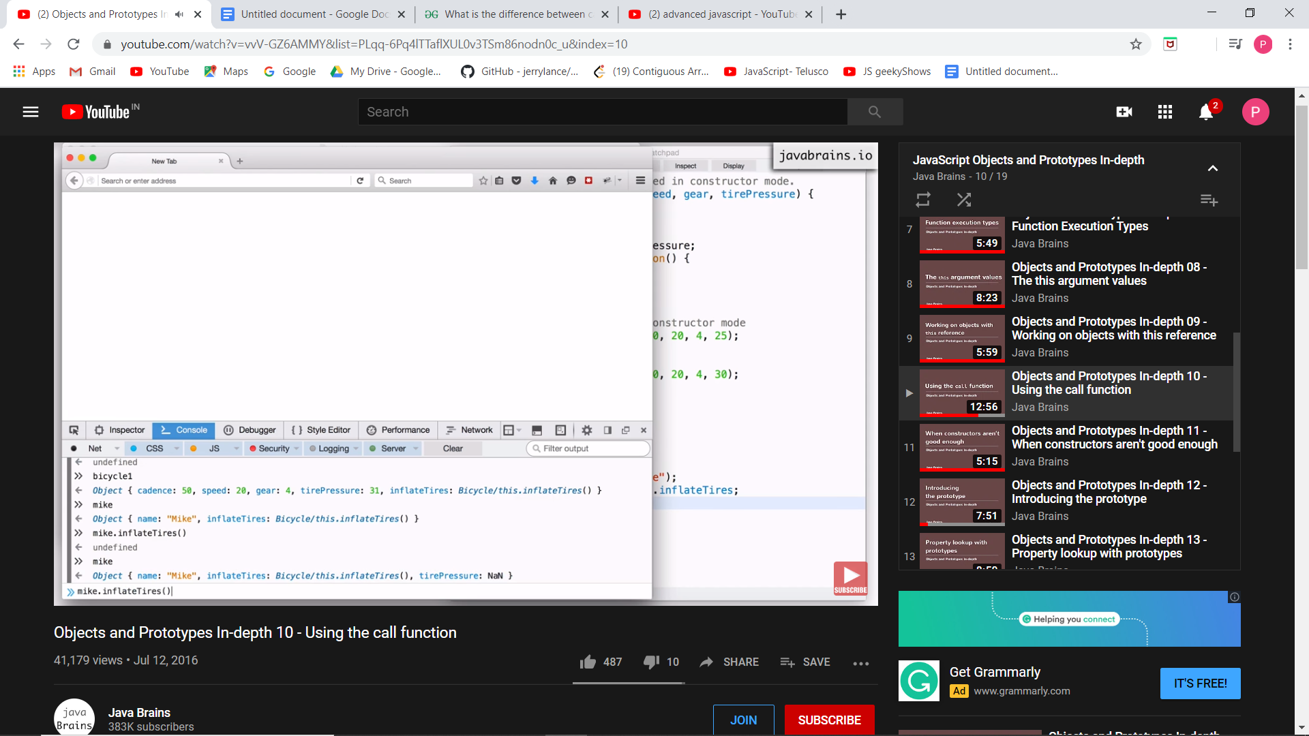 So it gives undefined. But we want to point to the bicycle to which mike want to do changes. Ie we should tell him to use other object. So we have function.call() which takes an object as a parameter and binds the object to this reference .

SO we have mike.inflateTyre.call(bicycle1);

------------------

Functions are basically objects in javaScript. Whenever the JS engine processes functions , it creates 2 objects (fn object and prototype object). So there is a property prototype on the function objects that points to the prototype object. So if we create a fn foo, it’s prototype object can be accessed by foo.prototype. We can access the fn obj by the name of the fn.

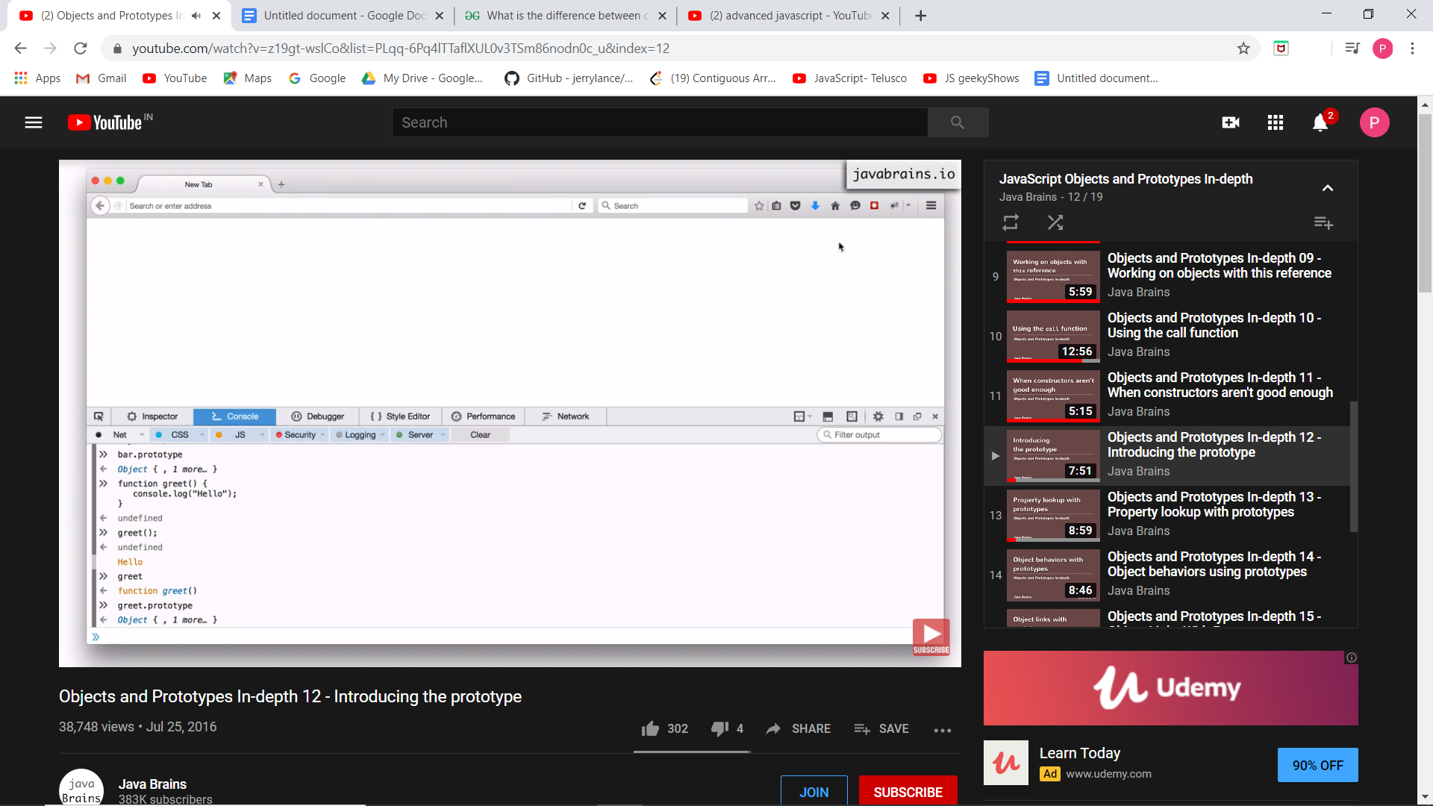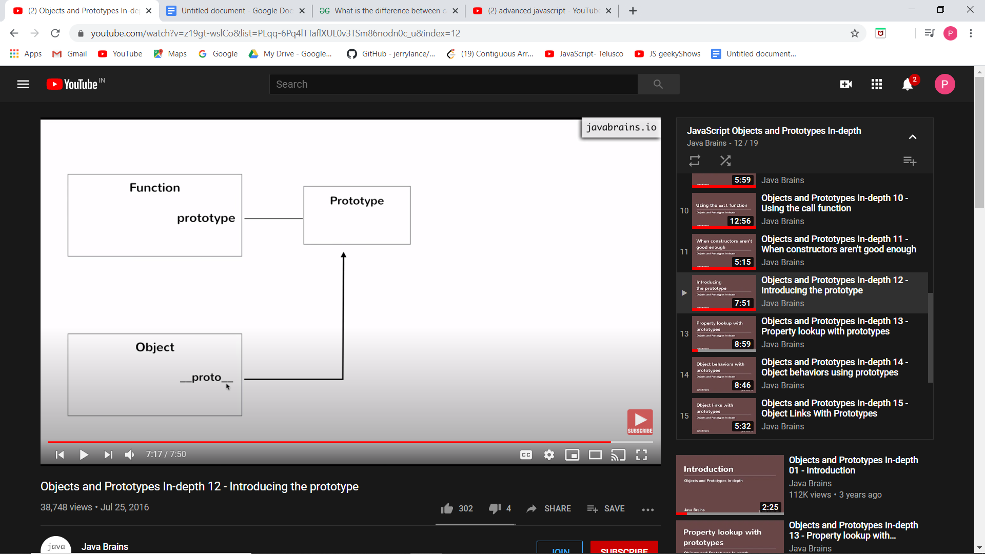

If we have a function and we do not create objects from it, the prototype object just sits ideal or is not used. To bring it in action, we create an object using the new keyword.

__proto__ is a property that JS creates on all object created using new keyword on functions.

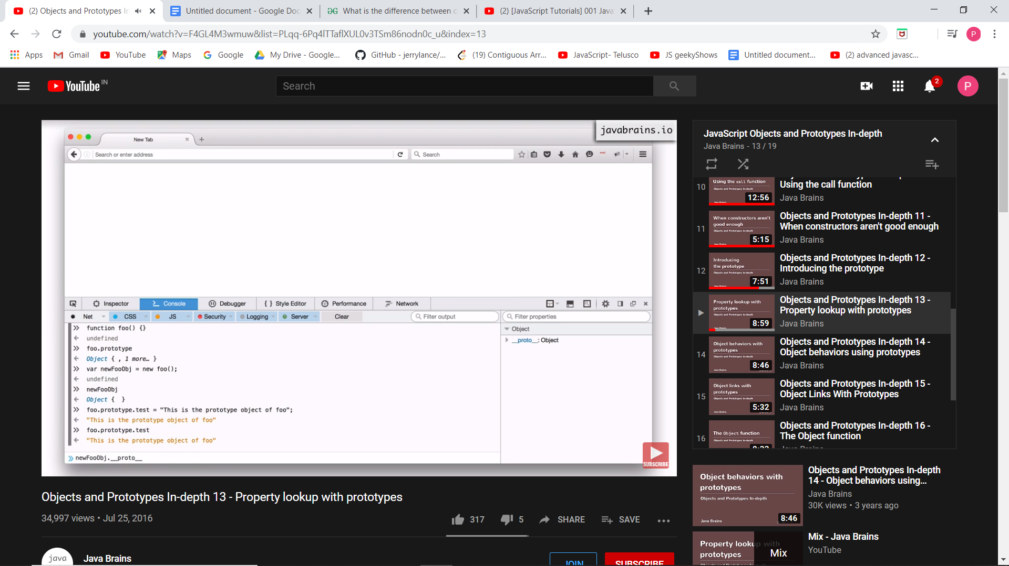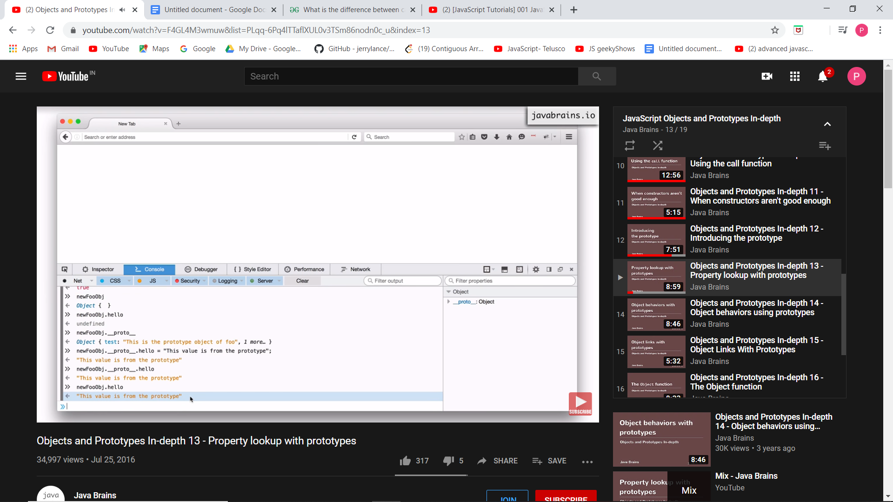

If you look for a property in an object and if that object does not have that property, it will look for that property in the prototype object and if it is not found there also , then it returns undefined.

Any property/function kept on a prototype is best bcoz no matter how many objects you create, all the objects will share only the one copy.

Now since one copy is present, a change done by any object will reflect in others too.

The __proto__ is also referred to as dunder-proto. Just as a function has a property prototype that points to the prototype object, similarly the prototype object also has a property named **‘constructor’** which points to the constructor function.

THE OBJECT FUNCTION:

Just lie you have global window object, we have global functions and one of those global functions is called object. The name of the function is Object but the type is function.

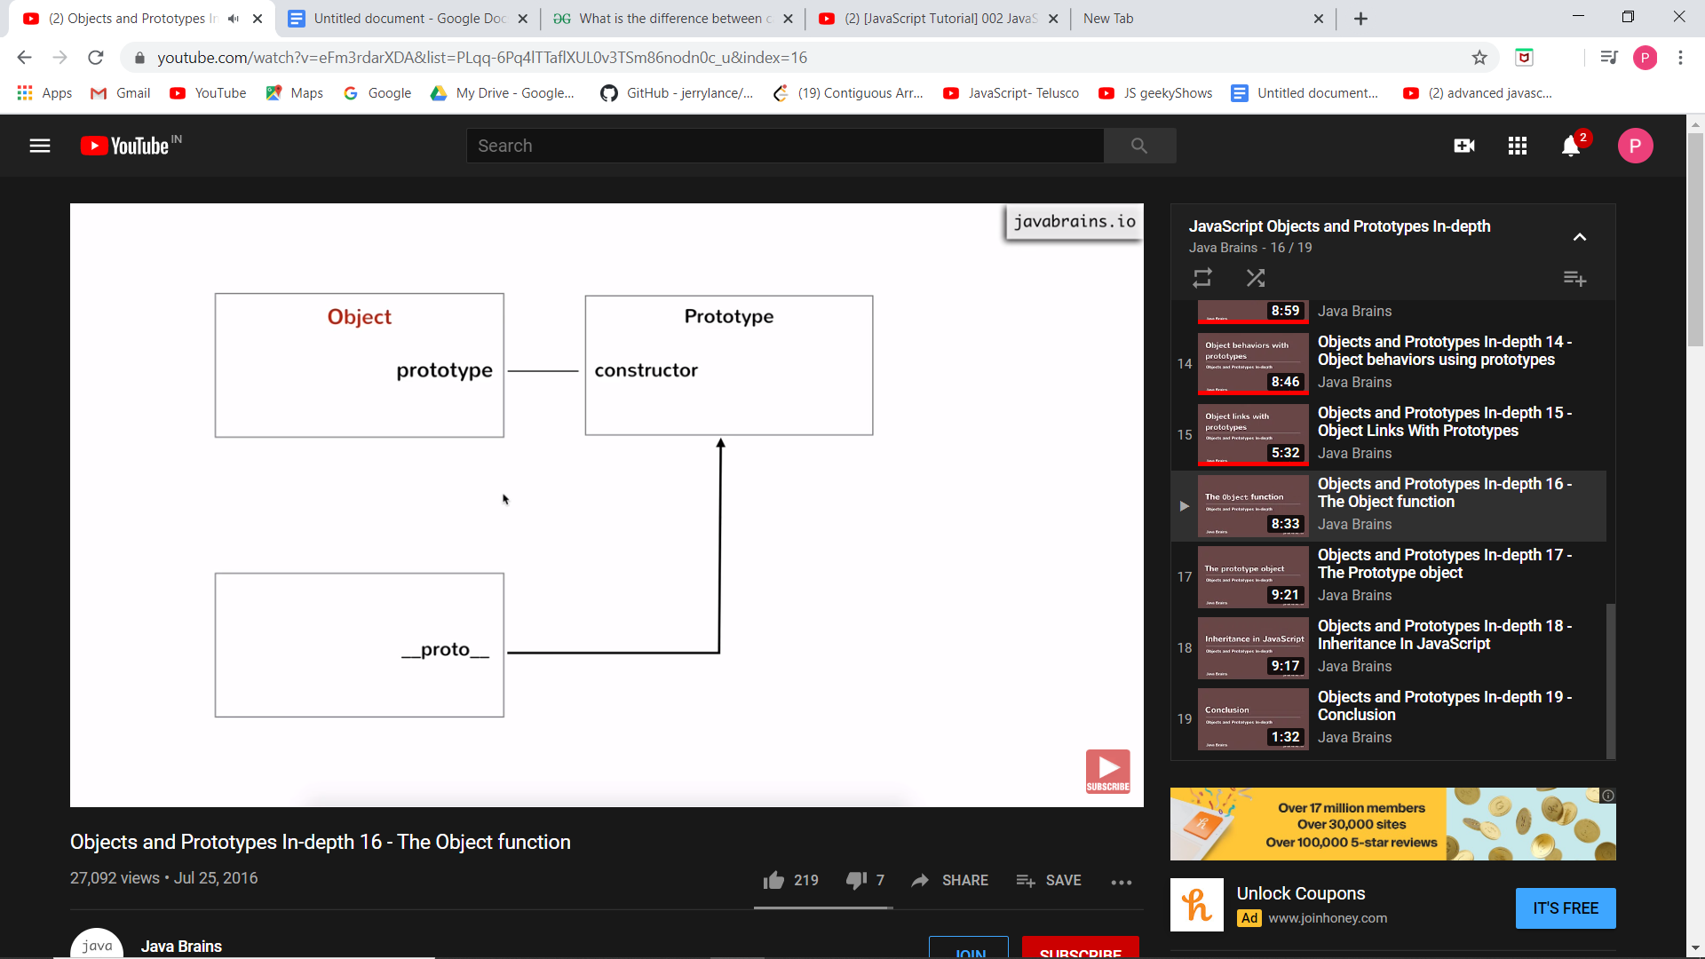

Hence object can be created by:

Var obj = { } **or** var obj = new Object()

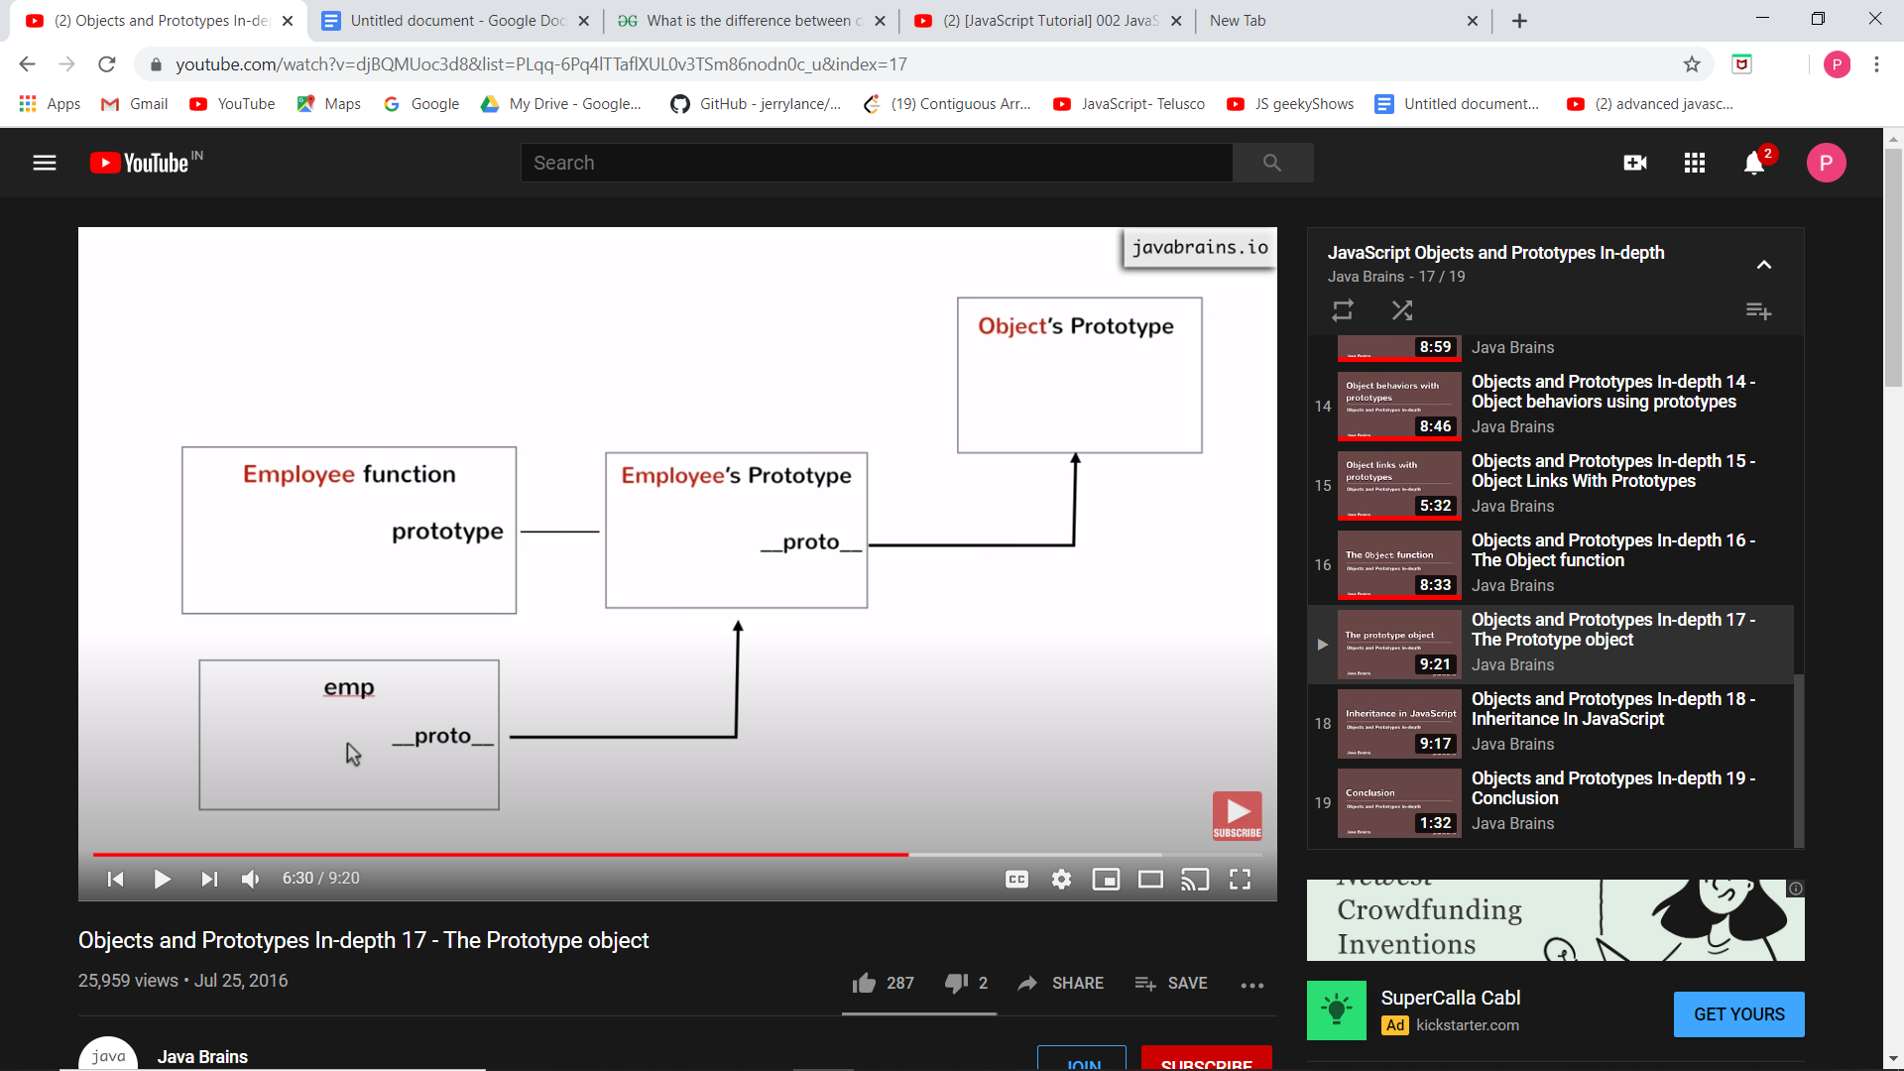

**Employee.prototype === emp.__proto__**

The emp object was created by using a new keyword. But the **Employee’s Prototype object** is not created using a new keyword. So who created it?? Well it was created using an Object Function in constructor mode. So it is created using ‘new Object()’.

Hence Object.prototype === emp.__proto__.__proto__ ===

If you search for any property on emp and if it does not get there, it then searches on Emp’s Prototype and if not there also it goes to Object prototype.

You are creating a property for all the objects in a system if you put it in Object’s Prototype.

**Imp:** **Object.prototype.__proto__ points to null**.

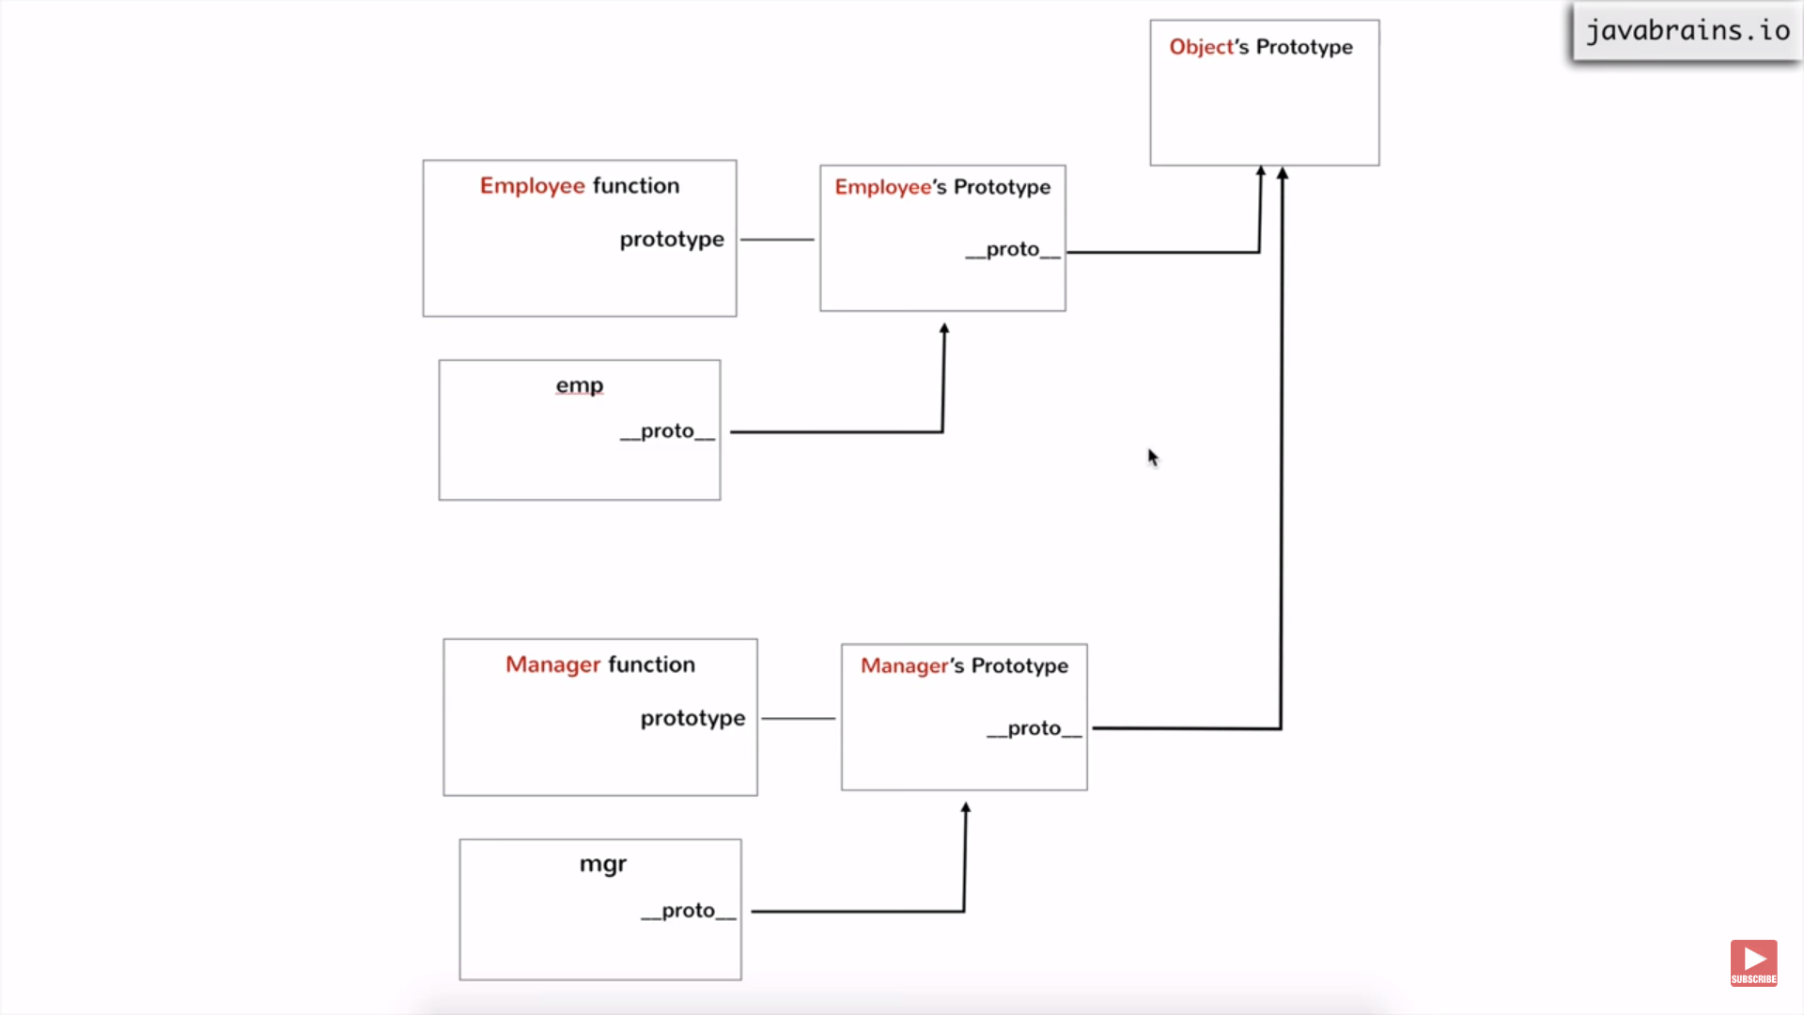

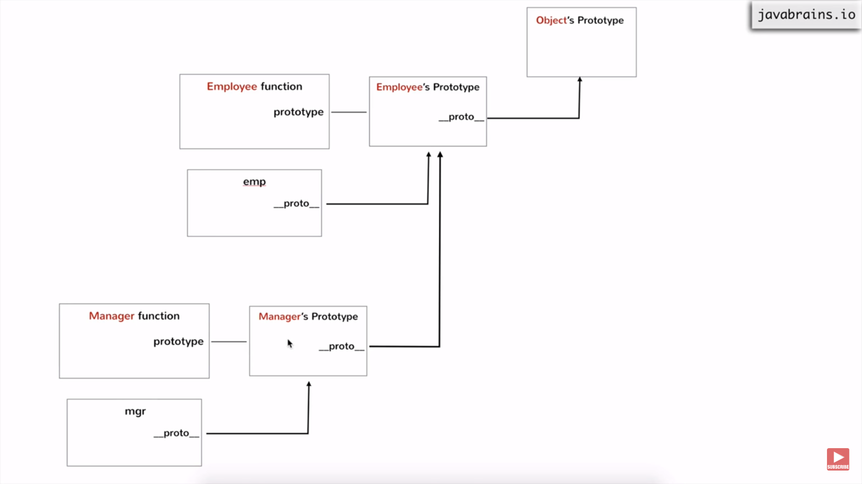

Here we do, **mgr.__proto__.__proto__ == Employee.prototype**.

**PROMISES in JavaScript**

**Promises** are used to handle asynchronous operations in JavaScript.

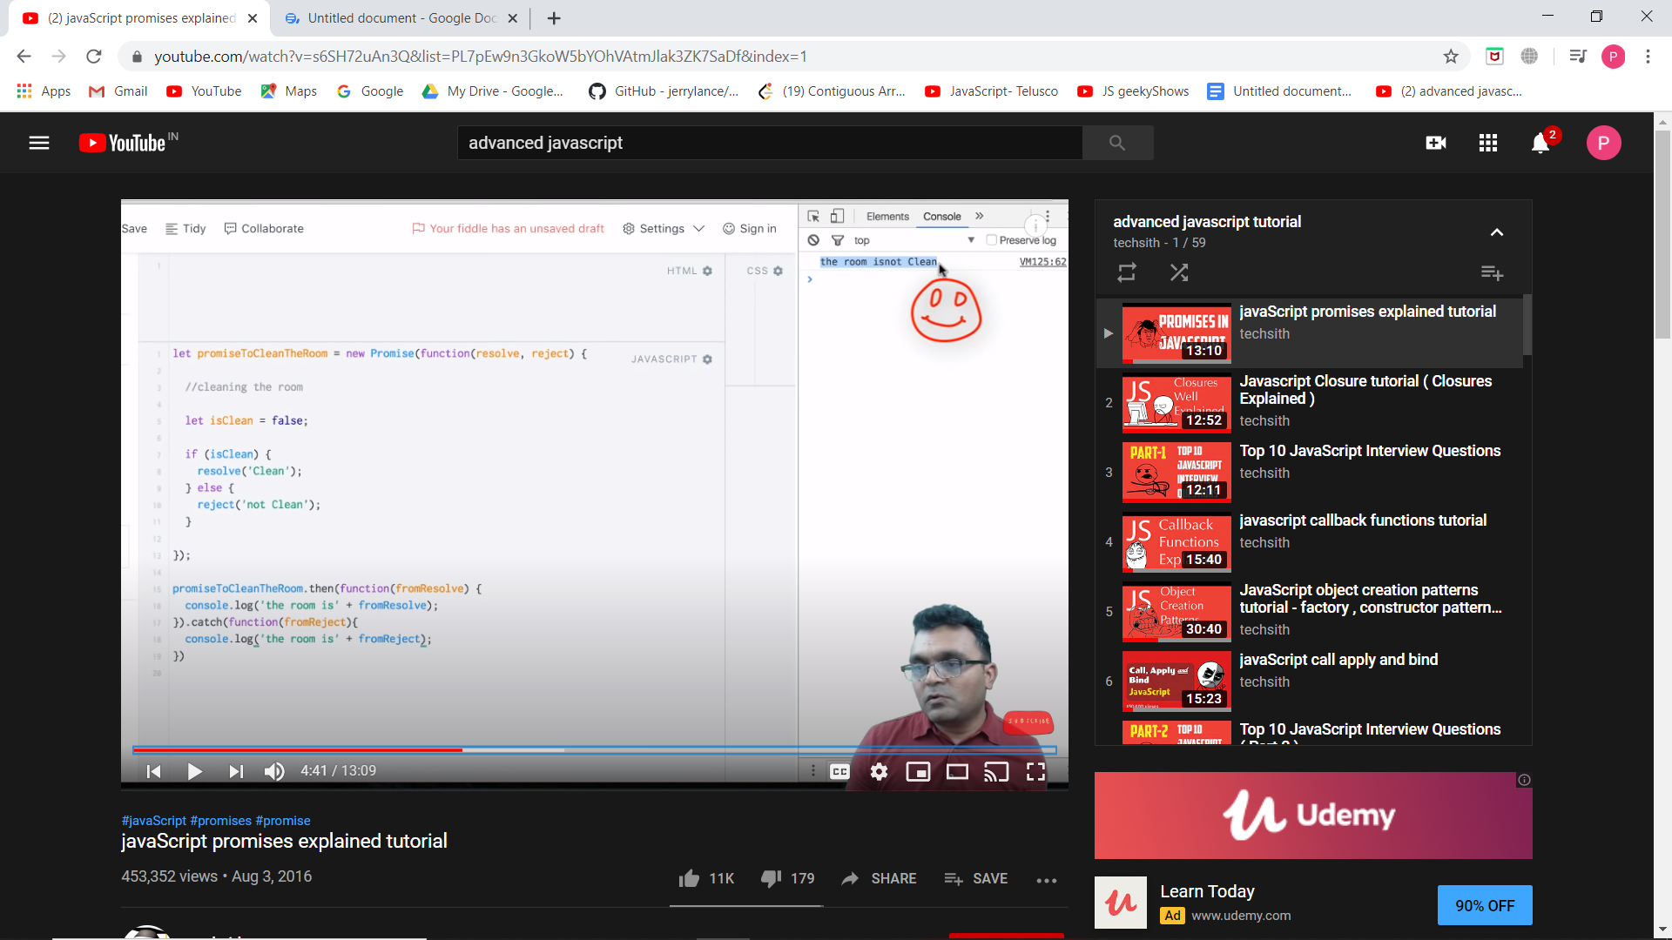

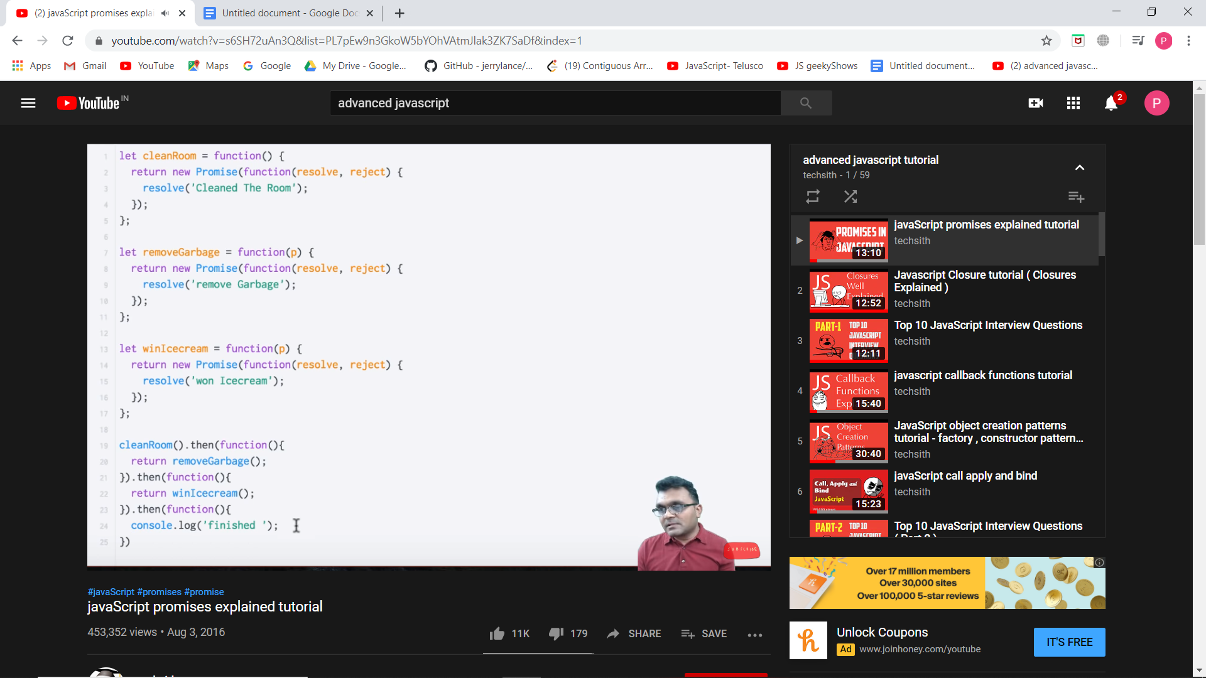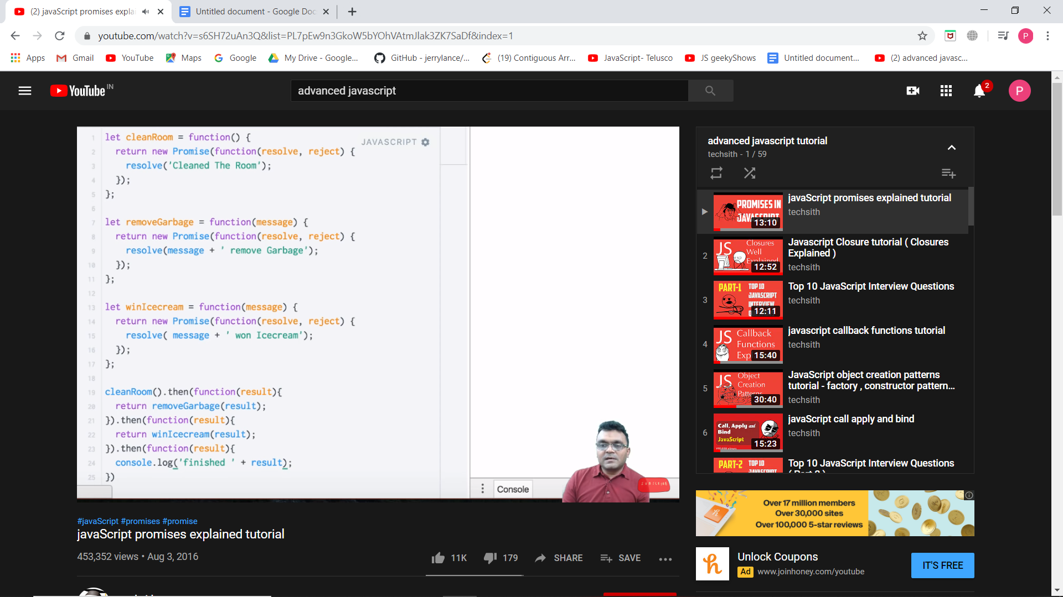

then() is called if a promise is resolved else catch() is called.The above code is used to wait for a fn to finish completely and then other is executed

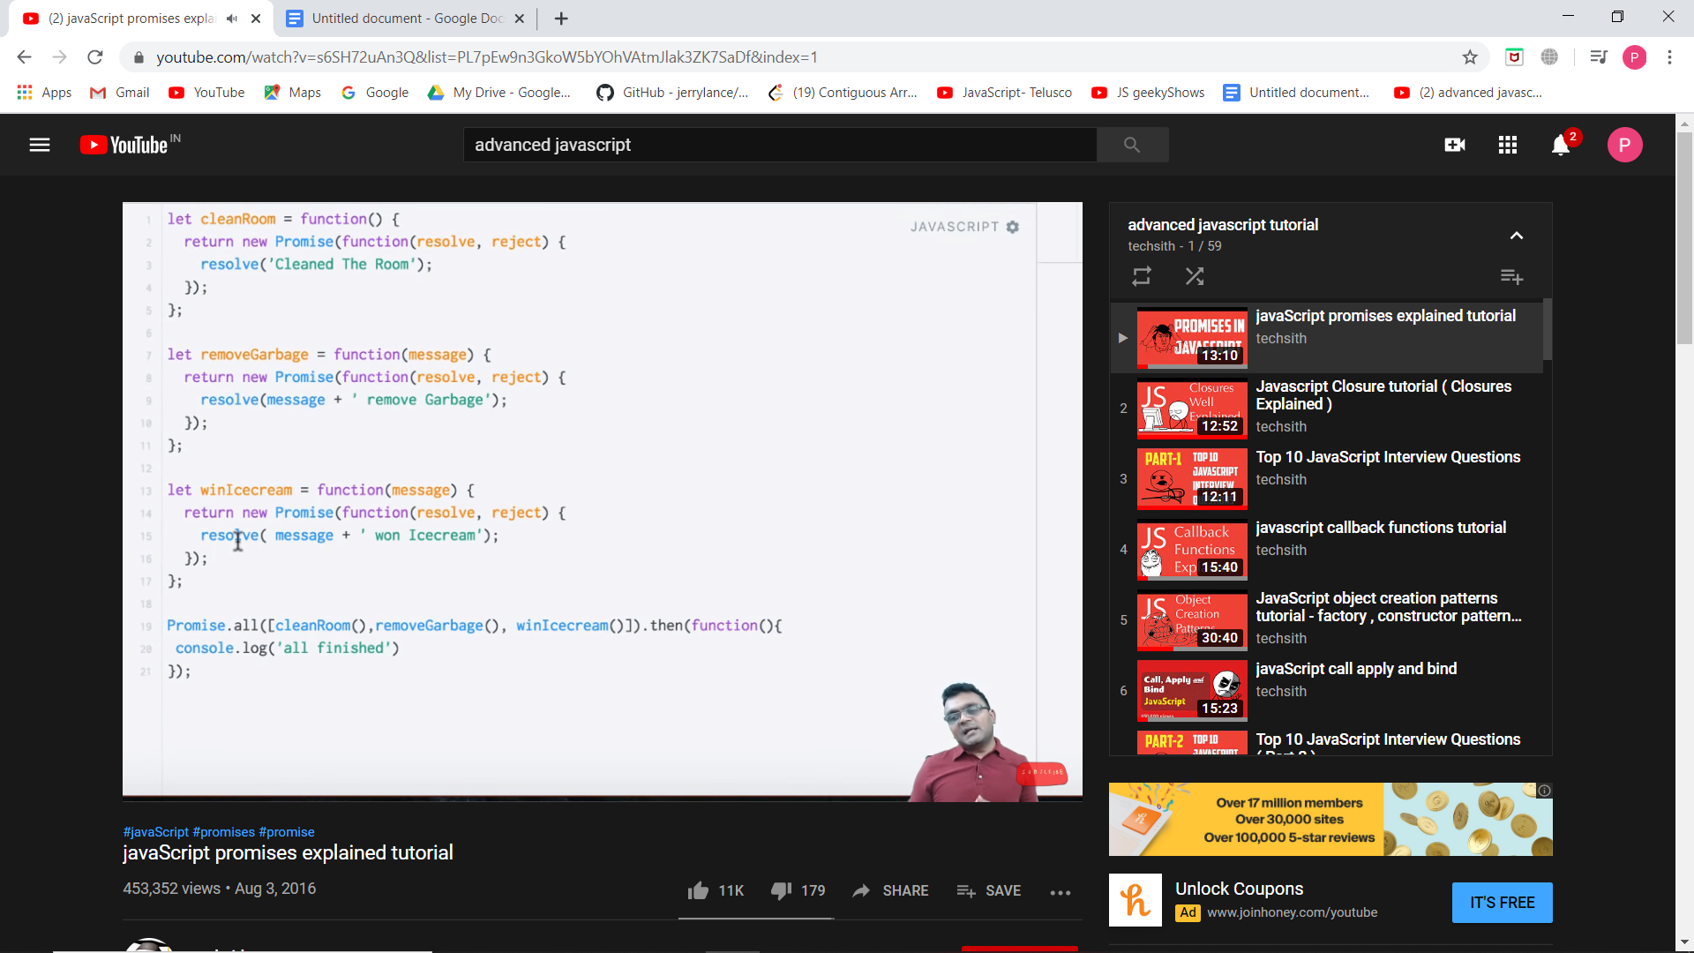

If we want to execute all of them in parallel use all() and when all of them are done you want to do something.

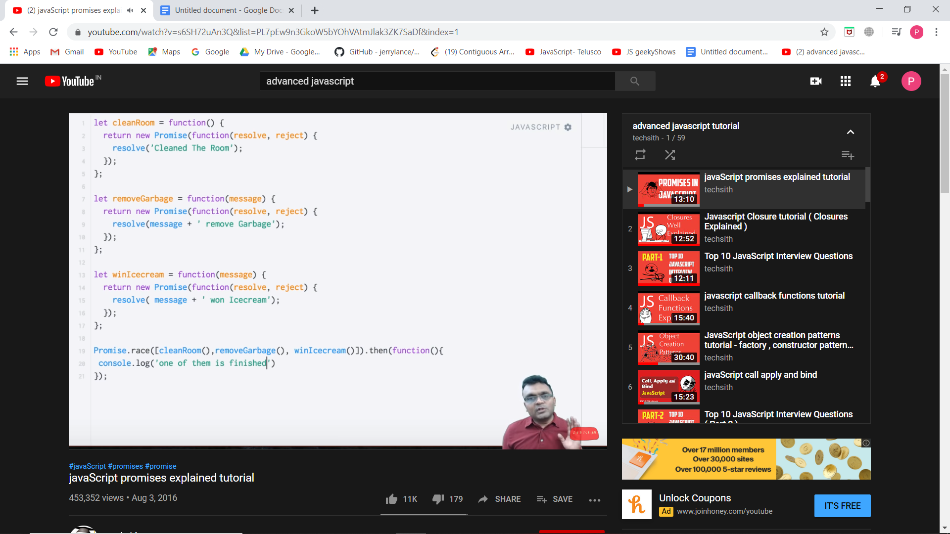

If we want any one of them to finish and you want to do something after any of them finishes, use race().

CLOSURES:

Lexical scoping (sometimes known as *static scoping* ) is a convention used with many programming languages that sets the *scope* (range of functionality) of a [variable](https://whatis.techtarget.com/definition/variable) so that it may only be *called* (referenced) from within the block of code in which it is defined. The scope is determined when the code is compiled. A variable declared in this fashion is sometimes called a *private* variable.

The opposite approach is known as *dynamic scoping* . Dynamic scoping creates variables that can be called from outside the block of code in which they are defined. A variable declared in this fashion is sometimes called a *public* variable.

In closure we see nested functions.

Closures concept: A global variable is accessed inside fns, an outer fn variable can be accessed inside an inside fn but an inside fn variable cannot be accessed by the outer functions.

Ex: Here if we do console.log(i), we do not get ‘i’ but if we do console.log(f), we get i. SO where is this function storing ‘i’.We see that the variable has block scope.

The output changes for let bcoz let is a block scope. # variables are created for it. But for var, the variable is updated and printed. Only 1 obj is present.

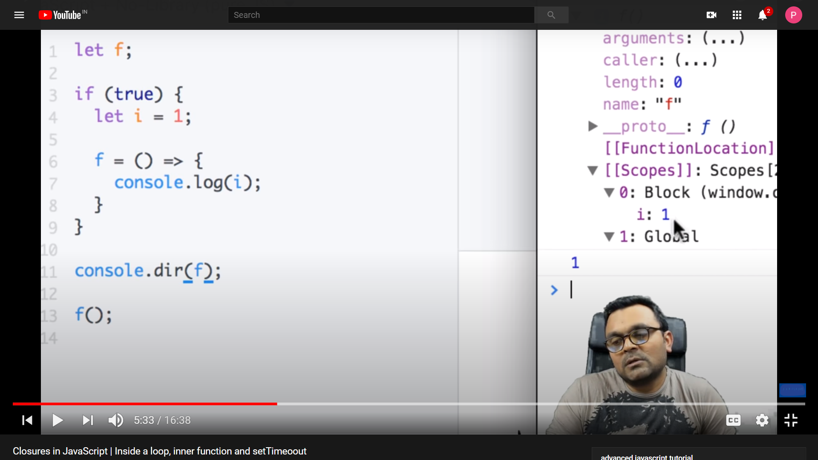

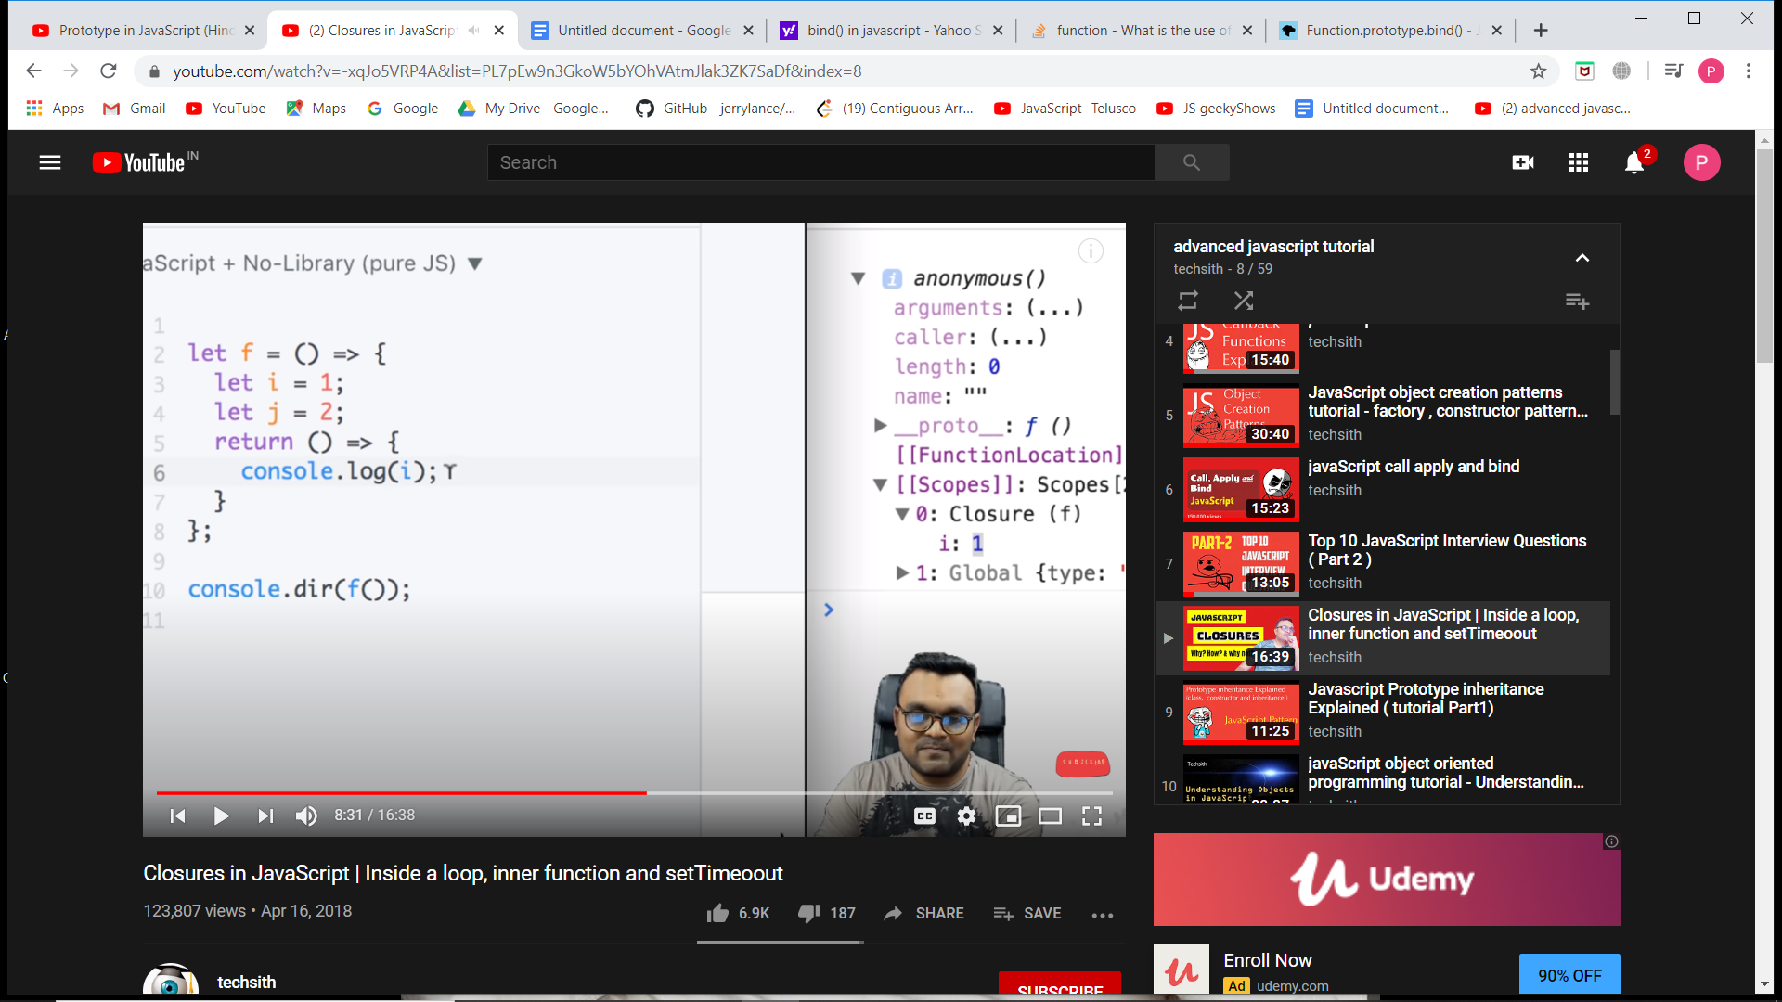

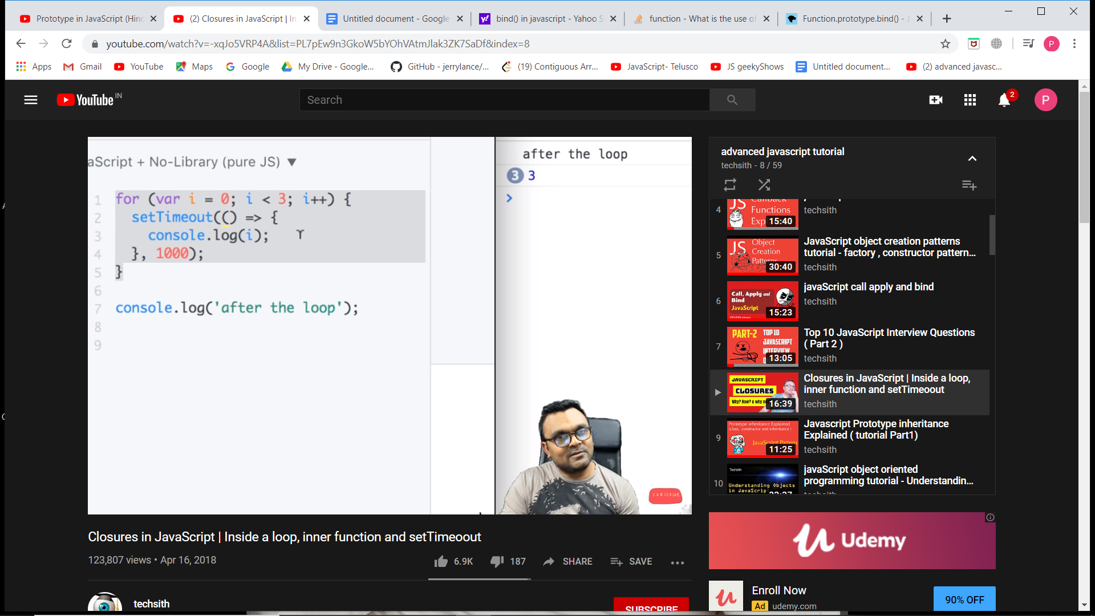for let i, o/p is 0 1 2.

**Call back functions or Higher Order Functions:**

Function passed as argument in another function. We can also declare the function in the parameter instead of declaring the function outside and calling it.

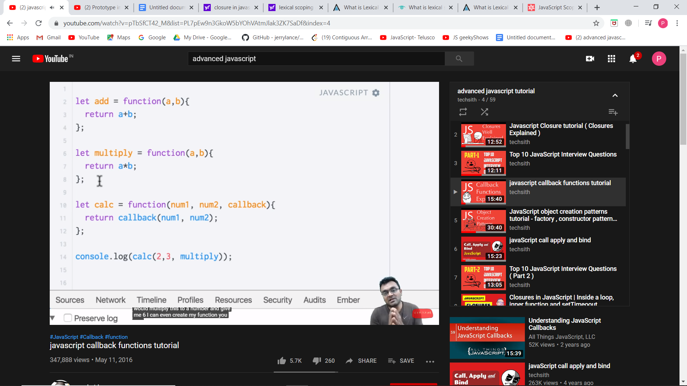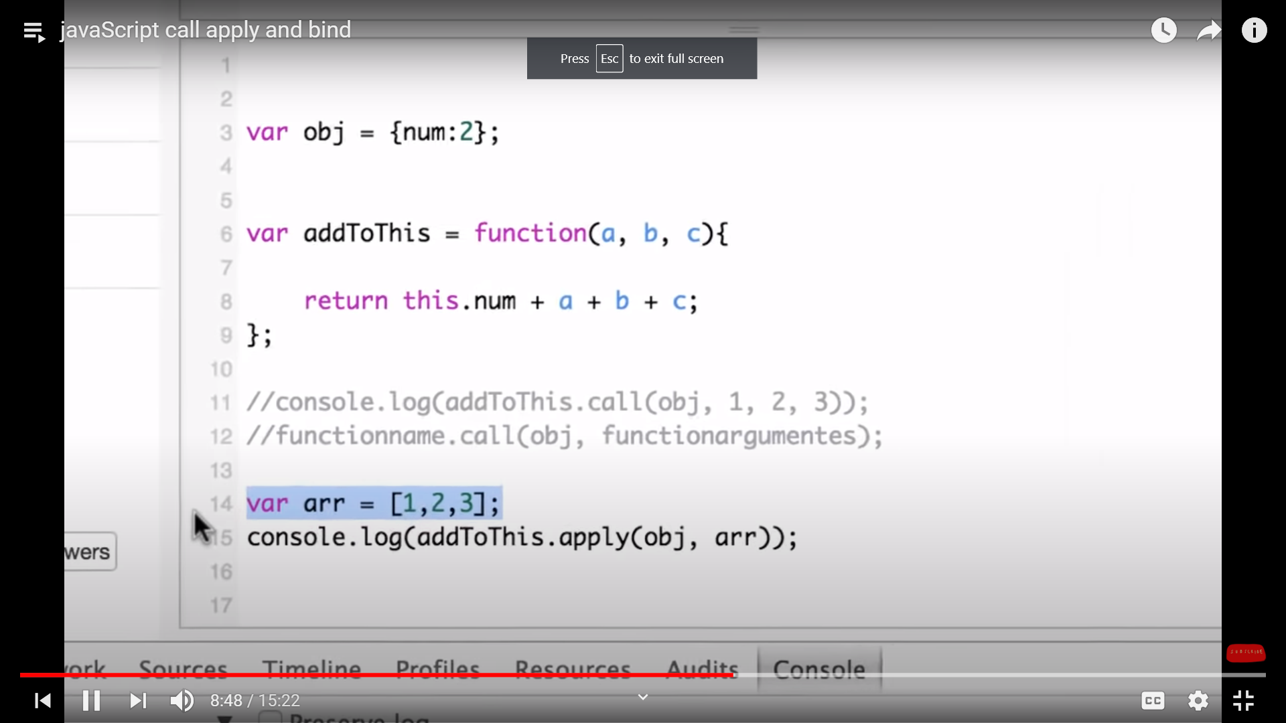

**apply(), call() and bind()**

The function is called for that specific object. This is done using apply() or call().Here obje

Whereas bind returns a function.The **bind()** method creates a new function that, when called, has its this keyword set to the provided value, with a given sequence of arguments preceding any provided when the new function is called.

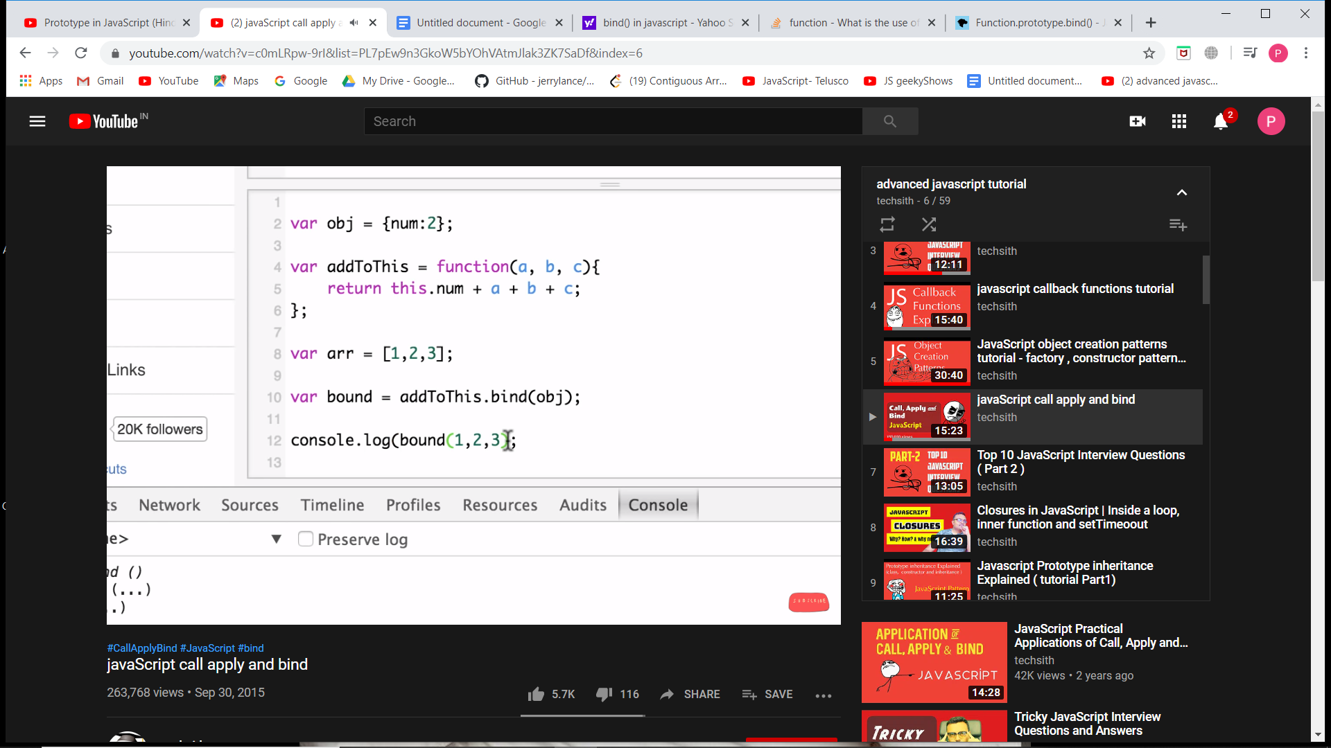

**Method Chaining:**

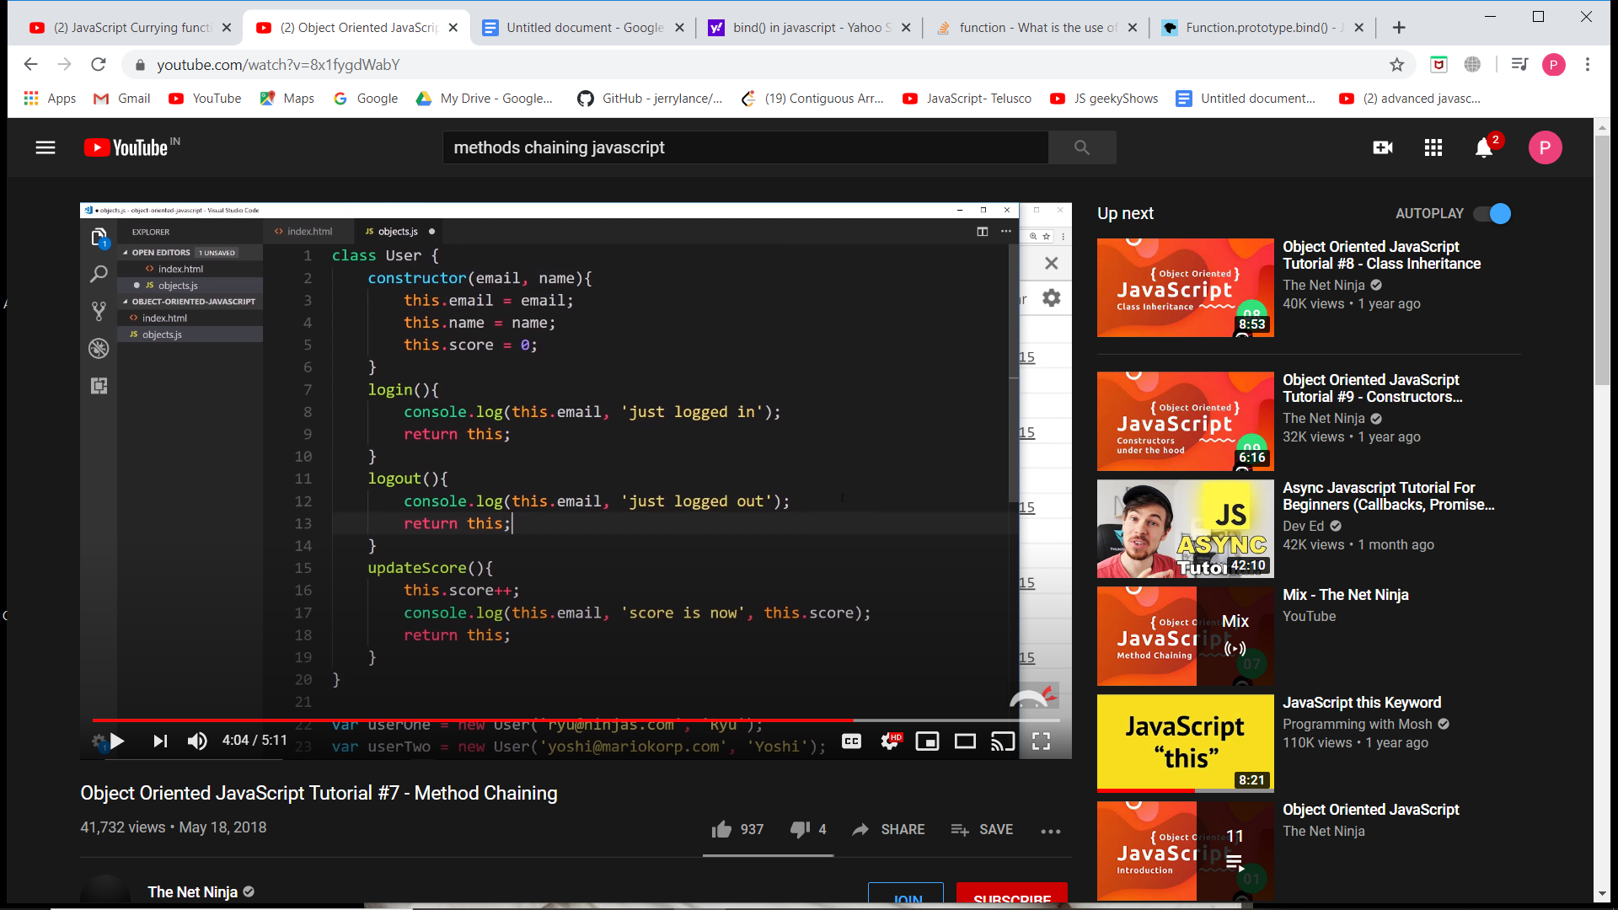

If we want to perform actions for a user continuously say login, updateScore and logout. So instead of writing them one by one we can chain them. But chaining on function should return an object so that other method should be called by that same object.

Chaining: **user1.login().updateScore ().updateScore ().updateScore ().logout()**

**Currying in JavaScript**

Currying is a transform that makes f(a,b,c) callable as f(a)(b)(c). JavaScript implementations usually both keep the function callable normally and return the partial if the arguments count is not enough. Currying allows us to easily get partials.

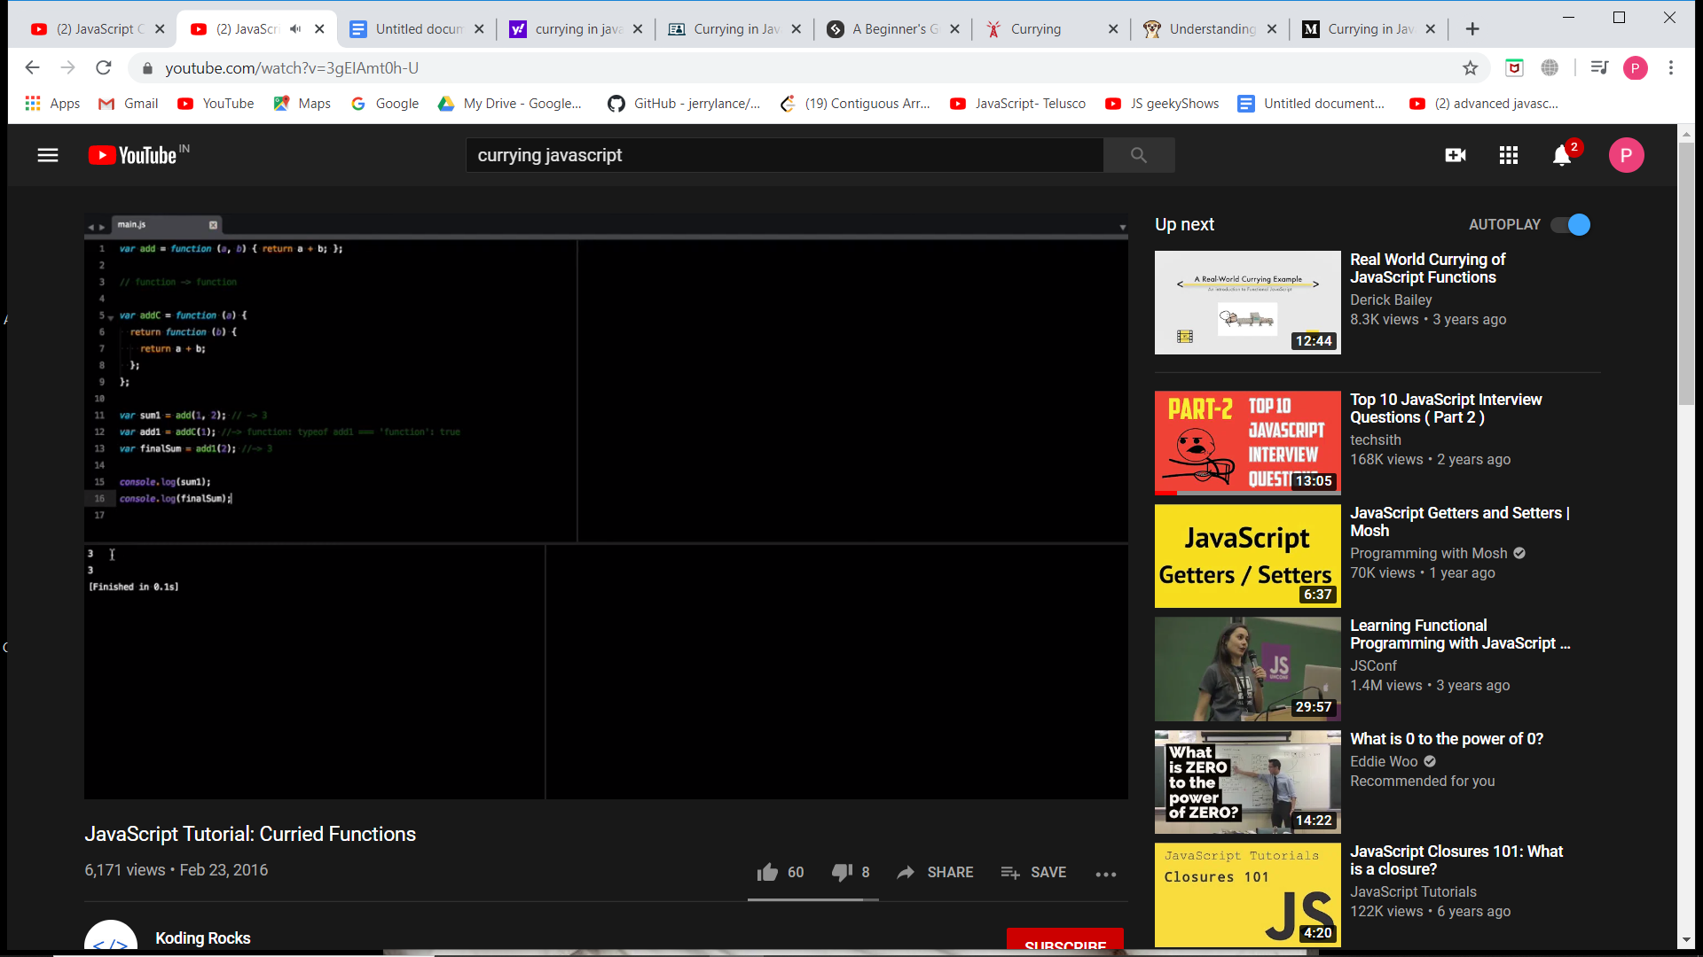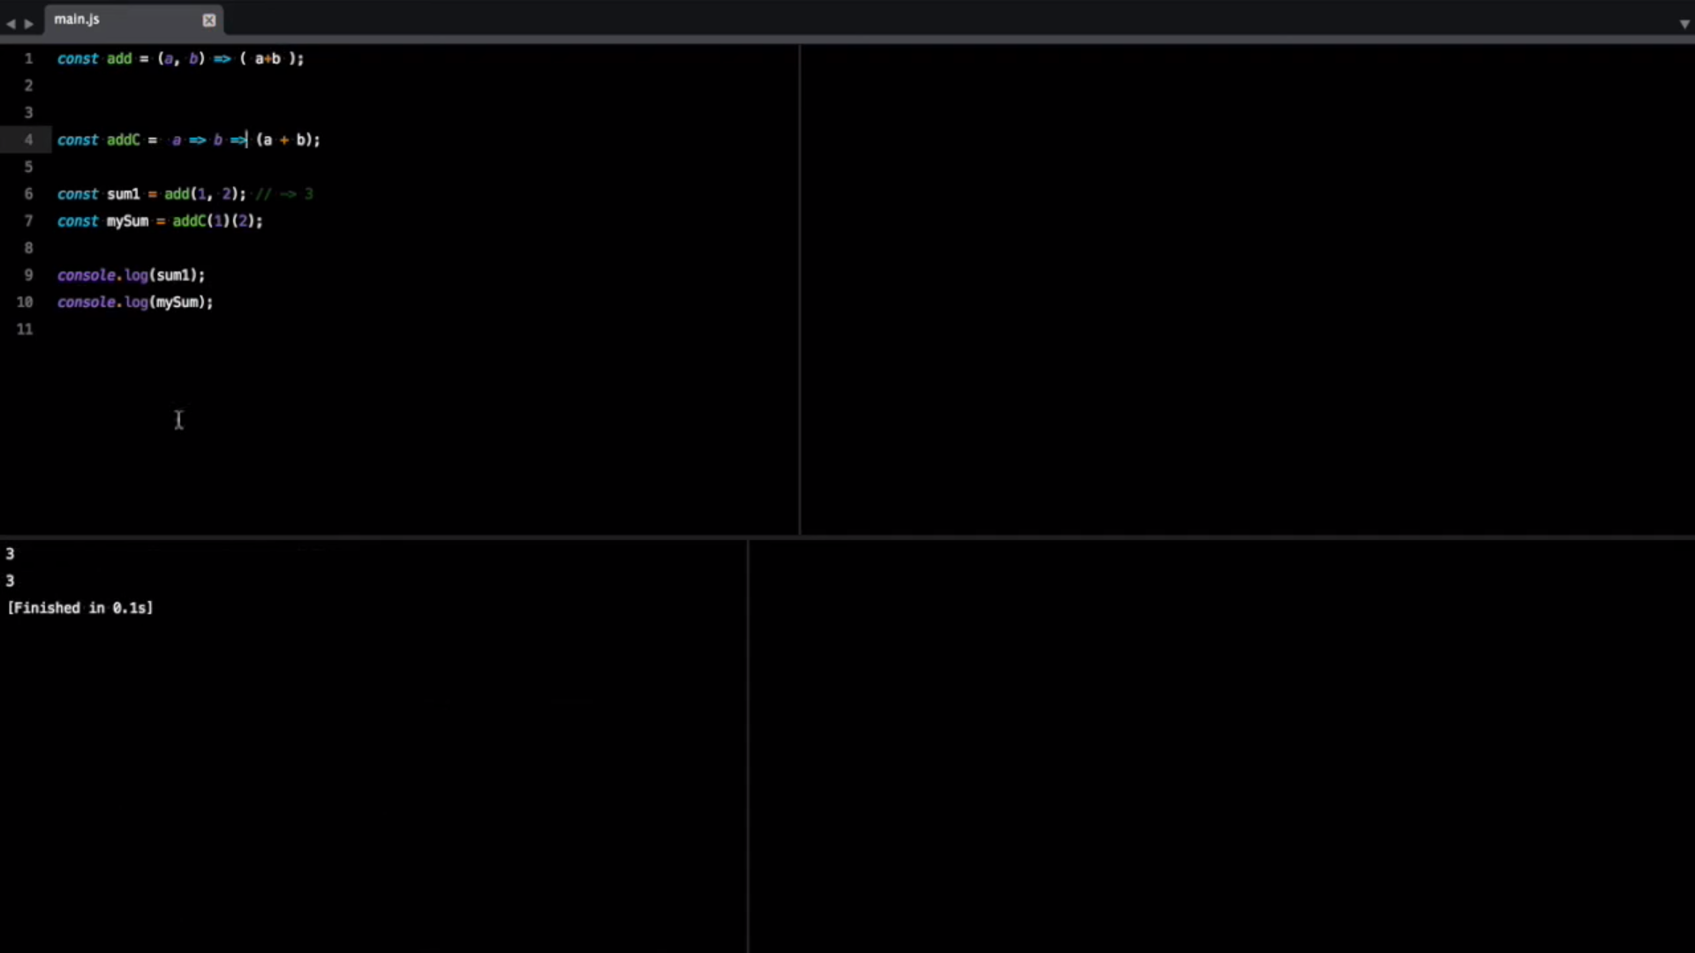

<https://blog.bitsrc.io/understanding-currying-in-javascript-ceb2188c339>

**HOISTING in JavaScript**

A variable has function scope while a var declared using let has a block scope ex - if block else block.

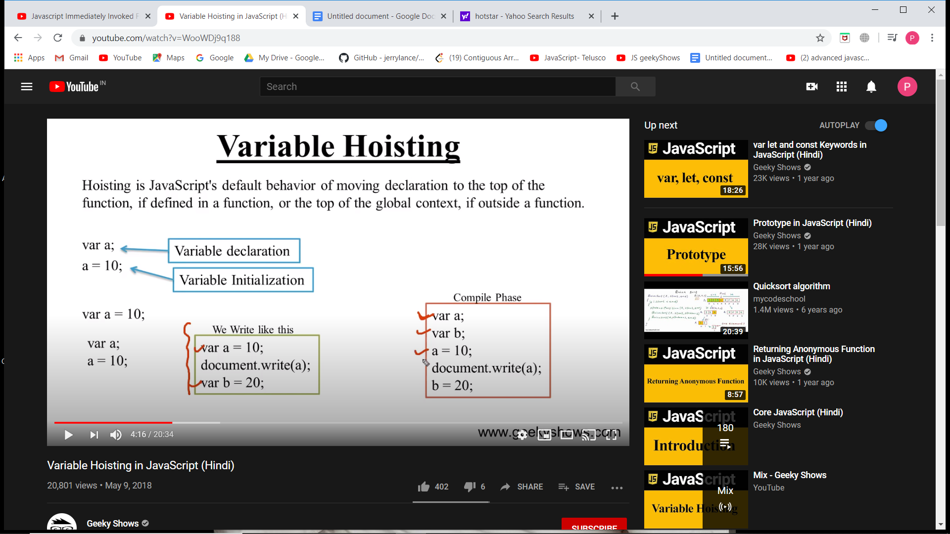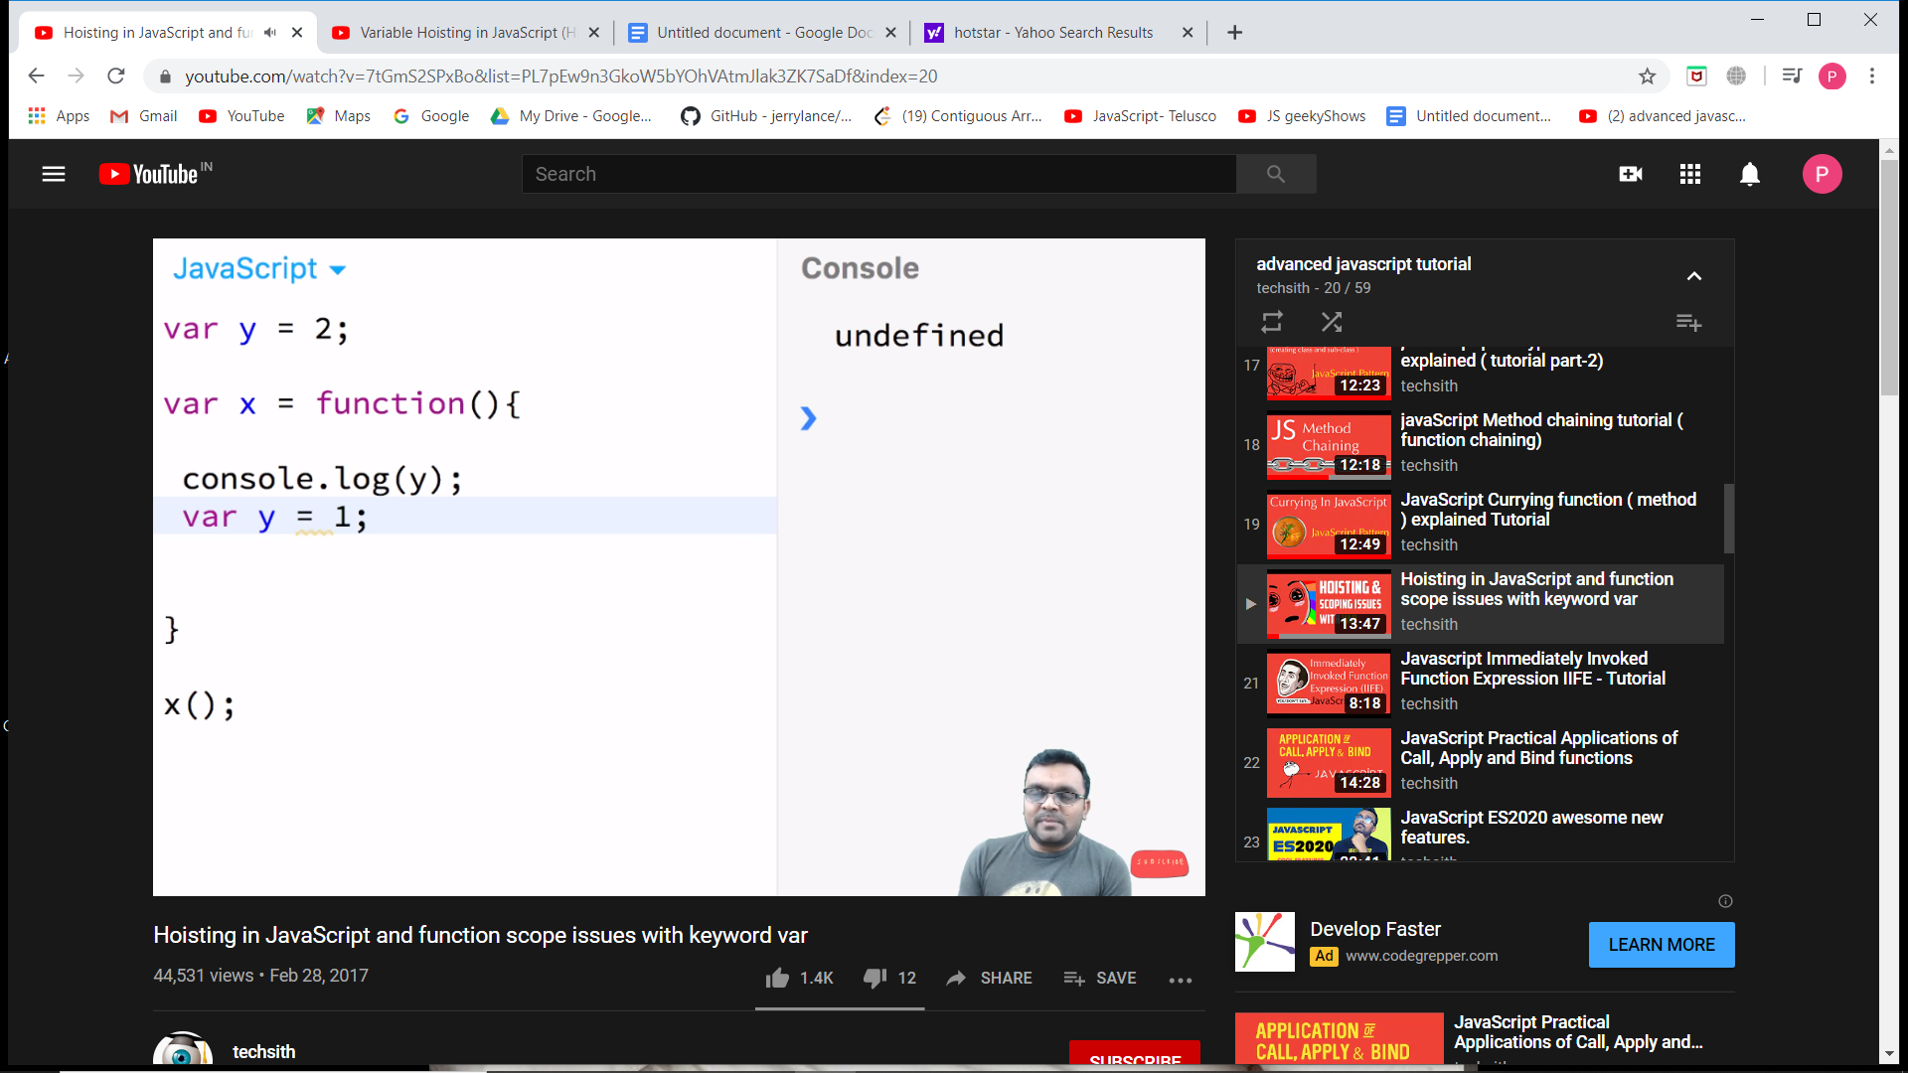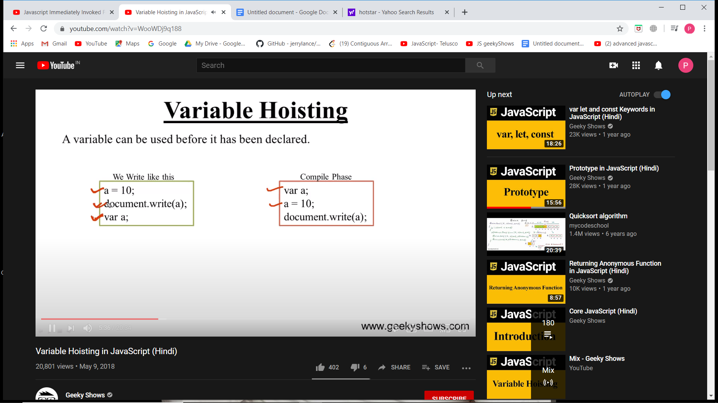

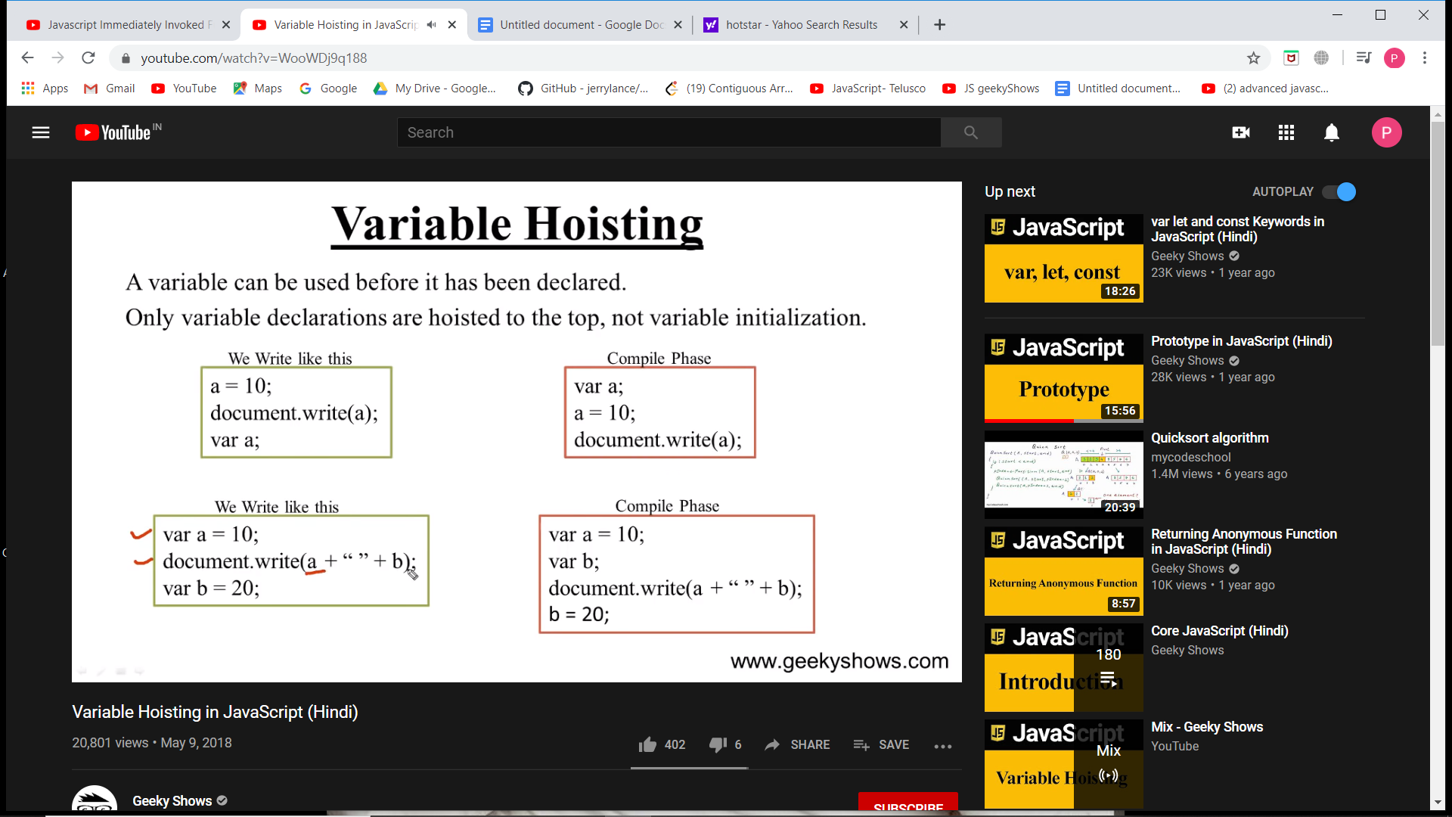

**Recursion:**

It goes in a stack way. The function called first goes in the stack first.

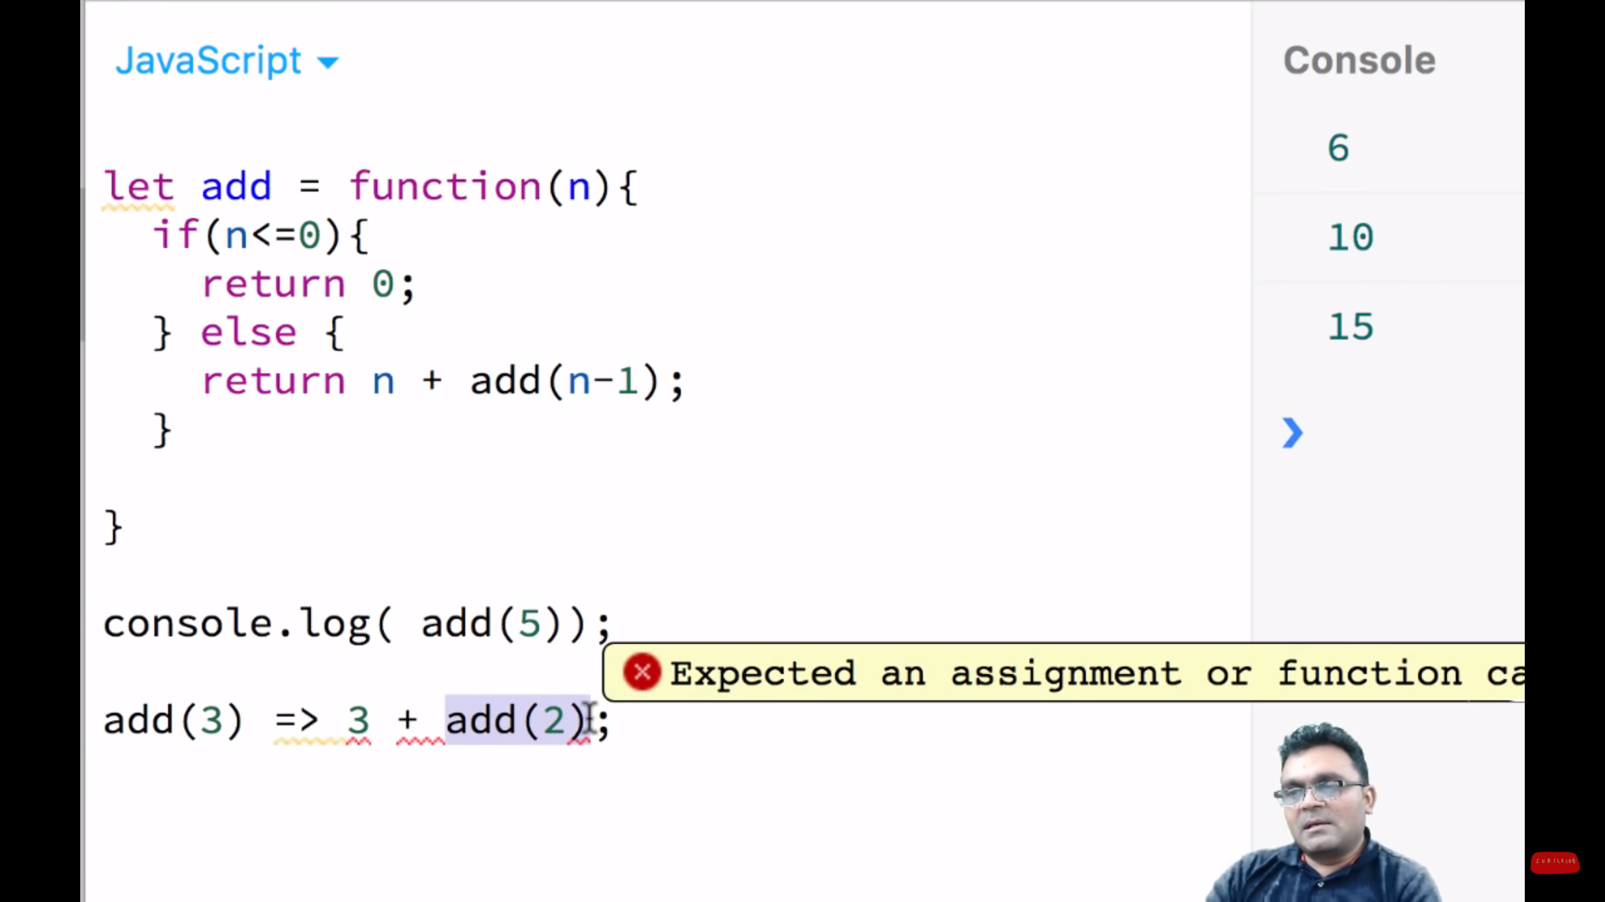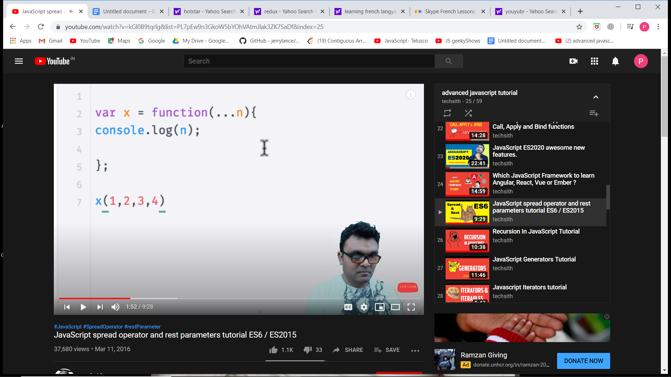

**SPREAD OPERATOR (...n)**

If passed as an argument takes any no of arguments. But why does JS need this? And also why do we need a parameter passed. JavaScript has an object named arguments inside a function.

But using an arguments object we get an array but it is actually an object as an array. So we have to convert it into an array using slice.call or shown. Or a more simple step shown in line 3. So for better performance we use spread operator.

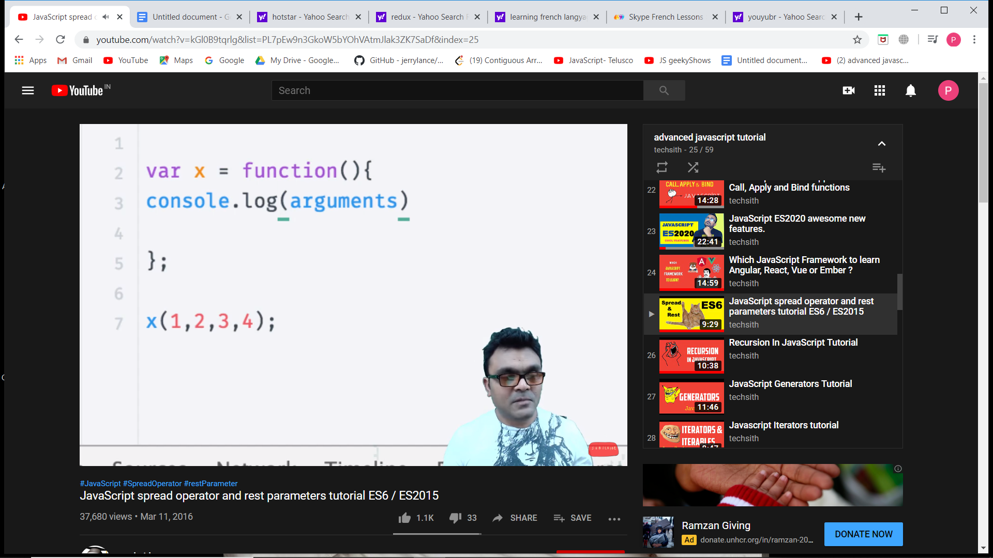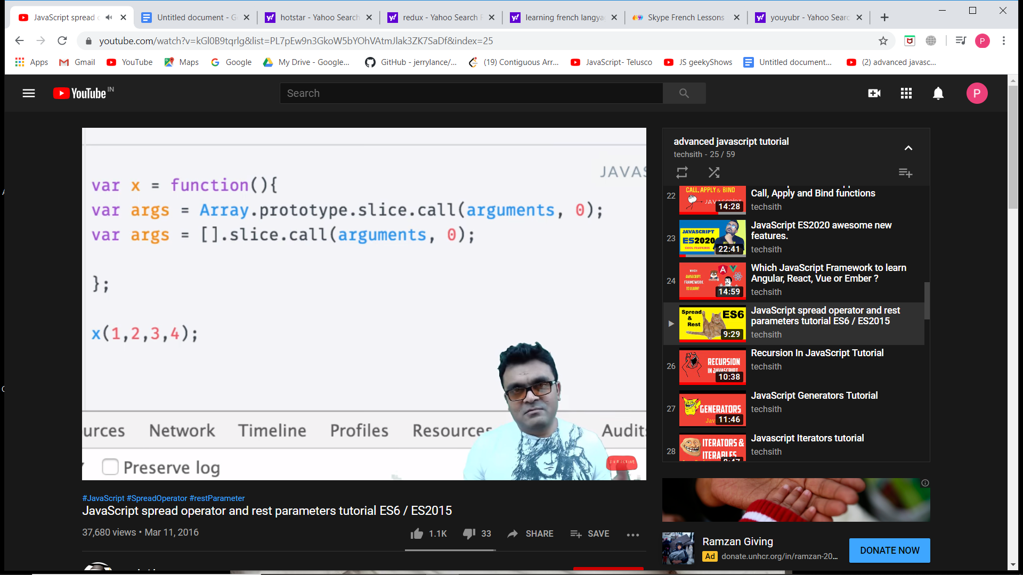

Outside the function when you pass an argument, you pass it as an array. Also since it is an operator we can use it at other places too.

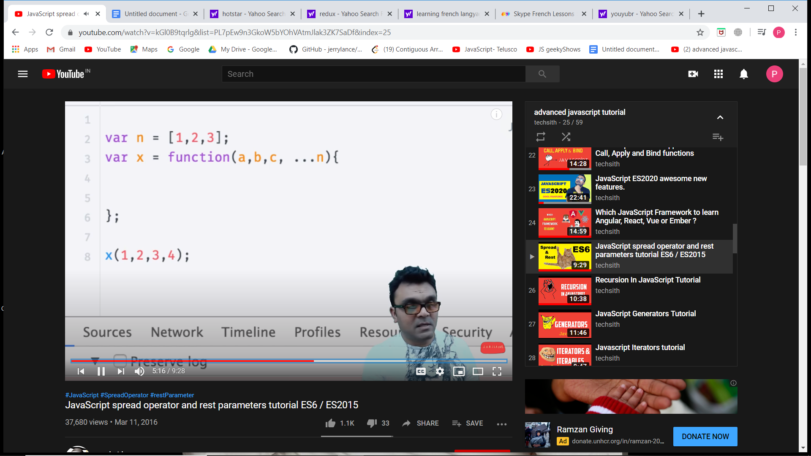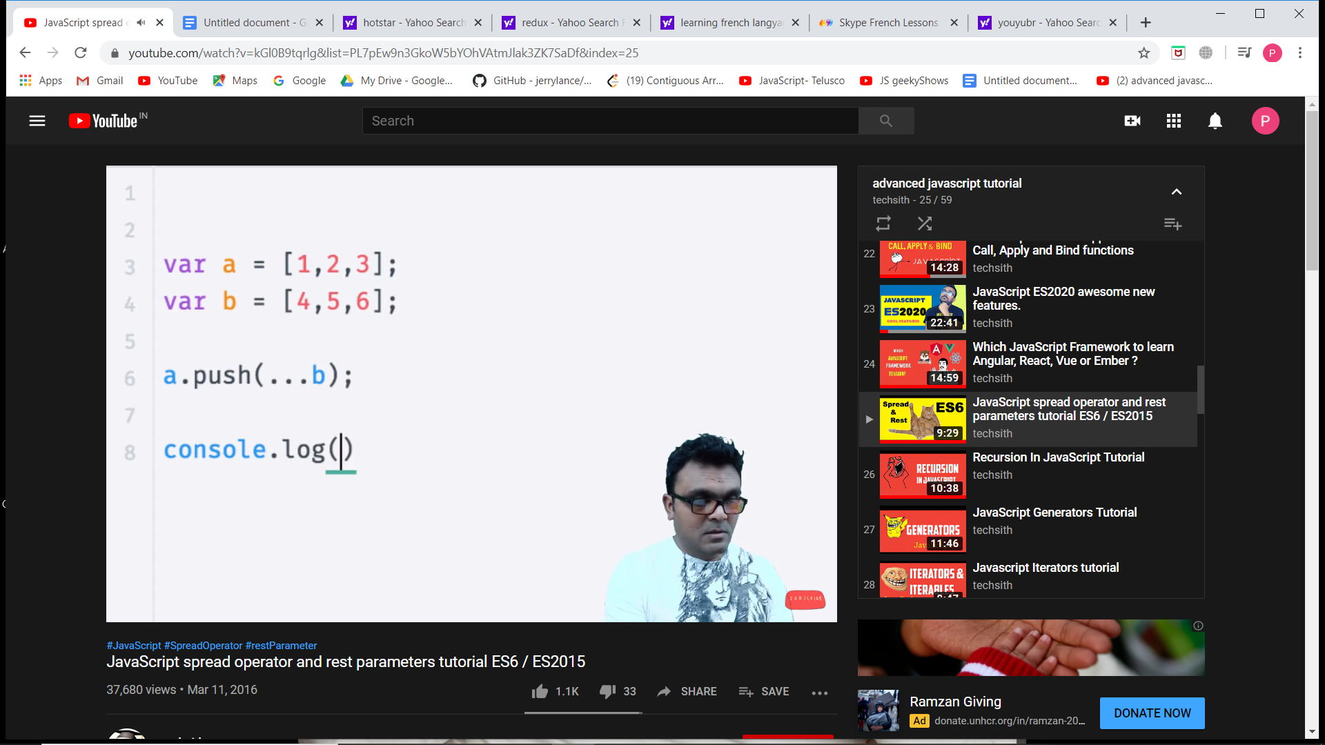

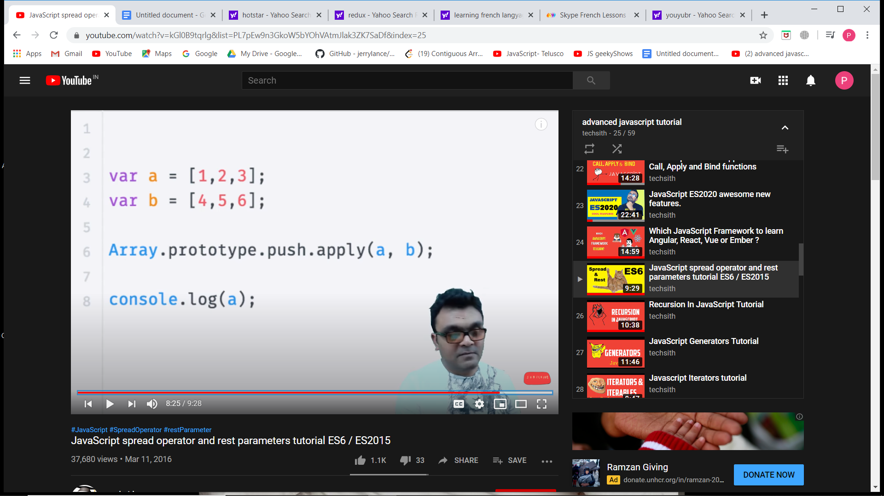 ← **earlier we used to do**

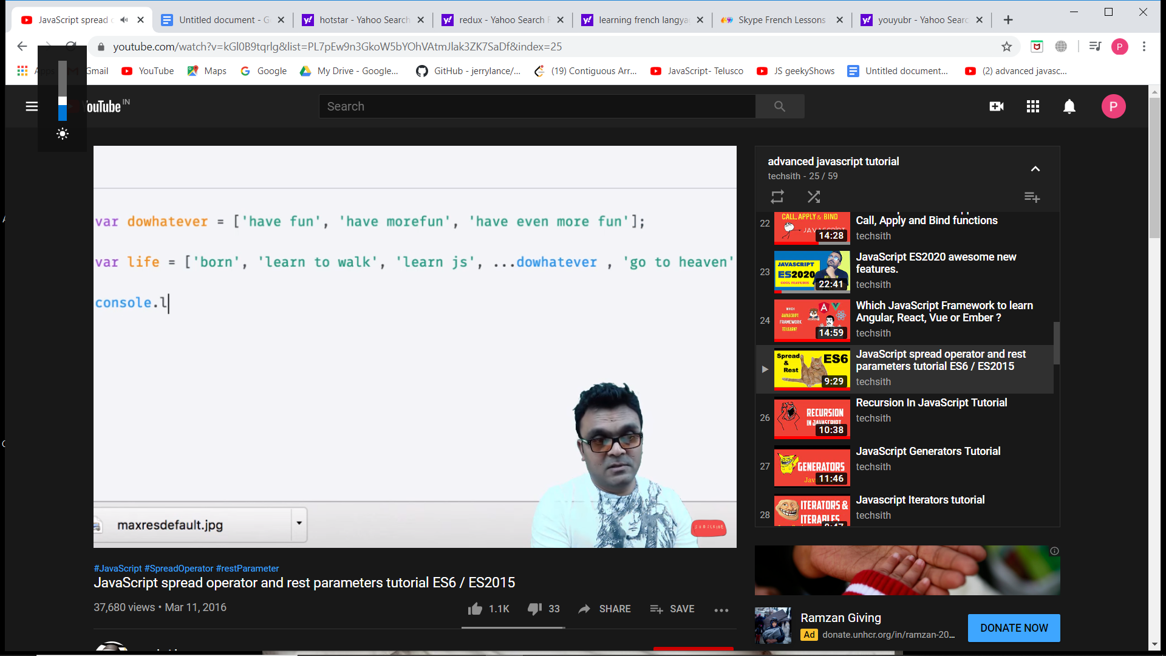

**ITERATOR AND ITERABLE**

Symbol.iterator property in new versions of JS on iterable objects.

To check if an object has this property or not do **console.dir(object)**. If it has a property in its __proto__, it is an iterable object.

**“this” in JavaScript**

We should not have this inside a function. A this inside a constructor function refers to the object of that function but this in a normal function is not able to read this.

So if we want to access a function having this, we have to pass an object so that this will point to that object. This is achieved using call().

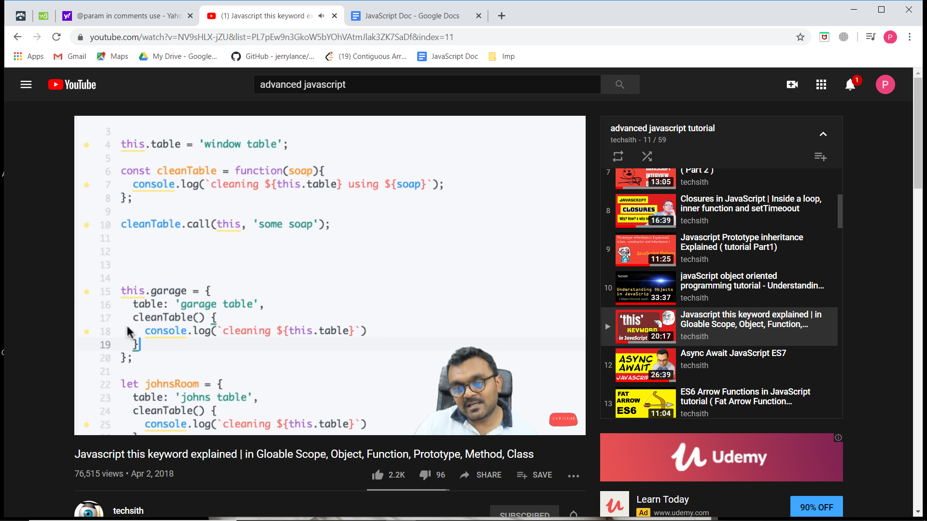

‘this’ inside an inner function.

Inside a function this is not useful unless you use call, apply or bind.

For inner functions using this, we have 3 solutions.

1. Use a keyword let that = this; in outer function and use that in inner fn.
2. Use call apply bind on inner function.
3. Using arrow function

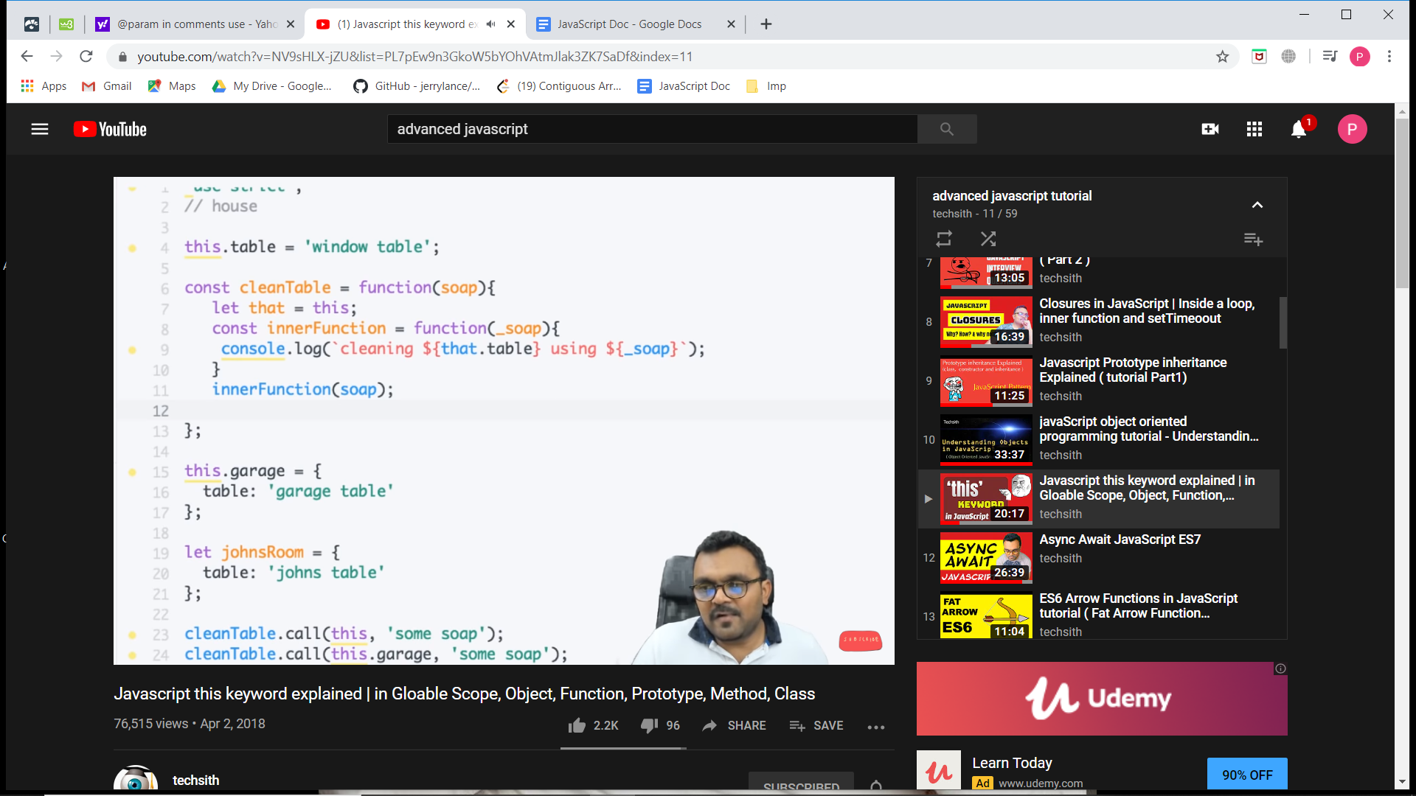

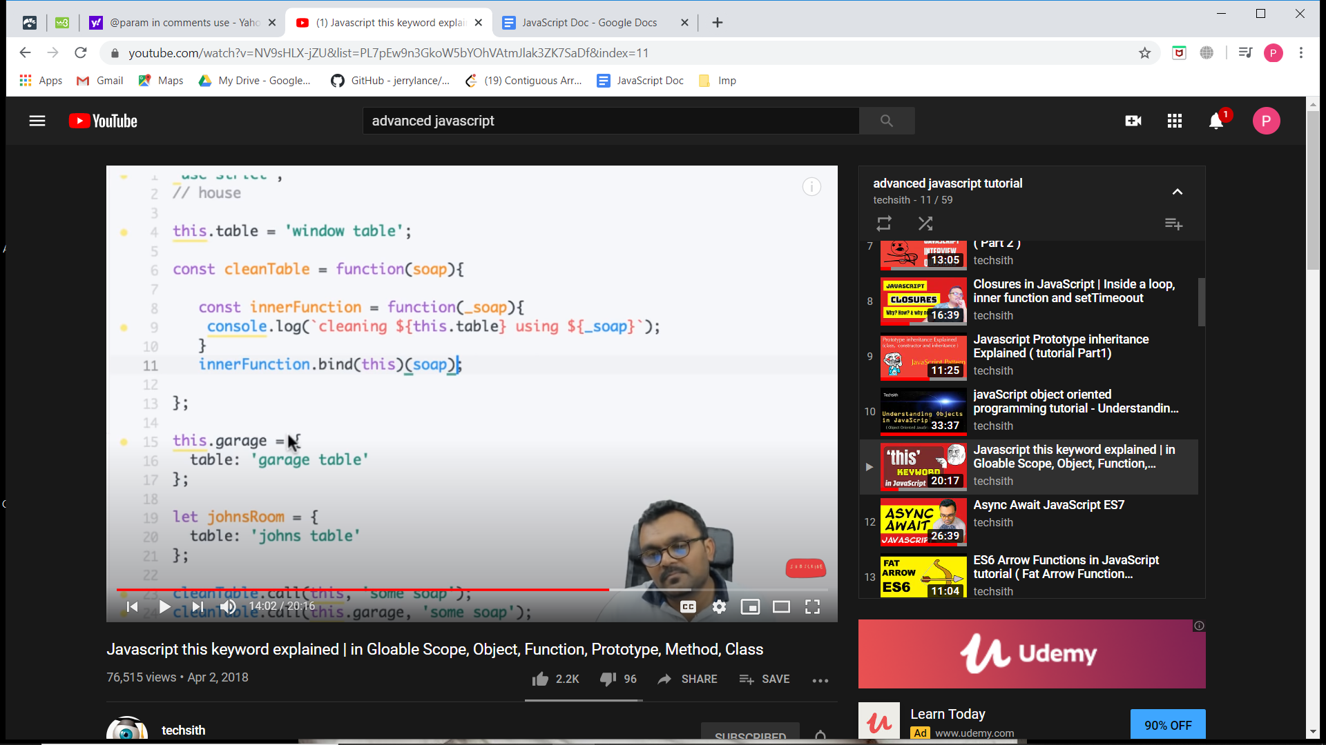

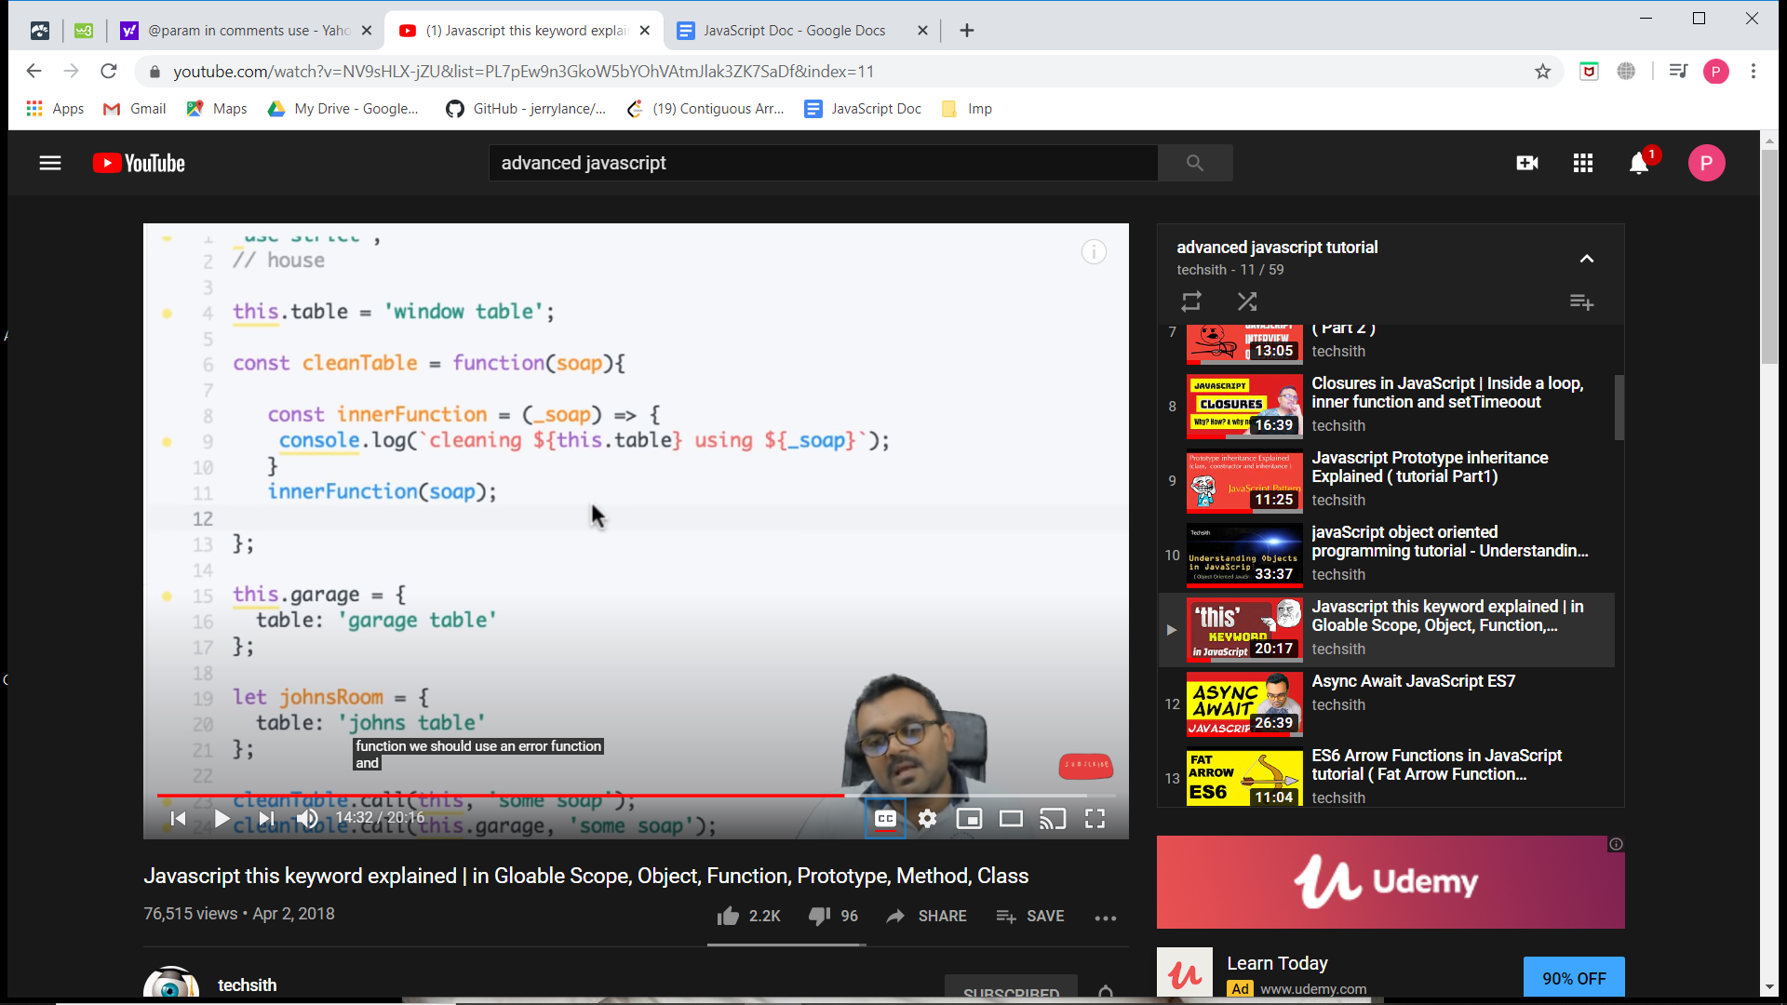

**Immediately invoked functions**

**Async Await**

**Fat arrow functions**

**Web workers**

**Event bubbling and capturing**

**Generators**

**Classes in JavaScript**

Js classes are function constructor with prototype methods.

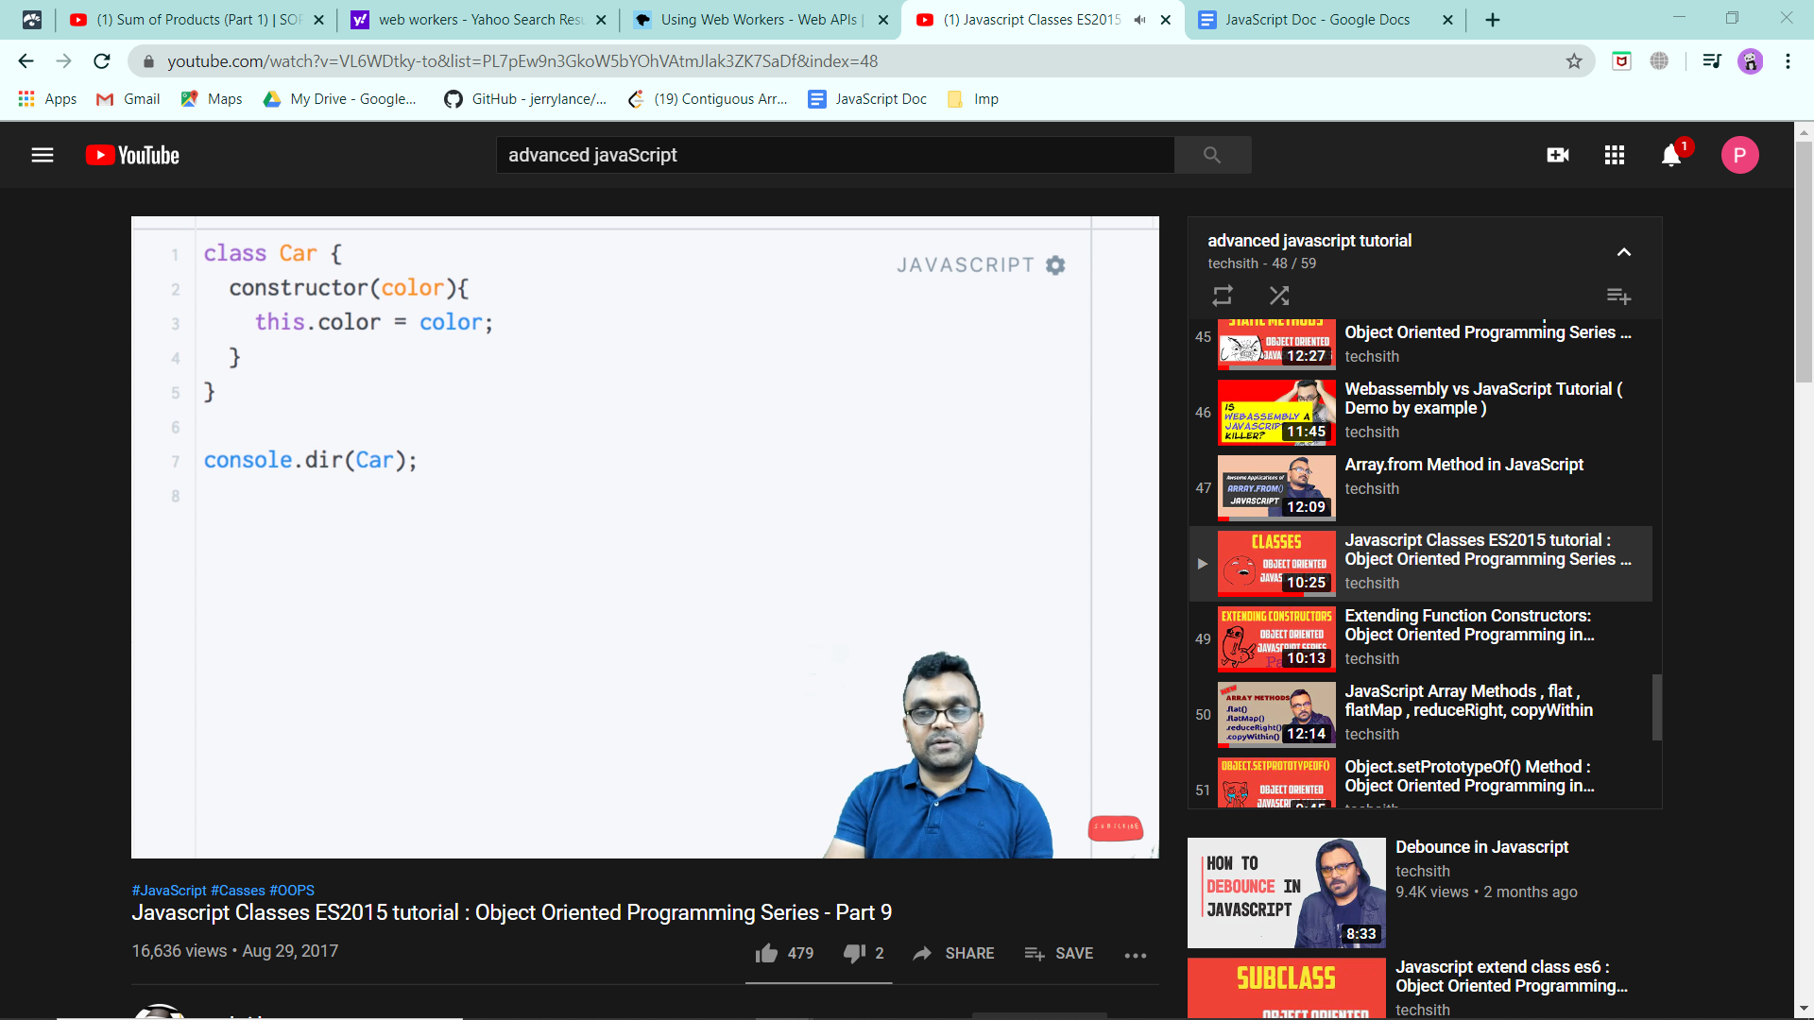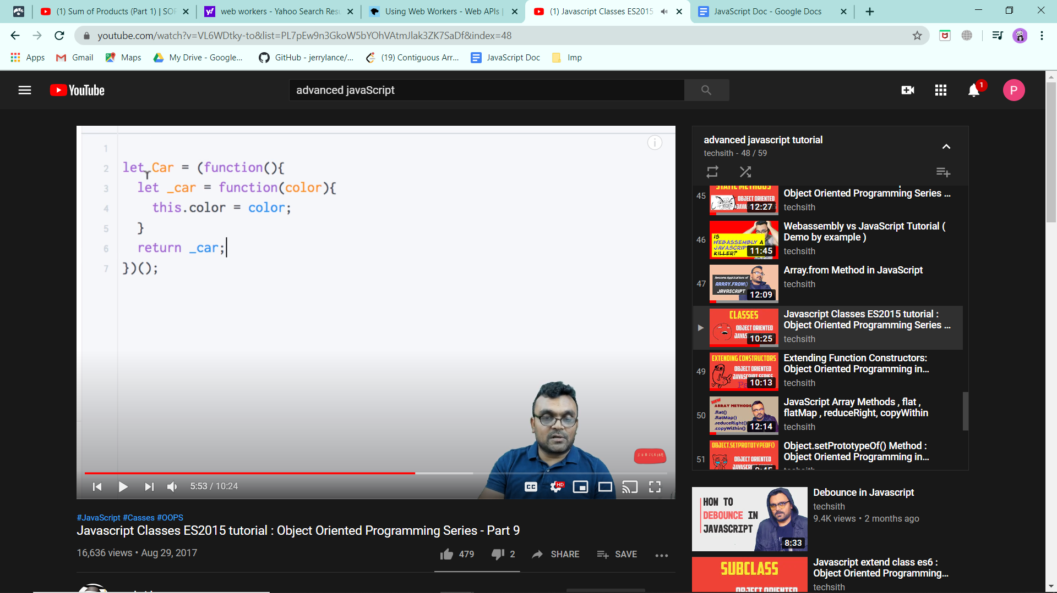

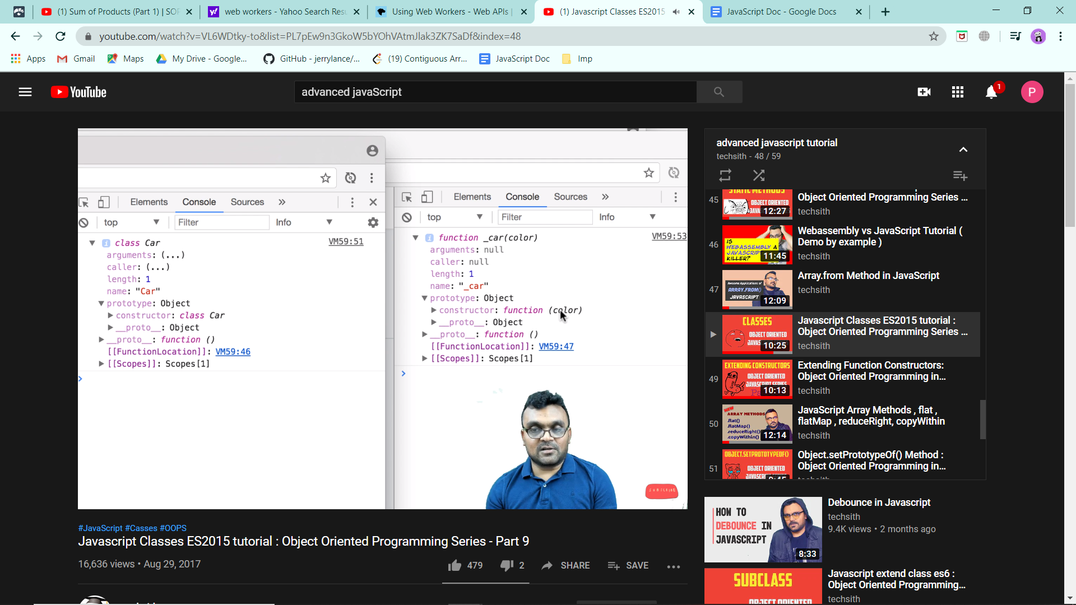

Methods written inside class get inside the prototype object.

**SubClasses (Extending classes)**

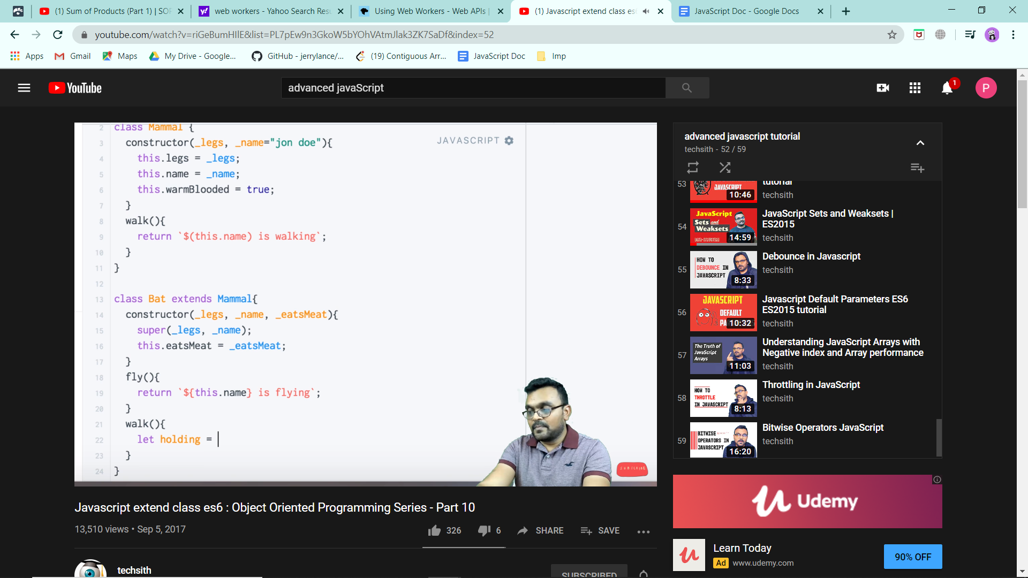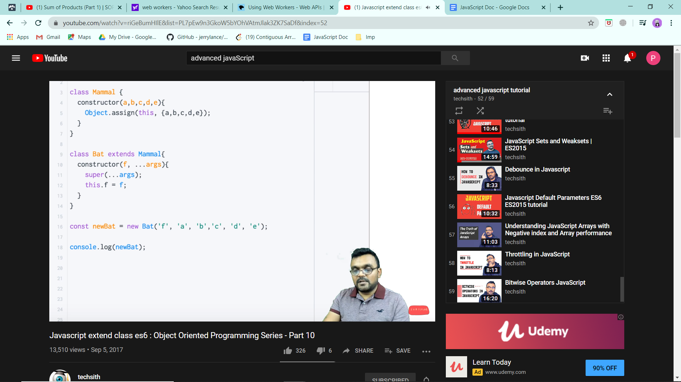

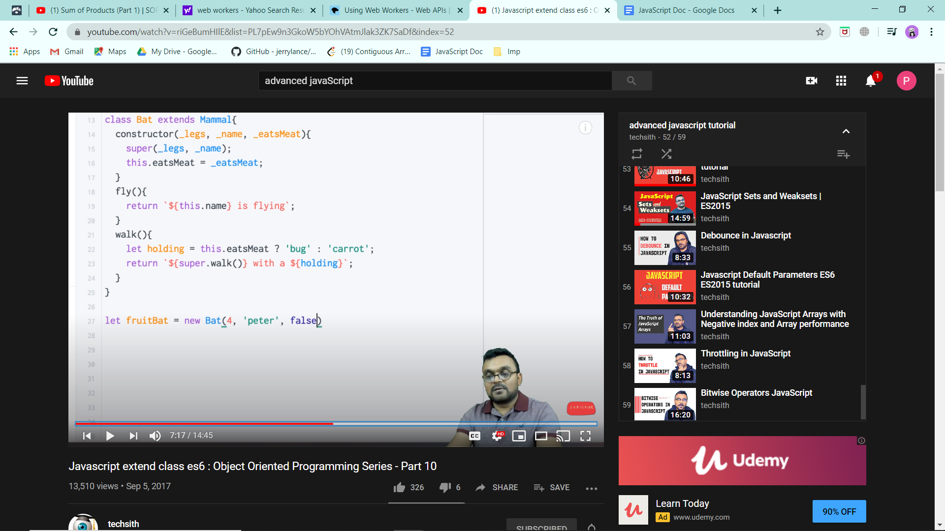We can override the walk method.

Now if the parent has a large no of arguments, use spread operator.

**Extending Constructors from base to sub constructor.**

**Pass by value and reference**

**Decorators**

**Throttling**

**JavaScript TypeConversion**

It is easier to convert a number into a string rather than a string into a number. Similarly it is easy to convert a boolean into a number or a boolean to a string. So Javascript does it implicitly for us.

Let x = 2 + ‘2’; console log gives => **22**

Let x = 2 + 2 + ‘2’; console log gives => **‘42’**

Let x = 2 + true; console log gives => **3**

Let x = 2 + true + ‘2’; console log gives => **32**

Let x = true + ‘2’; console log gives => **true2**

Let x =Boolean(null/ undefined/ ‘ ‘/ 0); console log gives => **false**

Let x =Boolean(‘false’); console log gives => **true**

For all strings, Boolean conversion gives true. Also conversion of objects to Boolean is always true. Ex: **if([ ]) => gives true**

**AJAX**

Ajax is an acronym for Asynchronous Javascript and XML. It is used to communicate with the server without refreshing the web page and thus increasing the user experience and better performance.

Ajax allows web pages to be updated asynchronously by exchanging small amounts of data with the server behind the scenes.

* Not a language, not a framework or library.
* It is a set of web technologies to send data from a client to servers asynchronously.
* JSON has replaced XML in Ajax and XML is very less used.

XmlHttpRequest (xhr) object is actually an API in form of object.It has methods, properties.

* It is provided by the browser’s JS environment.
* Can be used with other protocols than HTTP.
* It transfers data between client and servers.

You need to have some server to work with AJAX. (ex: XAMPP).

Ex: On btn click text changed without refreshing the page.

onreadyStatechange() is the older way of doing things. New is onload().

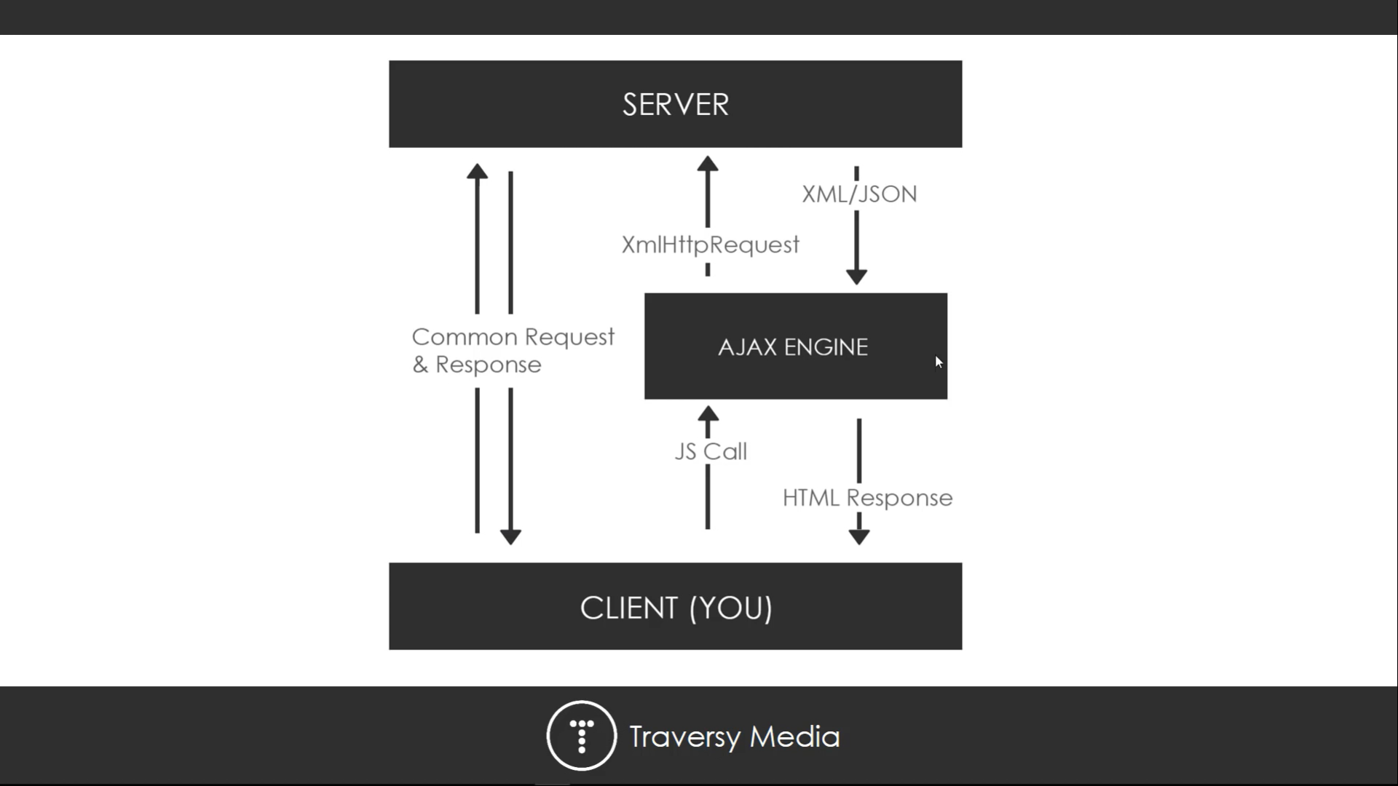

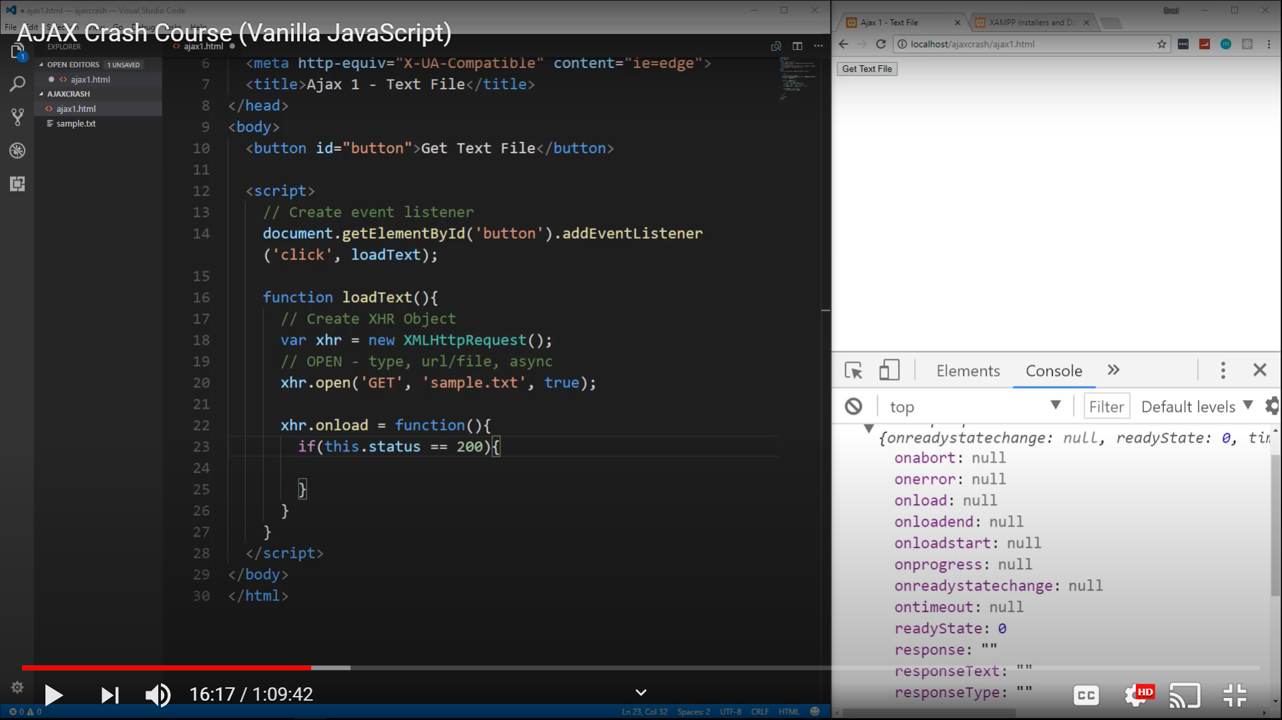

xhr.send() will send the request. In the network tab, we see a call of type xhr.

While using onreadystatechange, we also need to check readystate = 4 apart from status. While onload gets executed only if readystate is 4. Response can be accessed using property responseText.

xhr.onprogress();

xhr.onerror(); <= for errors

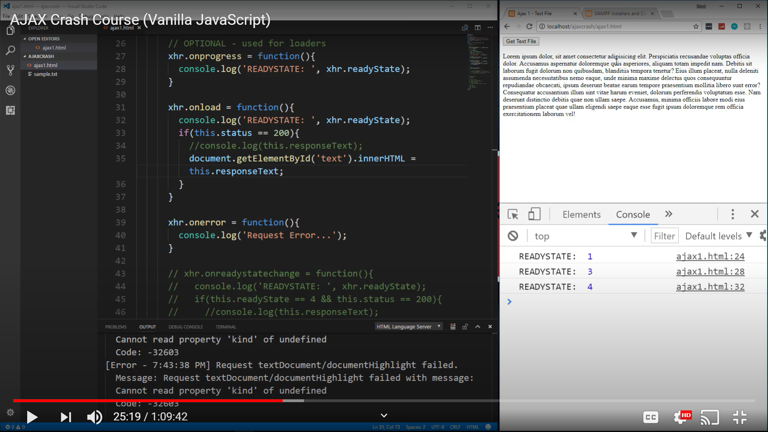

Ajax: <https://www.youtube.com/watch?v=82hnvUYY6QA>

<https://www.w3schools.com/xml/ajax_xmlhttprequest_response.asp>

<https://www.tutorialspoint.com/ajax/ajax_in_action.htm>

Json: <https://www.w3schools.com/Js/js_json_parse.asp>

Javascript Stringsa are stored as value type.

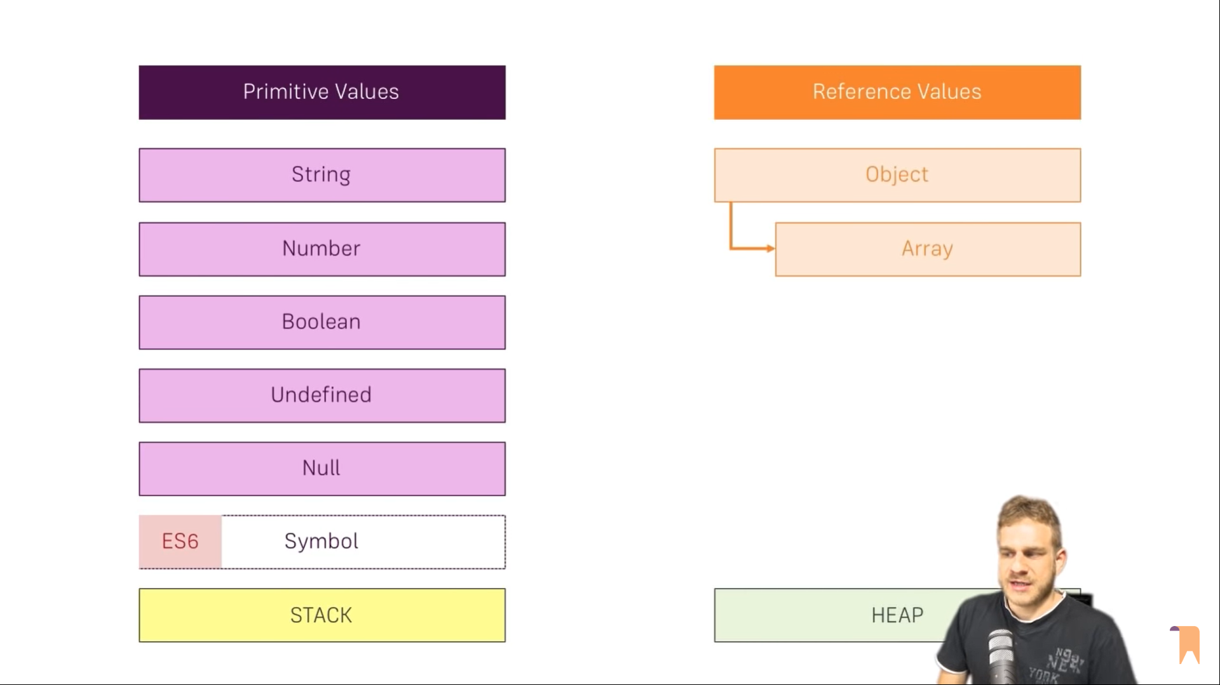

Heap is used to store a large amount of data as compared to Stack. But data retrieval takes more time as compared to stack where data can be retrieved faster.

Stack and heap differ in the following ways:

1. **Memory Allocation:** Stack is used for static memory allocation and Heap for dynamic memory allocation, both stored in the computer's RAM .
2. **Variables:** Variables allocated on the *stack* are stored directly to the memory and access to this memory is very fast, and it's allocation is dealt with when the program is compiled. When a function or a method calls another function which in turns calls another function etc., the execution of all those functions remains suspended until the very last function returns its value. Variables allocated on the *heap* have their memory allocated at run time and accessing this memory is a bit slower, but the heap size is only limited by the size of virtual memory.
3. **Access:** The stack is always reserved in a *LIFO order*, the most recently reserved block is always the next block to be freed. This makes it really simple to keep track of the stack, freeing a block from the stack is nothing more than adjusting one pointer. Elements of the heap have no dependencies with each other and can always be *accessed randomly* at any time. You can allocate a block at any time and free it at any time. This makes it much more complex to keep track of which parts of the heap are allocated or free at any given time.

**In heap, each element has its own address. We do have a pointer which has the address of the heap and this pointer is stored in the stack.**

**When to use stack and when to use heap?**

You can use the stack if you know exactly how much data you need to allocate before compile time and it is not too big. You can use heap if you don't know exactly how much data you will need at runtime or if you need to allocate a lot of data.

In a multi-threaded situation each thread will have its own completely independent stack but they will share the heap. Stack is thread specific and Heap is application specific. The stack is important to consider in exception handling and thread executions.